 | MINISTRY OF EDUCATION AND TRAINING

FPT UNIVERSITY
Capstone Project Document
OMW – ONLINE MOBILE WORLD
Moontek Group
Group Members | Nguyễn Xuân Minh – Minhnx00017  Phạm Ngọc Sơn – Sonpn00286  Lê Thị Bích Thảo - Thaoltb00238  Nguyễn Đức Long - Longnd00102  Trương Đức Vinh - Vinhtd00290
Supervisor | Nguyễn Trường Long
Ext Supervisor
Capstone Project code | CS_OMW

- Hanoi,04/2011 -

Contents at Glance

Report No.1: Introductions 10
1.1 The initial idea 10
1.2. Existing system 11
1.3. Project team 11

Report No.2: Software Project Management Plan 14
2.1 Problem Definition 14
2.2 Problem Organization 15
2.3 Problem Management plan 19
2.4 Coding Convention 23
2.5 Risk Management 38

Report No.3: Software Requirements Specifications 42
3.1 User Requirement Specification 42
3.2 System Requirements Specification 45
3.4 Entity Relationship Diagram or Data Structures 60
3.5 Risk-Driven Specification 64

Report No.4: Software Design Description 66
4.1 Design Overview 66
4.2 System Architectural Design 67
4.3 Component Diagram 71
4.4 Detailed Description of Components 72
4.5 Sequence Diagram 82
4.6 User Interface Design 87
4.7 Database Design or Data Structures 96

Report No.5: Software Test Documentation 101
5.1 Introduction 101
5.3 Test Plan 102
5.5 Test Cases 103
5.5 Detail plan 123
5.6 Checklists 127
5.7 Appendix 128

Report No.6: Software User’s Manual 133
6.1 Installation Guide 133
6.2 User’s Guide 134

Appendixes 185

Table of Contents

Report No.1: Introductions 10
1.1 The initial idea 10
1.1.1 Definition of OMW 10
1.1.2 Why need our system 10
1.1.3 Limitation of our system 11
1.1.4 Business model 11
1.2. Existing system 11
1.2.1 Overview existing system 11
1.2.2 Limitation of existing system 11
1.3. Project team 11
1.3.1 Basic norms 11
1.3.2 Advantages of team 12
1.3.3 Disadvantages of team 12
1.3.4 Time lines 12
1.3.5 Technology (original ideas) 13

Report No.2: Software Project Management Plan 14
2.1 Problem Definition 14
2.1.1 Name of this Capstone Project 14
2.1.2 Problem Abstract 14
2.1.3 Project Overview 14
2.1.3.1 The current system 14
2.1.3.2 The proposed system 14
2.1.3.3 Bounderies of the system 15
2.1.3.4 Development Environment 15

2.2 Problem Organization 15
2.2.1 Software Process Model 15
2.2.2 Roles and Responsibilities 16
2.2.3 Tools and Techniques 17
2.3. Problem Management Plan 19
2.3.1 Tasks: 19
2.3.2 Task Sheet: Assignments and Timetable 21
2.4 Coding Convention 23
2.4.1 Purpose 23
2.4.2 Scope 23
2.4.3 Table of rule 23
2.4.4.1 Java Coding Convention 23
2.4.4.2 SQL Coding Convention 33
2.4.5 Code Demo 36
2.4.5.1 Java Code Demo 36
2.5 Risk management 38
2.5.1 Risks with respect to work to be done 38
2.5.2 Risks with respect to management 40
2.5.3 Risks with respect to resources 41
2.5.4 Summary 41

Report No.3: Software Requirements Specifications 42
3.1 User Requirement Specification 42
3.1.1 Use Cases and Actors 42
2.1.1.1 Diagram 42
2.1.1.2 Description of Actors 43
2.1.1.3 Description of Use Cases 43
3.1.2 Mobile client application 44
3.1.3 Server application 44
2.1.4 Description of Use case 45
3.2 System Requirements Specification 45
3.2.1 External interface requirement 45
3.2.1.1 User Interfaces 45
3.2.1.2 Hardware Interfaces 45
3.2.1.3 Software Interfaces 46
3.2.1.4 Comunications Protocol 46

3.2.2 System Features 46
3.2.2.1 System Features 1 46
3.2.2.2 System Features 2 47
3.2.2.3 System Features 3 49
3.2.2.4 System Features 4 50
3.2.2.5 System Features 5 51
3.2.2.6 System Features 6 53
3.2.2.7 System Features 7 54
3.2.2.8 System Features 8 55
3.2.2.9 System Features 9 56
3.2.2.10 System Features 10 58

3.2.3 Software System Attributes 59
3.2.3.1 Realiablity 59
3.2.3.2 Availability 59
3.2.3.3 Security 59
3.2.3.4 Maintainability 60
3.2.3.5 Portability 60
3.2.3.6 Performance 60

3.3 Entity Relationship Diagram or Data Structure 60
3.3.1 Entity Relationship Diagram 60
3.4 Risk-Driven Speacification 64
3.4.1 Risk Identification 64
3.4.2 Risk analysis and classification 64
3.4.3 Risk reduction and assessment 65

Report No.4: Software Design Description 66
4.1 Design Overview 66
4.2 System Architectural Design 67
4.2.1 Choice of System Architecture 67
4.2.2 Discussion of Alternative Designs 69
13.3 Description of System Interface 70
4.3 Component Diagram 71
4.4 Detailed Description of Components 72
4.4.1 CRC Cards (Class-Responsibility-Collaborators) 72
4.4.2 Customer account Component 74
4.4.3 Read news online Component 76
4.4.4 Shared news via SMS Component 77
4.4.5 Music streaming Component 78
4.4.6 Send music via SMS Component 79
4.4.7 Music download Component 81
4.5 Sequence Diagram 82
4.5.1 Create Customer account Sequence Diagram 82
4.5.2 Read news online Sequence Diagram 83
4.5.3 Music streaming Sequence Diagram 85
4.6 User Interface Design 87
4.6.1 Active application 87
4.6.2 Active application: Send SMS 87
4.6.3 Active application: Register service success 88
4.6.4 Loading welcome screen 88
4.6.5 List service OMW system 89
4.6.6 New online service: List category of News 89
4.6.7 New online service: List news of category 90
4.6.8 New online service: News detail 91
4.6.9 Music service: List category in service 92
4.6.10 Music service: List album in service 92
4.6.11 Music service: List song by category and by album 93
4.6.12 Music service: Download songs 94
4.6.13 Music service: Listen music streaming 94
4.6.14 Account service 95
4.7 Database Design or Data Structures 96
4.7.1 Entity Relationship Diagram 96
4.7.2 Designs Tables and Column Listing 96

Report No.5: Software Test Documentation 101
5.1 Introduction 101
5.1.1 System Overview 101
5.1.2 Test Approach 101
5.2 Test Plan 102
5.2.1 Features to be tested 102
5.2.2 Features is not to be tested 102
5.2.3 Testing Tools and Environment 102
5.2.3.1 Testing Tools 102
5.2.3.2 Testing Environment 102
5.3 Test Cases 103
5.3.1 Test case for GUI 103
5.3.2 Test case for functions 110
5.3.2.1 Test case for client 110
5.3.2.2 Test case for server 118
5.4 Detail plan 123
5.5 Checklists 127
5.5.1 Checklist of Code 127
5.5.2 Case and Requirement Mapping Review Checklist 127
5.6 Appendix 128

Report No.6: Software User’s Manual 133
6.1 Installation Guide 133
Installation on the mobile device 133
6.2 User’s Guide 134
6.2.1 Reading news 134
6.2.2 Listenging and downloading music 136
6.2.2.1 Structure of Music box 137
6.2.2.2 Listening to music 139
6.2.2.3 Downloading music 140
6.2.3 Managing Account 143
6.2.3.1 Structure of Account 144
6.2.3.2 Adding money for your account 144
7 Appendixes 147
7.1 Appendix A 147
7.2 Appendix B 149
7.3 Appendix C 152
7.4 Appendix D 153
7.5 Appendix E 154
7.6 Appendix F 156
7.7 Appendix G 157
7.8 Appendix H 159
7.9 Appendix I 160
8 GLOSSARY 162

Table of Figures

Figure 1: Software Process Model 15
Figure 2: Master Schedule 21
Figure 3: Use Cases Diagram 43
Figure 4: Download and setup application 46
Figure 5: Log on 47
Figure 6: Read News 49
Figure 7: Play music 50
Figure 8: Search a song 52
Figure 9: Buy a song and send a gift 53
Figure 10: Buy a song and Download 54
Figure 11: User account management 56
Figure 12: Content Management 57
Figure 13: Configuration Management 58
Figure 14: Entity Relationship Diagram 61
Figure 15: System Architecture 67
Figure 16: Component Diagram 71

Report No.1: Introductions
The way that people buy creative content has changed a lot in the last few years. Whereas a few years ago it was a high stress shop that distributed CDs, Newspaper, and DVD, now it is all done on the internet. Most people will buy almost all of the creative content online. Publishing, information and news organizations have been transitioning for some time, to a new Premium Digital Content distribution strategy to combat decreasing advertising revenues. As a traditional advertising model continues to erode and sales and earning remain stagnant – new revenue channels must be developed. Premium Content sold online is becoming a primary new driver for future growth.
People no longer simply use their home or work computer to use the internet. Many people will have a laptop, which they can use to surf the net wirelessly. Increasingly, since the launch of intelligent smart phones, people are choosing to use their mobile phone to browse the internet. At the same time, there are many new platforms available for the publisher to distribute digital content including – smart mobile phone and devices. In 2013, the number of mobile phone subscribers worldwide will rise to 5.8 billion. Also, in 2014, global mobile users will send and receive more data each month than they did in the whole of 2008.
With more and more people communicating on the go, a workforce that is becoming more mobile and content being distributed to a myriad of devices – market of the mobile distribution of proprietary content become ever more challenging.

1.1 The initial idea

1.1.1 Definition of OMW:
Develop Online Mobile World system base on Mobile Content Distribution Network model to provide digital content such as high quality music, useful information, news, etc in the mobile phone fastest and most convenient.
- Server intelligent store data. End-user will connect to use data through application is setup in mobile. Application will support speed of connection and association interface for each type of smart phone.
- Firstly we develop for Nokia phone and Symbian Operating System. Because it is standard OS for mobile and devices based on Symbian accounted for 43,5% of worldwide smart phone sales in 2010. We hope that after system run smooth on Nokia, we believe other OS will be easy to deploy.
- Premium content will be sold and get revenue. Also advertising is managed by server will earning huge money.

1.1.2 Why need our system
- Online Mobile World provides all players in mobile arena with extensive, flexible and highly performing mobile services and solution.
- We commit “quickly and cost effectively”
- Nowadays users connect to the internet anytime anywhere and they need satisfy in smart devices such as smart phone. We develop the system base on an understanding customer need.
- In Vietnam mobile content provider is potential market. Existing system support payment gate through telecom companies by SMS. We are developing direct payment gate, decrease nuisance for users.
- Frequent update routines
- Online catalogue
- Error correction

1.1.3 Limitation of our system
- Online Mobile World just support for smart phone which base on Mobile Operating System.
- Currently we develop two service is music online and news for Symbian OS. We have some difficult for video streaming because size of video is big and it make low the system.
- Online Mobile World is depended greatly on server and bandwidth of internet. We have to invest if we want to guarantee system good

1.1.4 Business model
- Fixed fee per download
- Percentage revenue share
- Outright purchase
- Tailored production

1.2. Existing system

1.2.1 Overview existing system
- Mainly apply to business
- Currently Content Publisher is depending on Telecom Company such as Viettel, Mobiphone, and Vinaphone. This telcos have deployed own content system. And certainly they support for them to competitive others content publishers.

1.2.2 Limitation of existing system
- Existing system such as xalomobile, socbayimedia, etc, develop from web version. They have users and want to keep on them. However content will be double and bored.

1.3. Project team

1.3.1 Basic norms
- Having a clear purpose: Team have an outlined plan and an indicated strategic. Our project must get good results. We expect that this project get 8.5 marks or more to demonstrate our team work spirit and our knowledge.
- Understanding of roles and structure: The roles of team members are assigned base on the personal skill and the knowledge of everyone. All of team members are clear about the work in each role and about what is expected of them as well as clear about the roles of others on the team.
- Output products: It’s very important. It demonstrates the attitude of team about the project. The quality of output is high and submits output on time.
- Using diversity effectively: Each member of team have the different abilities and knowledge in some subjects. Team diversity is used to the team’s benefit. The experienced members train others to understand widely knowledge such as business, technical or personal skills…
- Solving problem and Making decisions: Differences in opinion are discussed openly and decisions are usually arrived at through consensus. If it has many decision-makings to solve a problem, team will create vote to decide solution for that problem.
- Marking Self-assessment: Periodically, the team stops to examine how well it is functioning and what may be interfering with its effectiveness. The team will sometimes call on supervisors to honestly assess team processes and effectiveness.

1.3.2 Advantage of team
- All of us are close friends. We have learned together about 4 years. We know each other very well so we will work together well.
- All members know java programming language
- Some of us are very good at java-programming technique and have experienced with programming in mobile phone.
- All members are hard working and most of us are finished all required subject so we have more time to do.
- All of us like a project related to mobile phone specially Nokia branch.

1.3.3 Disadvantage of team
- This is the first project we work in mobile phone environment. Some of us have not experience or have never program in this environment so it takes us many times to over training.
- This project is a quite big with the student like us. Although we have learned about managing skill and work allocation, we still have some trouble in allocating and managing work for all members in a big real project like that.
- Another small disadvantage is the geographical distance between us. Most of us are quite far each other so maybe sometime we make the meeting more difficult than other team that near each other.

1.3.4 Time line
We have 13 weeks to build this system
- Study and defile problem : 1 week
- Collect requirement : 2 weeks
- Design : 2 weeks
- Coding : 4 weeks
- Testing : 2 weeks
- Summary and finish : 2 weeks

1.3.5 Technology
- Server
  - Application Server
    - Apache Tomcat 6.0
    - Memcached-1.4.5
  - Java Framework
    - J2EE
    - Spring – Hibernate framework
  - Database
    - MySql Database
- Client
  - Environment
    - Java - J2ME
    - Nokia Symbian S60
  - Device
    - Nokia - Mobile Phone
- Server – Client protocol
    - HTTP 1.1
    - Data format: JavaScript Object Notation (JSON)

Report No.2: Software Project Management Plan

2.1 Problem Definition

2.1.1 Name of this Capstone Project
“Online Mobile World” is name of our project. From this name, we know that our product is mobile content distribution system and it is applied for mobile through mobile internet.

2.1.2 Problem Abstract
- Handling application delivery solutions.
- Establish a fast and stable access channel for delivery.
- Ensure the stability and speed of application systems (such as the program load, server load, etc )
- Increase security to protect user from unlicensed application.
- Connect mobile to server.
- Established payment systems for delivery.
- Reduce statistic mistakes to a minimum.
- As part of an integrated system, User’s mobile can transfer data to a central site (such as transaction, delivery solutions) instantly.
- Data security is achieved by using OMW, which provide storage of personal secret keys for data encryption and electronic signature generation, while communicating on-line with the database.
- Operation and maintain easily.

2.1.3 Project Overview

2.1.3.1 The Current System
- Mainly apply to manage mobile connect to Online Mobile World Server.
- Manage all visual applications on delivery network.

2.1.3.2 The Proposed System
- The system uses and maintains easily, interface is friendly with users. Users needn’t know expertly about technical skill, they still use this system easily.
- Because of statistics with computer, it’s going to reduce mistakes to a minimum. Providers can manage users, applications, payroll via server exactly.
- The system can help the user reduce time and effort of buying applications for their mobile. The application provider can also directly receive information about customer and business.
- In the future, this system will be applied in every digital network device.

2.1.3.3 Boundaries of the System
- After finishing this project, we hope that the system can be applied in multi mobile network.
- From now, we develop two services. There are Mp3music and News
- In the near future, we will develop more functions such as: Video, Image, lottery, EBook.

2.1.3.4 Development Environment
1) OS: Windows XP, Symbian
2) Developing language: Java, J2ME
3) IDE: Eclipse
4) Web Server: Tomcat 6
5) Framework: Hibernate, spring, STruts2.0
6) Database: MySQL

2.2 Problem Organization

2.2.1 Software Process Model
This model is preferred where the requirements are clearly and un-ambiguously outlined. Complete project execution is divided in to well defined stages of analysis, design, development, testing and QA, release and user acceptance followed by maintenance and support. A schedule is typically set with deadline for each stage of development at the start of the project. In theory, this model leads to the project being delivered on time because each phase has been planned in detail. Practically this model involves high risk as it does not embrace the inevitable changes and revisions that become necessary with most of the projects. Once an application is in the testing stage, it is very difficult to go back and change something that was not thought of in the analysis stage.
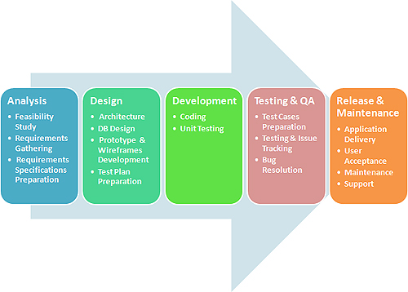
Figure 1: Software Process Model

Our project (Online Mobile World): Right way has been doing application and product development based on waterfall models and has been key role players in all stages of OMW. Our expertise have helped our clients in clearly laying down their requirements in understandable format using advanced tools and managing project execution to ensure definite end results.

2.2.2 Roles and Responsibilities
a. Project member
Project Manager: Nguyễn Xuân Minh
General Manager: Phạm Ngọc Sơn
Team Members:
- Nguyễn Đức Long
- Lê Thị Bích Thảo
- Trương Đức Vinh

b. Roles and Responsibilities
Because number of member is limited, so that one member can take more than one role in this project.

STT | Roles | Responsibilities | Members
1 | Project Manager | - Create project plan, take meeting, check status, and monitor activities...of team members.  - Promote the project implementation and evaluate steps of project.  - Solve problems raised in the project  - Ensure the objectives of the project.  - Create meeting minutes report. | MinhNX(50%)  SonPN(50%)
2 | Technical Leader | - Support other members about technical issues.  - Build framework and guide for developers.  - Identify major risks that may arise during the course of this project | - MinhNX(50%)  - SonPN(20%).
3 | Developer | - Design, coding, unit test. | - SonPN(30%)  - LongND(50%)
4 | Tester | - Create test case, integration test. | - LongND(50%)  - ThaoLTB(50%)
5 | BA(Business Analyst) | - Communicate with customer to create SRS. | - VinhTD(50%)  - ThaoLTB(50%)
6 | CM (Configuration Manager) | Manage all resource of projects. Support others member about development environment.  Deploy source code on server for testing. | - VinhTD(50%)

2.2.3 Tools and Techniques
The workflows will be performed in accordance with the Unified Process.
- Server
  - Application Server
    - Apache Tomcat 6.0
    - Memcached-1.4.5
  - Java Framework
    - J2EE
    - Spring – Hibernate framework
  - Database
    - MySQL Database
- Client
  - Environment
    - Java - J2ME
    - Nokia Symbian S60
  - Device
    - Nokia - Mobile Phone
- Server – Client protocol
    - HTTP 1.1
    - Data format: JavaScript Object Notation (JSON)

2.3 Project Management Plan

2.3.1 Tasks:
STT | Task Name | Description | Resources Needed | Deliverables | Dependencies and Constraints | Risk
1 | Planning | Determine scope of project, resources, and create project schedule. | PM | Project Plan Document
2 | Create SRS | Study requirement, celebrate meeting with Service Department to confirment requriment. | BA members | SRS Document | Customer volunteer | Lack of requirement
3 | Setup Development Environment | All member setup tools need for project as soon as project start.  Technical Leader has to build framework and guide other members to use it. | All members
4 | Create Prototype. | Create screen description. | Developers |  | SRS
 | Database Design | Create Database Design | Technical Leader |  | SRS
5 | Architectural Design | Create Architectural Design | Technical Leader | Architectural Design Document | SRS
6 | Detail Design | Base on SRS, and High Level Design, Developers create detail design; it contains Class Diagram, Sequence Diagram. | Developers | Detail Design Document
7 | Create Test Case | Base on SRS, Testers will create Test cases. | Testers |  | SRS
8 | Coding and Unit Test | Base on Detail Design and prototype, Developers will implement and write Unit Test for each function. | Developers |  | Detail Design and Prototype
9 | Integration Test | Test all system. Integration with other ERP module | Testers |  |  | Integrated with other module
10 | Acceptance Test | Customer volunteer | Customer volunteer
11 | Communication with customer | In development period, if have any questions about requirement, communicate with customer volunteer by email or direct meeting | BA members |  | Customer volunteer
12 | Meeting Minutes | Meeting takes about 5 to 10 minutes before each working day. All members report status of their task, If have any issue, raise it to receive support from others. | All members

2.3.2 Task Sheet: Assignments and Timetable

2.3.2.1 Master Schedule
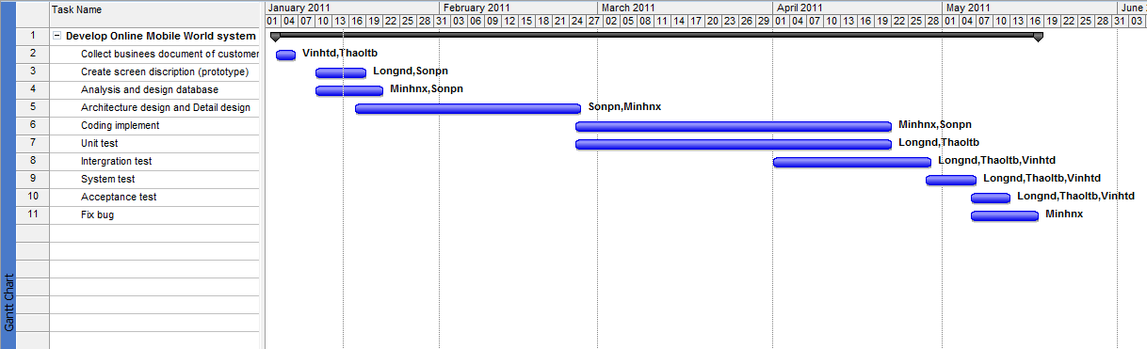
Figure 2: Master Schedule
No | Name | Tasks
1 | Nguyễn Xuân Minh | Leading the project team.  Analysis and design database  Architecture design and Detail design  Coding implement  Fix bug
2 | Phạm Ngọc Sơn | Assistant project management, managing the project team  Create screen description  Lead and support team members to design and to execute database  Analysis and design database  Architecture design and Detail design  Coding implement
3 | Lê Thị Bích Thảo | Unit test  Integration test  System test  Acceptance test  Quality assurance
4 | Nguyễn Đức Long | Unit test  Integration test  System test  Acceptance test  Quality assurance
5 | Trương Đức Vinh | Business analysis  Integration test  System test  Quality assurance

2.4 Coding Convention
Our capstone project uses the Java and SQL language so we will follow Java, C, PHP, SQL coding standard. These coding standards should be updated after each TSP cycle, or as needed. Code inspection results are expected to be a good source of additional material for this document.

2.4.1 Purpose
Coding conventions help ensure that project code has a consistent structure and style. They are intended to make the code easier to read, understand, review, and maintain. This document is intended for the following uses:
- Desk-side reference for OMW developers during coding
- Source for code review checklists
- Reference for developers who must extend and maintain the OMW project

2.4.3 Scope
This document describes the following for the Online Mobile World system:
- Naming conventions for projects, files, objects, variables, and other code constructs
- Formatting conventions for code modules and their comments
- Error handling conventions
- Coding practices and recommendations

2.4.4 Table of rule

2.4.4.1 Java Coding Convention:

Category | Type | Rules | Example
Indentation | Line length | Avoid lines longer than 80 characters, since they’re not handled well by many terminals and tools
Indentation | Wrapping Line | When an expression will not fit on a single line, break it according to these general principles:  • Break after a comma.  • Break before an operator.  • Prefer higher-level breaks to lower-level breaks.  • Align the new line with the beginning of the expression at the same level on the previous line.  • If the above rules lead to confusing code or to code that’s squished up against the right margin, just indent 8 spaces instead. | - the break occurs outside the parenthesized expression:  name1 = name2 * (name3 + name4 - name5)  + 4 * name6; // PREFER  name1 = name2 * (name3 + name4  - name5) + 4 * name6; // AVOID  - indenting method declarations  //DON’T USE THIS INDENTATION  if ((condition1 && condition2)  || (condition3&& condition4)  ||!(condition5 && condition6)) { //BAD WRAPS  doSomethingAboutIt(); //MAKE LINE EASY TOMISS  }  //USE THIS INDENTATION INSTEAD  if ((condition1 && condition2)  || (condition3&& condition4)  ||!(condition5 && condition6)) {  doSomethingAboutIt();  }
Comments | Block comments | A block comment should be preceded by a blank line to set it apart from the rest of the code.Block comments have an asterisk “*” at the beginning of each line except the first. | /*  * Here is a block comment.  */
Comments | Single-Line comments | Short comments can appear on a single line indented to the level of the code that follows. If a comment can’t be written in a single line, it should follow the block comment format. A single-line comment should be preceded by a blank line. | if (condition) {  /* Handle the condition. */  ...  }
Comments | Trailing comments | Very short comments can appear on the same line as the code they describe, but should be shifted far enough to separate them from the statements. If more than one short comment appears in a chunk of code, they should all be indented to the same tab setting. Avoid the assembly language style of commenting every line of executable code with a trailing comment. | if (a == 2) {  return TRUE; /* special case */  } else {  Return isprime(a); /* works only for odd a */  }
Comments | End-of-line comments | The // comment delimiter begins a comment that continues to the newline. It can comment out a complete line or only a partial line. However, it can be used in consecutive multiple lines for commenting out sections of code. | if (foo > 1) {  }  else  return false; // Explain why here.  //if (bar > 1) {  // // Do a triple-flip.  //}  //else  // return false;
Declarations | Number per line | One declaration per line is recommended since it encourages commenting. In absolutely no case should variables and functions be declared on the same line. Do not put different types on the same line | int level, size;  longdbaddr, getDbaddr(); // WRONG!  int foo, fooarray[]; //WRONG!
Declarations | Placement | Put declarations only at the beginning of blocks. (A block is any code surrounded by curly braces “{” and “}”.) Don’t wait to declare variables until their first use; it can confuse the unwary programmer and hamper code portability within the scope.  The one exception to the rule is indexes of for loops, which in Java can be declared in the for statement.  Avoid local declarations that hide declarations at higher levels. For example, do not declare the same variable name in an inner block. | voidMyMethod() {  int int1; // beginning of method block  if (condition) {  int int2; // beginning of "if" block  ...  }  }  - can be declared in the for statement:  for (inti = 0; i<maxLoops; i++) { ... }  - Avoid local declarations that hide declarations at higher levels:  int count;  ...  func() {  if (condition) {  int count; // AVOID!  ...  }  ...  }
Declarations | Initialization | Try to initialize local variables where they’re declared. The only reason not to initialize a variable where it’s declared is if the initial value depends on some computation occurring first
Declarations | Class and Interface Declarations | When coding Java classes and interfaces, the following formatting rules should be followed:  • No space between a method name and the parenthesis “(“ starting its parameter list  • Open brace “{” appears at the end of the same line as the declaration statement  • Closing brace “}” starts a line by itself indented to match its corresponding opening statement, except when it is a null statement the “}” should appear immediately after the“{“  • Methods are separated by a blank line | class Sample extends Object {  int ivar1;  int ivar2;  Sample(inti, int j) {  ivar1 = i;  ivar2 = j;  }  intemptyMethod() {}  ...  }
Statements | Simple Statements | Each line should contain at most one statement.  Do not use the comma operator to group multiple statements unless it is for an obvious reason. | argv++; // CORRECT  argc--; // CORRECT  argv++; argc--; // AVOID!  if (err) {  Format.print(System.out, “error”), exit(1); //VERY WRONG!  }
Statements | Compound Statements | Compound statements are statements that contain lists of statements enclosed in braces“{ statements }”. See the following sections for examples.  • The enclosed statements should be indented one more level than the compound statement.  • The opening brace should be at the end of the line that begins the compound statement; the closing brace should begin a line and be indented to the beginning of the compound statement.  • Braces are used around all statements, even singletons, when they are part of a control structure, such as an if-else or for statement. This makes it easier to add statements without accidentally introducing bugs due to forgetting to add braces.
Statements | Return Statements | A return statement with a value should not use parentheses unless they make the return value more obvious in some way. | return;  returnmyDisk.size();  return (size ? size : defaultSize);
Statements | if, if-else, if-else-if-else Statements | The if-else class of statements should have the following form (see Example column).  if statements always use braces {}. | if (condition) {  statements;  }  if (condition) {  statements;  } else {  statements;  }  if (condition) {  statements;  } else if (condition) {  statements;  } else if (condition) {  statements;  }  - This omits the braces {}:  if (condition) //AVOID!  statement;
Statements | for Statements | A for statement should have the following form (see Example column).  When using the comma operator in the initialization or update clause of a ‘for’ statement, avoid the complexity of using more than three variables. If needed, use separate statements before the ‘for’ loop (for the initialization clause) or at the end of the loop (for the update clause). | for (initialization; condition; update) {  statements;  }  - An empty for statements:  for (initialization; condition; update);
Statements | While Statements | A while statement should have the following form (see Example column) | while (condition) {  statements;  }  - An empty while statements:  while (condition);
Statements | do-while Statements | A do-while statement should have the following form(see Example column) | do {  statements;  } while (condition);
Statements | Switch Statements | A switch statement should have the following form (see Example column). Every time a case falls through (doesn’t include a break statement), add a comment where the break statement would normally be. This is shown in the preceding code example with the  /* falls through */ comment .Every switch statement should include a default case. The break in the default case is redundant, but it prevents a fall-through error if later another case is added. | switch (condition) {  case ABC:  statements;  /* falls through */  case DEF:  statements;  break;  case XYZ:  statements;  break;  default:  statements;  break;  }
Statements | Try-catch Statements | A try-catch statement should have the following format (see Example column). | try {  statements;  } catch (ExceptionClass e) {  statements;  }
White Space | Blank Lines | Blank lines improve readability by setting off sections of code that are logically related. Two blank lines should always be used in the following circumstances:  • Between sections of a source file  • Between class and interface definitions.  One blank line should always be used in the following circumstances:  • Between methods  • Between the local variables in a method and its first statement  • Before a blocker single-line comment  • Between logical sections inside a method to improve readability
White Space | Blank Spaces | Blank spaces should be used in the following circumstances:  • A keyword followed by a parenthesis should be separated by a space.  • A blank space should appear after commas in argument lists.  • All binary operators except .should are separated from their operands by spaces. Blank spaces should never separate unary operators such as unary minus, increment (“++”), and decrement (“--”) from their operands.  • The expressions in a ’for’ statement should be separated by blank spaces.  • Casts should be followed by a blank. | - A keyword followed by a parenthesis  while (true) {  ...  }  - Operators, increments, decrements  a += c + d;  a = (a + b) / (c * d);  while (d++ = s++) {  n++;  }  prints("size is " + foo + "\n");  - For statements:  for (expr1; expr2; expr3)  - cast statements:  myMethod((byte) aNum, (Object) x);  myFunc((int) (cp + 5), ((int) (i + 3))  + 1);
Naming conventions | Classes | Class names should be nouns, in mixed case with the first letter of each internal word capitalized. Try to keep your class names simple and descriptive. Use whole words—avoid acronyms and abbreviations (unless the abbreviations much more widely used than the long form, such as URL or HTML). | class Raster;  classImageSprite;
Naming conventions | Interfaces | Interface names should be capitalized like class names. | interfaceRasterDelegate;  interface Storing;
Naming conventions | Methods | Methods should be verbs, in mixed case with the first letter lowercase, with the first letter of each internal word capitalized. | run();  runFast();  getBackground();
Naming conventions | Variables | Except for variables, all instance, class, and class constants are in mixed case with a lowercase first letter. Internal words start with capital letters.  Variable names should be short yet meaningful. The choice of a variable name should be mnemonic— that is, designed to indicate to the casual observer the intent of its use. One-character variable names should be avoided except for temporary “throwaway” variables. Common  names for temporary variables are i, j, k, m, and n for integers; c, d, and e for characters. | inti;  char *cp;  floatmyWidth;
Naming conventions | Constants | The names of variables declared class constants and of ANSI constants should be all uppercase with words separated by underscores(“_”). (ANSI constants should be avoided, for ease of debugging.) | int MIN_WIDTH = 4;  int MAX_WIDTH = 999;  int GET_THE_CPU = 1;
Programming Practices | Providing Access to Instance and Class Variables | Don’t make any instance or class variable public without good reason. Often, instance variables don’t need to be explicitly set or gotten—often that happens as a side effect of method calls.  One example of appropriate public instance variables is the case where the class is essentially a data structure, with no behavior. In other words, if you would have used a struct instead of a class (if Java supported struct), then it’s appropriate to make the class’s instance variables public.
Programming Practices | Referring to Class Variables and Methods | Avoid using an object to access a class (static) variable or method. Use a class name instead | classMethod(); //OK  AClass.classMethod(); //OK  anObject.classMethod(); //AVOID!
Programming Practices | Constants | Numerical constants (literals) should not be coded directly, except for -1, 0, and 1, which can appear in a for loop as counter values
Programming Practices | Variable Assignments | Avoid assigning several variables to the same value in a single statement. It is hard to read.  Do not use the assignment operator in a place where it can be easily confused with the equality operator.  Do not use embedded assignments in an attempt to improve run-time performance. This is the job of the compiler, and besides, it rarely actually helps. | fooBar.fChar = barFoo.lchar = 'c'; // AVOID!  if (c++ = d++) { // AVOID! Java disallows  ...  }  should be written as:  if ((c++ = d++) != 0) {  ...  }  d = (a = b + c) + r; // AVOID!  should be written as:  a = b + c;  d = a + r;
Programming Practices | Parentheses | It is generally a good idea to use parentheses liberally in expressions involving mixed operators to avoid operator precedence problems. Even if the operator precedence seems clear to you, it might not be to others—you shouldn’t assume that other programmers know precedence as well as you do. | if (a == b && c == d) // AVOID!  if ((a == b) && (c == d)) // RIGHT
Programming Practices | Returning Values | Try to make the structure of your program match the intent | if (booleanExpression) {  return TRUE;  } else {  return FALSE;  }  should instead be written as:  returnbooleanExpression;  Similarly,  if (condition) {  return x;  }  return y;  should be written as  return (condition ? x : y);
Programming Practices | Expressions before ‘?’ in the Conditional Operator | If an expression containing a binary operator appears before the ?in the ternary ?: operator, it should be parenthesized. | (x>= 0) ? x : -x
Programming Practices | Special Comments | Use XXX in a comment to flag something that is bogus but works. Use FIXME to flag something that is bogus and broken.

2.4.4.2 SQL coding convention

Category | Type | Rule | Example
MySQL Naming Convention | Engine and char set | - Engine is always MyISAM except in special case when required different. All databases must use UTF8 char set.
MySQL Naming Convention | Database | - Database name must have the same name as project name. | If the project name is "My Web Site" database should be created as:  CREATE DATABASE mywebsite DEFAULT CHARSET UTF8;
MySQL Naming Convention | Tables | - All tables must be UTF8 encoded. All tables in the same package must have prefix. Use 2 or 3 letters that describe the package to prefix database | If the project name is Real Deal Marketing, the most obvious prefix will be "rdm_";  CREATE TABLE rdm_affiliates;
MySQL Naming Convention | ALTER TABLE and file versions major.minor[.build[.revision]] | - All alterations for all tables should be saved in a (database_name).sql file | If database name is "realdealmarketing" filename should be realdealmarketing-1.0.0.sql  - Initial file must be version 1.0.0  - If there are only table alterations file should have new version increased by 0.0.1 Example: realdealmarketing-1.0.7.sql  - If new tables are created, version must be increased by 0.1. Example: realdealmarketing-1.2.0.sql  - If tables are dropped, version must be increased by 1.0. Example: realdealmarketing-2.0.0.sql  - All versions should be saved in the same directory
Fields | Field Names | - Field names must be prefixed with 2-4 letters of table name. | DROP TABLE IF EXISTS rdm_affiliates;  CREATE TABLE IF NOT EXISTS rdm_affiliates  (  aff_id INT(10) UNSIGNED NOT NULL AUTO_INCREMENT,  aff_url VARCHAR(120) NOT NULL DEFAULT '',  aff_title VARCHAR(120) NOT NULL DEFAULT '',  aff_website CHAR(10) NOT NULL DEFAULT '',  aff_gender CHAR(8) NOT NULL DEFAULT '',  aff_landing_page VARCHAR(120) NOT NULL DEFAULT '',  aff_link VARCHAR(120) NOT NULL DEFAULT '',  aff_text TEXT,  PRIMARY KEY (aff_id),  INDEX (aff_website)  ) ENGINE=MyISAM DEFAULT CHARSET=utf8;
Fields | NULL and DEFAULT | - All fields except AUTO_INCREAMENT, TEXT, DATE (and similar) must be defined as NOT NULL DEFAULT 'value' | aff_title VARCHAR(120) NOT NULL DEFAULT '' aff_gender ENUM('male','female') NOT NULL DEFAULT 'male'  user_id INT UNSIGNED NOT NULL DEFAULT 0  user_birthday DATE DEFAULT NULL user_allow_newsletter TINYINT(1) UNSIGNED NOT NULL DEFAULT 0  art_text TEXT
Indices | In order to select | - All fields in WHERE and ORDER BY should be defined as INDEX | If you have query like this:  SELECT * FROM table1 WHERE a='something' ORDER BY b  Then fields a, b should be considered as indices  INDEX index_name (a,b)
Indices | CHAR Indices | - If text field (CHAR, VARCHAR) is used as index for larger tables (> 5000 records) should be always defined as CHAR | if you have fields like this:  aff_url VARCHAR(255) NOT NULL DEFAULT '' ... INDEX afiliate_url (aff_url)  To improve performance, this table should be changed to something like this  aff_url CHAR(20) NOT NULL DEFAULT '' ... INDEX afiliate_url (aff_url)
Queries | Long queries | - Reserved words should be uppercase to increase readability. Also try to separate long queries in multiple lines, while simple queries should stay in one line

2.4.5 Code Demo:

2.4.5.1. Java code demo
/*
* FirstnameLastname
*
* Copyright (c) 1993-1996 Sun Microsystems, Inc. All Rights Reserved.
*
* This software is the confidential and proprietary information of Sun
* Microsystems, Inc. ("Confidential Information"). You shall not
* disclose such Confidential Information and shall use it only in
* accordance with the terms of the license agreement you entered into
* with Sun.
*
* SUN MAKES NO REPRESENTATIONS OR WARRANTIES ABOUT THE SUITABILITY OF
* THE SOFTWARE, EITHER EXPRESS OR IMPLIED, INCLUDING BUT NOT LIMITED
* TO THE IMPLIED WARRANTIES OF MERCHANTABILITY, FITNESS FOR A
* PARTICULAR PURPOSE, OR NON-INFRINGEMENT. SUN SHALL NOT BE LIABLE FOR
* ANY DAMAGES SUFFERED BY LICENSEE AS A RESULT OF USING, MODIFYING OR
* DISTRIBUTING THIS SOFTWARE OR ITS DERIVATIVES.
*/
Package java.omw;

import java.com.;

/**
* Class description goes here.
*
* @version 1.10 04 Oct 1996
* @authorFirstnameLastname
*/
public class Blah extends SomeClass {
/* A class implementation comment can go here. */

/** classVar1 documentation comment */
public static int classVar1;

/**
* classVar2 documentation comment that happens to be
* more than one line long
*/
private static Object classVar2;

/** instanceVar1 documentation comment */
public Object instanceVar1;

/** instanceVar2 documentation comment */
protectedint instanceVar2;

/** instanceVar3 documentation comment */
private Object[] instanceVar3;

/**
* ...method Blah documentation comment...
*/
public Blah() {
// ...implementation goes here...
}

/**
* ...methoddoSomething documentation comment...
*/
public void doSomething() {
// ...implementation goes here...
}

/**
* ...methoddoSomethingElse documentation comment...
* @paramsomeParam description
*/
public void doSomethingElse(Object someParam) {
// ...implementation goes here...
}
}

2.5 Risk management

During the project some things are bound not to happen according to plan. Those things may pose a threat to the progress of the project and to the project result. Identifying risks and preparing to handle them may minimize their impact. Having the final responsibility for the success of the project the Project Manager deals with all risks. Four categories of risks can be distinguished:

- Risks with respect to work to be done,
- Risks with respect to management,
- Risks with respect to resources,
- Risks with respect to the customer.

In the list of risks that follows, each risk is classified with high, medium, low and non-existents.

2.5.1 Risks with respect to work to be done

No | Risk Name | Level | Description | Solution
1 | Miscommunication | High | Miscommunication can lead to misunderstanding, delay, frustration, lack of coordination, et cetera. | Prevention: While monitoring progress it needs to be determined whether people understand the tasks they have been assigned to. Project Group Meetings should help in keeping everyone up-to-date on what everyone else is doing. Team members should not hesitate to ask and re-ask questions if things are unclear.  Correction:  When it becomes clear that lack of miscommunication is causing problems, the team members involved are gathered in a meeting to clear things up.
2 | Overload | High | Too many planned features lead to infeasible design | Prevention: The Technical Advisor should be consulted on whether the delivery of the planned product can be done within the time budget.  Correction: By closely monitoring progress the decision to drop certain requirements can be made in time.
3 | Time shortage | Medium | May be time don’t have enough to complete. | Prevention: Care is taken to plan enough spare time. For every external review two dates are planned in case the first review fails to lead to acceptance. Planning is based on experience from previous projects.  Correction: When tasks fail to be finished on time or when they are finished earlier than planned the project planning is adjusted. If time shortage becomes severe user requirements that have low priority are dropped after consultation with the Senior Management.
4 | Design errors | High | May be lead to errors of system. | Prevention: The design should be reviewed very critically. The Technical Advisor should be consulted frequently on his opinion about the feasibility and the correctness of certain design decisions. The external reviews of the systems design will also ensure that the team will not commence with an erratic design.  Correction: When errors in the design are noticed the Technical Advisor should be consulted to help correct the design errors as soon as possible. Also all work that depends on the faulty design should be halted until the error is corrected.
5 | Conflict | Medium | Personal conflicts between team members. | Prevention: By stimulating communication between team member’s conflicts may be avoided.  Correction: Team members who are known to have had conflicts between them will not be assigned to the same team. Furthermore, the PM will discuss the situation with the team member in an effort to clear the air.
6 | Product tests fail | Medium |  | Prevention: By ensuring that a good design is made before implementation is started a correct implementation of all features can be made. Unit testing will ensure that units function correctly and that problems on higher levels are not a result of units not functioning correctly. Integration testing ensures that the units interact correctly. A coding standard will guide programmers to write non-obfuscated code.  Correction: After the failure of a product tests the test results will be analyzed after which the reason of failure can be determined and dealt with.
7 | Illness or absence of team members | Medium |  | Prevention: Team members should warn their team leader or the PM sufficiently ahead of a planned period of absence.  Correction: By ensuring that knowledge is shared between team members’s work can be taken over quickly by someone else if a person gets ill. When work needs to be taken over by someone a division is made of his other tasks so that the workload does not get too high. Planned absence is dealt with in the planning, of course.
8 | Products are lost | Medium |  | Prevention: All products are stored in the project repository that is backed up regularly by the CM. Also, during the programming phase a Version Control System is used to avoid losing code.  Correction: When a product gets lost from its working store it is recovered from the most recent backup.

2.5.2 Risks with respect to management

No | Risk Name | Level | Description | Solution
1 | Illness or sudden absence of project manager | Low |  | Prevention: There are very few things in which the presence of the PM cannot be missed for a short period of time. Nevertheless the PM will inform the VPM of a planned period of absence in time so that the VPM can prepare to take over.  Correction: By keeping the VPM up-to-date on the project status he will have enough knowledge to take over in case of illness or absence of the PM.
2 | Failure of the PM | Low |  | Prevention: In difficult situations the PM will ask for advice from the Senior Management. Also project members could assist the PM when necessary.  Correction: If the PM fails to perform his duties the QM may decide to inform the Senior Management of the problems.

2.5.3 Risks with respect to resources

No | Risk Name | Level | Description | Solution
1 | Experts not available when needed | Medium |  | Prevention: Meetings with experts can be planned well in advance.  Correction: Since there are more experts available than there are required for an external review, other experts may be invited.
2 | Technical Advisor not available when needed | Medium |  | Prevention: Meetings with the technical advisor can be planned in advance and time has been reserved in his schedule for counseling the team.  Correction: A different appointment is made, or another expert is consulted.

2.5.4 Summary
It is obvious that problems will occur during the project. To avoid problems all should follow the following rules:
- Try to signal problems as early as possible so that action may be taken,
- Pay attention to communication and make sure everybody understands the things the same way,
- Focus on the agreed user requirements which express the wishes of the customer,
- Minimize friction between people by helping and supporting each other,
- Follow guidelines to aid coordination and to ensure product quality.

Report No.3: Software Requirements Specifications

3.1 User Requirement Specification

3.1.1 Use Cases and Actor

3.1.1.1 Diagram

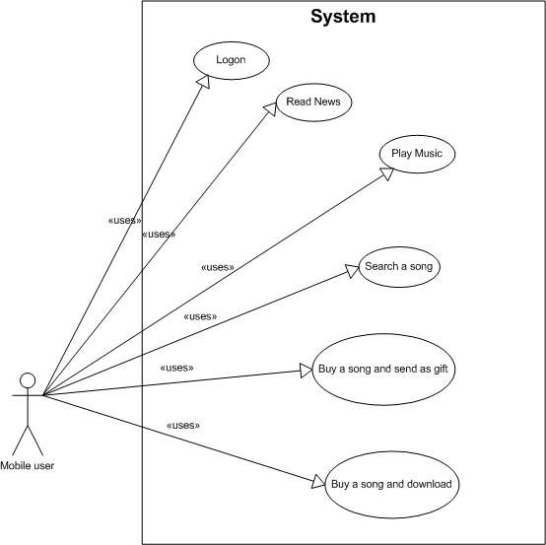

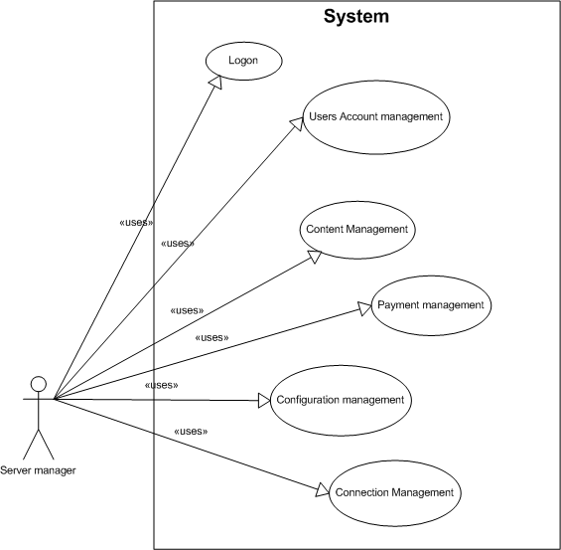

Figure 3: Use Cases Diagram

3.1.1.2 Description of Actors
# | Actor Name | Definition
1 | Mobile Users | User setup OWM system on their Mobiles
2 | Server Manager | Manager of server who work at content and technology department
3 | Authenticated User | A Group of people who have right to access the system
4 | System Timer | The actor that runs scheduled tasks daily or weekly.

3.1.1.3 Description of Use Cases
# | Use Case Name | Definition
1 | Log on | used to login and logout of system
2 | Account manager | Used to update user detail information such as name, date created, capacity downloaded, and money in use.
3 | Play music | Use to play a song on library music
4 | Search a song | Search a song you want to play on library
5 | Buy a song and send via SMS | Use to buy a song and send to friend as gift through link download
6 | Buy a song and download | Use to buy a song and download save it into mobile memory
7 | Read news | Use to read news daily
8 | User account management | Manage users in system, users created, users purchase
9 | Content management | CRUD Use Case, use to mange content on sever provide for client
10 | Configiration management | Use to mange version of mobile and configuration
11 | Connection management | Manage connection between mobile application and server

3.1.2 Mobile client application
- Download application
- Logon system
- System configuration management
- Account management
- Advertising management
- Promotion management
- Mashup Language Compiler
- UI Builder
- Theme management
- Service:
          - Main page
          - News
          - Music

3.1.3 Server application
# | Actor Name | Definition
5 | Dealer | A dealer of HTC
6 | Warranty Officer | A group of people who work at Warranty and training department and have responsibility for warranty section
7 | Training Officer | A group of people who work at Warranty and training department and have responsibility for training section
8 | Warranty Manager | Manager of Warranty and Training Department
9 | Authenticated User | A Group of people who have right to access the system
10 | System Timer | The actor that runs scheduled tasks daily or weekly.

3.1.4 Description of Use Case
- Frontend Servers
- Backend Servers
- Open application servers
- Online Mobile World connector

3.2 System Requirements Specification

3.2.1 External Interface Requirements

3.2.1.1 User Interfaces
The user interface to the system designed to allow user create class, member, warranty books… set schedule for each class, grade management… By providing friendly GUI, user should interact with the system easily.

Flow is GUI standard:
        - The interface must be friendly and clearly
        - Editable Grid: grid for displaying and allow modifying data directly, modification will be check for field validation (special character, etc) and business logic at server side when user click submit button.
        - Form validation: all form is invalid will be marked with red line and also show warning dialog for alerting user.
        - Model dialog: used for confirmation dialog, pop-up message dialog
        - Size of report: report should print in size of A4 paper
        - Short cut: system could provide user with shortcut mapping to allow them interative with system faster and easier. User could change these setting.
        - Navigation toolbar: dropdown menu bar with will be devided into categories, list will be automatically populated when mouse over
        - Changing theme: user could change theme for keeping them from boring GUI
        - The system uses default font Arial, default size 12. Howerver, with special cases, we use maximum of 3 fonts and sizes.
        - With component of menu list, the system must have function keys. Example: View ~ (Ctrl + V), Edit ~ (Ctrl + E)…
        - The confirmation dialog will specify the action and inform the user for a YES or NO or CANCEL to continue
        - The error dialog will be displayed if users have invalid actions. And this dialog has only OK button to continue
        - When log in, the password field encrypts characters
        - The system shall provide a help link from each displayed HTML page to explain how to use that page
        - Waiting icon should be displayed if the system crashes or overloaded
        - If the list of items is too long, the system will use scrollbars

3.2.1.2 Hardware Interfaces
        - Client: Nokia mobile phone with Symbian S60
        - Server: Window xp, J2ME.

3.2.1.3 Software Interfaces
        - OMW application can run on any platform with Symbian S60 compatible Runtime Environment.
        - We requires for browser is enable JavaScript and installed flash embedded.
        - Server system require:
          - Operating system: Windows 2000/XP SP2/Vista, or Windows 7
          - All software below needs to be installed.

Software name | Version | Source
Java Development Kit (JDK) | 1.6 | Sun Microsystems
Java Runtime Environment (JRE) | 1.6 | Sun Microsystems
Eclipse (Development tool) |  | Open source
My SQL (Database) | 5.1 | IBM

3.2.1.4 Communications Protocol
        - Common
          - Browser: Mozilla Firefox 3.5, Opera mini, Firefox for mobile
          - Communication Standards: HTTP
        - Client-Server communication protocol:
          - Each mobile application is connected to server throw WIFI, 3G or GPRS
          - Therefore, data will be transferred from server to client.

3.2.2 System Features

3.2.2.1 System Feature 1
        - Use Case-1 Diagram: Download and setup application

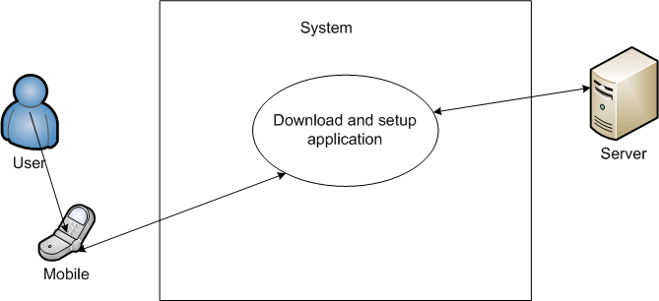
Figure 4: Download and setup application
        - Use Case-1 Specification

USE CASE-1 SPECIFICATION

Use-case No. | UC001 | Use-case Version |  | 1.0
Use-case Name | Download and setup application
Author | <Members>
Date | 12/02/2011 | Priority | Medium
Actor:
- Mobile users
Summary:
- For the first time using OMW application, users have to down load setup file form server via wapsite link or send messenger to CDN.
Goal:
- The goal of use case: Online Mobile World system in server will update detail information about mobile has been downloaded application. And with application user can access content easier and faster
Triggers
- User sends wrong systax message, cannot download setup file
- Application has not been supported for that mobile yet.
Preconditions:
- Version of mobile must be supported by application.
- The system must be set up correctly.
Main Success Scenario:
- Access to wapsite address of OMW and system will return wappush attack link to download setup file.
- Server creates code application (appcode) for application dowloaded.
- Extract jar file and write into jar file some information include appcode, phone number, mobile agent (information about that mobile).
- Setup application correctly.
Exceptions:
- Cannot access to wapsite.
- Application cannot setup correctly.

3.2.2.2 System Feature 2
        - Use Case-2 Diagram: Log on

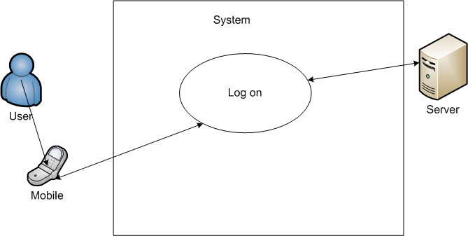
Figure 5: Log on
        - Use Case-2 Specification

USE CASE-2 SPECIFICATION

Use-case No. | UC002 | Use-case Version |  | 1.0
Use-case Name | Log on
Author | <Members>
Date | 12/02/2011 | Priority | High
Actor:
- Server manager
- Mobile users
Summary:
- After setup application and before use OMW application.
- Account store information about users include: Name, phone number, mobile version, date created, date purchase, money in use, capacity in use.
Goal:
- Ensure that what service user bought from OMW.
- Manage application effective
Triggers
- User use service but don’t pay for these.
- User can’t control service that they waste money for that
Preconditions:
- Application setup correctly
- Client application connects successfully with server
Post Conditions:
- Users can log in their account and read detail information.
- User can use services free or services that they buy with this account
- User can log out system
Main Success Scenario:
- User click [Sign in] button. Enter information include username and password
- User log in successful and can read deatail information
- User switch main page of OMW and use service.
- User click [sign out] button.
Exceptions:
- Client application can’t connect to server
- User enter wrong username or password
Business Rules:
- User has to buy services to use full fearture.
- To use services, user have to sign in.

3.2.2.3 System Feature 3
        - Use Case-3 Diagram: Read News

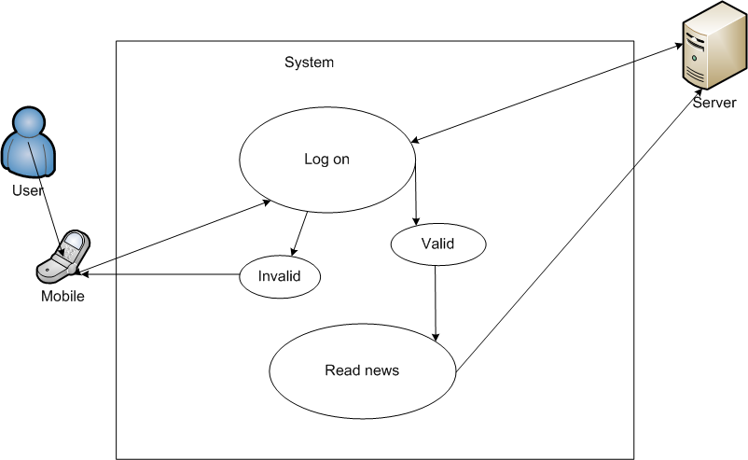

Figure 6: Read News
        - Use Case-3 Specification

USE CASE-3 SPECIFICATION

Use-case No. | UC003 | Use-case Version |  | 1.0
Use-case Name | Read News
Author | <Members>
Date | 12/02/2011 | Priority | Normal
Actor:
- Mobile users
Summary:
- After login system each user can use Read News service.
Goal:
- News is updated daily, and user can read easy just with one click
Triggers
- News can be error with font
Preconditions:
- User has to login system.
Post Conditions:
- News show correctly.
Main Success Scenario:
- After login application, user click News icon and read.
Exceptions:
- Client application cannot load data from server because error connection
Relationships:
- This case relates to “Log on” use case.
Business Rules:
- People can read News and then buy services to read full special news.

3.2.2.4 System Feature 4
        - Use Case-4 Diagram: Play Music
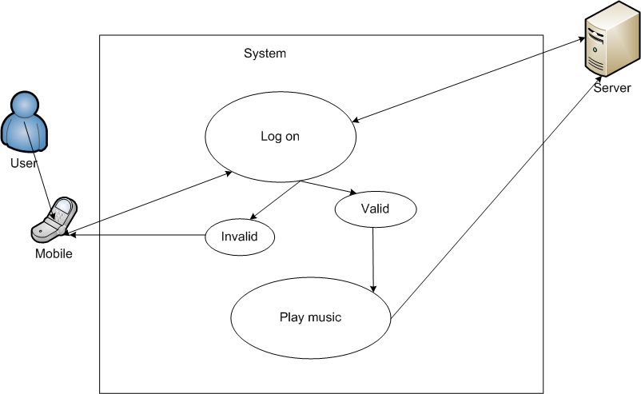
Figure 7: Play music
        - Use Case-4 Specification

USE CASE-4 SPECIFICATION

Use-case No. | UC004 | Use-case Version |  | 1.0
Use-case Name | Play music
Author | <Members>
Date | 12/02/2011 | Priority | Normal
Actor:
- Mobile users
Summary:
- After login application, user click incon Music on main page to use service
Goal:
- User can listen music high quality and high speed
Triggers
- A song load slow and time out
Preconditions:
- Users have to login application.
- Client application connects successful with server.
Post Conditions:
- Library present correctly, and music play good.
Main Success Scenario:
- After login application and then click Music icon. Music page appear
- Click a song people want to play
- A music player will play that song.
Exceptions:
- Client application can’t connect to server, request time out
Relationships:
- This case relates to “Log on” use case.
Business Rules:
- After listen that song, if you want to download or send it to friend you must buy it.

3.2.2.5 System Feature 5
        - Use Case-5 Diagram: Search a song

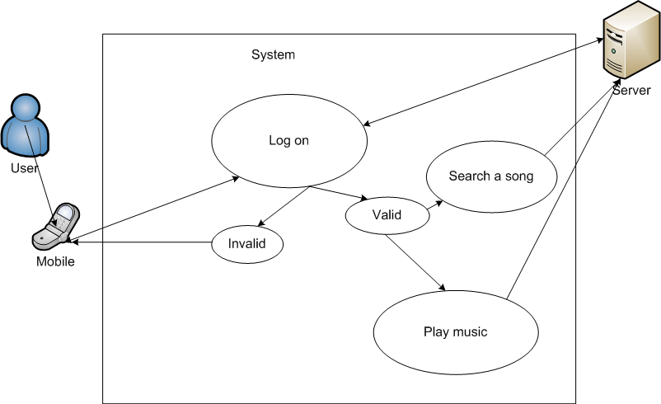

Figure 8: Search a song
        - Use Case-5 Specification

USE CASE-5 SPECIFICATION

Use-case No. | UC005 | Use-case Version |  | 1.0
Use-case Name | Roll call: Search a song
Author | <Members>
Date | 12/02/2011 | Priority | Normal
Actor:
- Mobile users
Summary:
- After login application and use Music service.
Goal:
- Search a song correctly and develop to advance search.
Triggers
- Return wrong result.
Preconditions:
- Login application and use Music service and then click [search] button
Post Conditions:
- Result list correctly and then click song to play
Main Success Scenario:
- Log in application
- Click Music icon on main page to use service
- Click search and enter some word about name of song.
- Return the list of result
Exceptions:
- Client application cannot connect to server, request time out
Business Rules:
- User search follow name of song

3.2.2.6 System Feature 6
        - Use Case-6 Diagram: Buy a song and send as gift
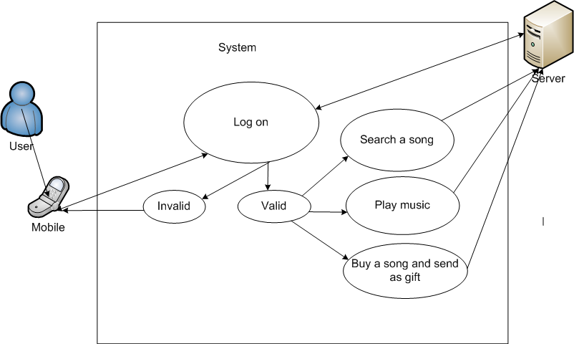

Figure 9: Buy a song and send a gift
        - Use Case-6 Specification

USE CASE-6 SPECIFICATION

Use-case No. | UC006 | Use-case Version |  | 1.0
Use-case Name | Buy and send as gift
Author | <Members>
Date | 12/02/2011 | Priority | Normal
Actor:
- Mobile users
Summary:
- After login OMW system, play a song and want share it with friend.
Goal:
- User have to buy a song if they want share it for friend
Triggers
- When people want to share music for friend, they have to send via Bluetooth or copy to usb. But with OMW you just click and your favourite song is sent to your friend.

Preconditions:
- User login application
- Money in user account is enough to buy a song
- Client application connect successful to server
Post Conditions:
- A song is sent successful to other mobile
- Account of user is paid money
Main Success Scenario:
- After login OMW system
- Click Music icon to use service, click or search a song you want to play
- Click [share with friend] button
- Enter receiver information, especial phone number and then click [Send] button.
Exceptions:
- Client application cannot connect to server, request timeout
Business Rules:
- User play a song first and then share with friend

3.2.2.7 System Feature 7
        - Use Case-7 Diagram: Buy a song and Download

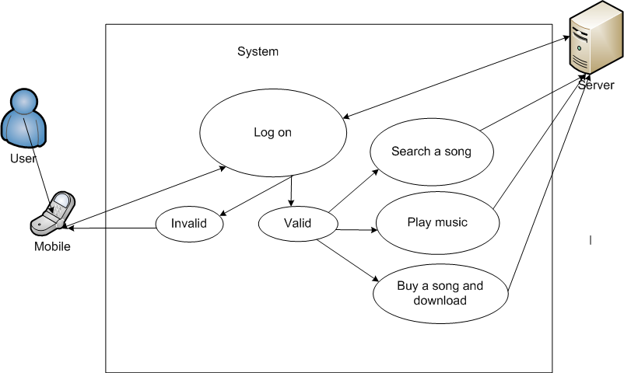

Figure 10: Buy a song and Download
        - Use Case-7 Specification

USE CASE-7 SPECIFICATION

Use-case No. | UC007 | Use-case Version |  | 1.0
Use-case Name | Buy a song and download
Author | <Members>
Date | 12/02/2011 | Priority | Normal
Actor:
- Mobile users
Summary:
- After login account.
- Want to download a song to save in mobile.
Goal:
- User have to download successful a song to mobile
Triggers

Preconditions:
- User login application
- Money in user account is enough to buy a song
- Client application connect successful to server
Post Conditions:
- A song is downloaded successful to other mobile
- Account of user is paid money
Main Success Scenario:
- After login OMW system
- Click Music icon to use service, click or search a song you want to play
- Click [Download] button
Exceptions:
- Client application cannot connect to server, request timeout.
Business Rules:
- User has to paid money after directly click [Mua] button.

3.2.2.8 System Feature 8
        - Use Case-8 Diagram: User account management

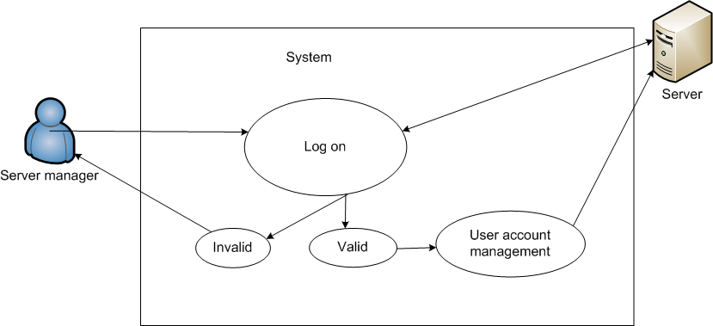
Figure 11: User account management

- Use Case-8 Specification

USE CASE-8 SPECIFICATION

Use-case No. | UC008 | Use-case Version |  | 1.0
Use-case Name | User account mangement
Author | <Members>
Date | 12/02/2011 | Priority | Normal
Actor:
- Server manager
Summary:
- Server manger login and have role to Create, Update, Read, Delete user account
Goal:
- Manage user easy, and statistic
Triggers
- Server manager can create user or Update or delete. However need to build quality assurance.
Preconditions:
- Server manager have to login server system
Post Conditions:
- Create, Read, Update, and Delete user account.
Main Success Scenario:
- After login server system
- Click [Account management] button
- Grid view total user account is shown.
- Can Delete, Update and Create new user account
Exceptions:
- Cannot connect to Data in database.
Business Rules:
- Server account have to login system first

3.2.2.9 System Feature 9
        - Use Case-9 Diagram: Content management

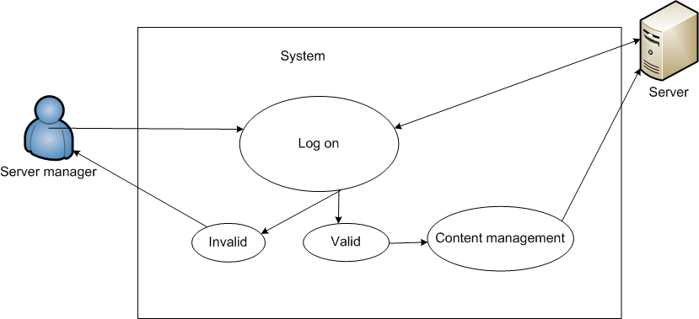
Figure 12: Content Management

- Use Case-9 Specification

USE CASE-9 SPECIFICATION

Use-case No. | UC009 | Use-case Version |  | 1.0
Use-case Name | Content management
Author | <Members>
Date | 12/02/2011 | Priority | normal
Actor:
- Server manager
Summary:
- Server manager login to system
- Music content management
- News content management
- Advetising management
- Promotion management
Goal:
- Manage content show in client application such as: layout, data and image.
Triggers
- Server stores all content show in client application. If server not working, client die
Preconditions:
- Server manager have to login to server system
- Server management application connect successful with database
Post Conditions:
- Can Create new content, Update, Delete successful
Main Success Scenario:
- Login to server application system
- Click [News] to manage content for News service
- Click [Music] to manage content for Music service
- Click [Ads] to manage content for Advertising service
- Click [Promotion] to manage content for Promotion service
- Manager can create, update, read, delete
Exceptions:
- Database disconnect
Business Rules:
- Manager must login system.

3.2.2.10 System Feature 10
- Use Case-10 Diagram: Configuration management
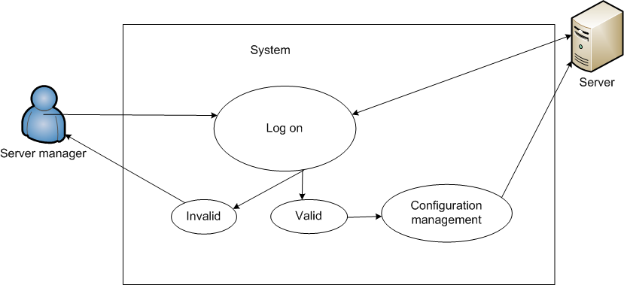
Figure 13: Configuration management
- Use Case-10 Specification

USE CASE-10 SPECIFICATION

Use-case No. | UC010 | Use-case Version |  | 1.0
Use-case Name | Configuration management
Author | <Members>
Date | 12/02/2011 | Priority | Normal
Actor:
- Server manager
- Mobile users
Summary:
- Each application is setup at mobile will have particular configuration that is downloaded from server. Configurations is defined in client server protocol
- Because flexible of user and server to define three configuration types: Default configuration in Online Mobile World setup file, Update configuration from server, Customize configuration by User.
Goal:
- To support for configuration management.
Preconditions:
- Client setup default configuration management
- Server require update configuration
- User want to customize configuration
Main Success Scenario:
- Server send requirement update configuration.
- Configuration information include:
  - Navigation bar configuration
  - Display and control configuration in screen list
  - Display music, image configuration
Exceptions:
- Client cannot connect to server
Business Rules:
- Server send requirement update configuration

3.2.3 Software System Attributes

3.2.3.1 Reliability
        - The system will be designed, and tested in the laboratory with the objective of determining its feasibility for use in the real world. As a result a major factor that will contribute to the success of the project will be the reliability of the system developed.
        - The level of security provided should be higher than that provided by conventional security systems in use today. This fact should be emphasised in the design of the security policy if the system is to be considered for commercial use.
        - While keeping all the above factors in mind the system should be relatively fast so as to be feasible.
        - Data collected and calculate correctly.
        - System is capable to deal with unusually situation.
        - The database has continuous back up and can be recovering if necessary.
        - Software compatible with the operating system, running smoothly on Symbian.
        - Not conflict with other software.

3.2.3.2 Availability
        - Systems have to run 24/7
        - Can be turned off when upgrading
        - System is capable to deal with unusually situation.
        - The database has continuous back up and can be recovering if necessary
        - Percentage of time available is about 95-97%. Because the system is used client/server protocol through LAN network, we cannot control case of force majeure such as power failure, disconnected network…

3.2.3.3 Security
        - The system will authenticate users via their mobile. The information contains the name of the user, phone number and mobile agent.
        - The server system will also generate application key for each mobile download client application.
        - The system will use payment system to help user use safe service.
        - The procedure for user authentication is shown in the system overview above. All users will be authenticated using this procedure. Users will be revoked if they fail to authenticate themselves a certain fixed number of times. When this happens, the system administrator will need to reinitialize that particular us.
        - Check data integrity for critical variables.
        - Keep specific log or history data sets.

3.2.3.4 Maintainability
        - The system will require little maintenance apart from that needed by the normal wear and tear of the individual components or by environmental factors if any. Other information in the system will need to be constantly updated for the addition of new users, cancellation of users, and changing personal details.
        - System can be maintaining any data access layer.
        - Can be combined with available systems.
        - The system is designed based on separated modules, so it is easy to maintain or implement new version with many new functions.

3.2.3.5 Portability
        - The process of system must be easily for teacher and Mobile users who don’t have too much technical knowledge.

3.2.3.6 Performance
        - The main criteria for grading the performance of the system are:
          - The verification process should be efficient and take less than 1 - 3 seconds to complete.
        - The first version of system can serve 8000 people include student, teacher, staff and guest at the same time.
        - System can deployment at different mobile operation system
        - Content will display and done after less than 6 seconds.

3.3 Entity Relationship Diagram or Data Structures

3.3.1 Entity Relationship Diagram
        - Diagram
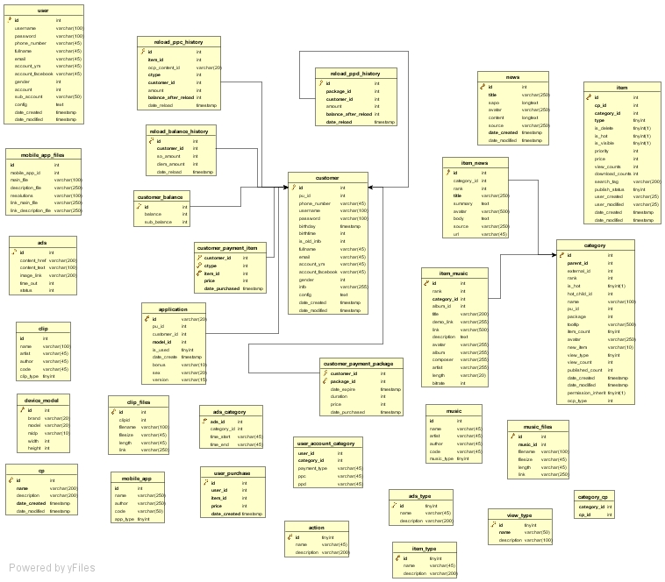
Figure 14: Entity Relationship Diagram

        - Symbol explanation
Symbol | Meaning
(1,n) | It stands for “one-many” relationship.  - First character in parenthesis correspond to table which is at the end of arrow  - Second character in parenthesis correspond to table which is at the start of arrow
(1,1) | It stands for “one-one” relationship  - First character in parenthesis correspond to table which is at the end of arrow  - Second character in parenthesis correspond to table which is at the start of arrow
(n,n) | It stands for “many-many” relationship  - First character in parenthesis correspond to table which is at the end of arrow  - Second character in parenthesis correspond to table which is at the start of arrow
PK | It stands for: Primary Key.  The Primary Key of a relational table uniquely identifies each record in the table. It can either be a normal attribute that is guaranteed to be unique (such as Social Security Number in a table with no more than one record per person) or it can be generated by the DBMS (such as a globally unique identifier, or GUID, in Microsoft SQL Server). Primary keys may consist of a single attribute or multiple attributes in combination
FK | It stands for: Foreign Key  A foreign key is a field in a relational table that matches the primary key column of another table. The foreign key can be used to cross-reference tables.
Explanation:
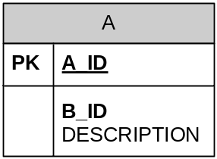
It means Table has name is A.
It has primary key is A_ID.
It has two columns with name are “B_ID” and "Description”.
“B_ID” is requiring by database, it mean “B_ID” cannot null.

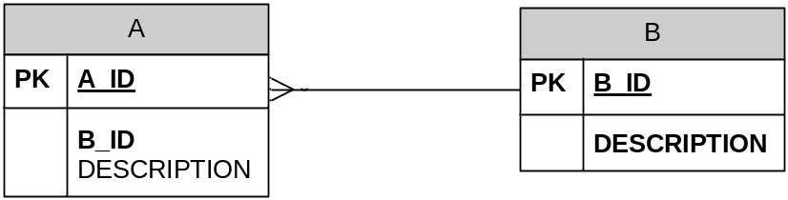
It means B has one to more relationship with A. One B can have one or more A.

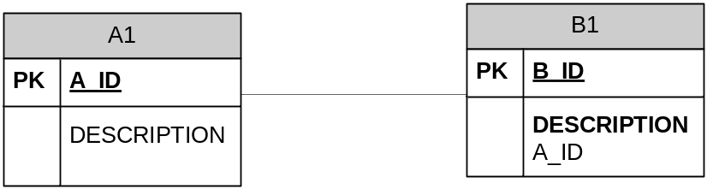
It means A1 has one to one relationship with B1.

        - Diagram description
- customer | Contain all information of customer: service customer is allow to access:  - id  - username  - password  - pu_id  - …
- customer_balance | Contain information customer’s account:  - id  - balance  - sub_balance
- customer_payment_item | Contain information of item that is bought by customer:  - customer_id  - ctype  - item_id  - price  - date_purchase
- reload_balance_history | Contain balance information after purchase for service:  - id  - customer_id  - so_amount  - diem_amout  - date_reload
- reload_ppc_history | Contain information of pay per content reload after purchse  - id  - item_id  - ctype  - customer_id  - …
- reload_ppd_history | Contain information of pay per day reload after purchse  - id  - item_id  - ctype  - customer_id  - …
- news | This table store information about news:  - id  - title  - sapo  - content  - source  - avatar  - date_created  - date_modified
- item_news | This table store information about category of news  - id  - category_id  - rank  - title  - source  - url  - …
- item | Store information about all item service of OMW system:  - id  - cp_id  - category_id  - type  - is_delete  - is_hot  - …
- category | Store information about category of service item:  - id  - parent_id  - external_id  - rank  - name  - …
- music | Store information about music service:  - id  - name  - artist  - author  - code  - music_type
- music_files | Store information about music files:  - id  - music_id  - file_name  - file_size  - length  - link
- action | Store information about action for server response:  - id  - name  - description

3.4 Risk-Driven Specification

3.4.1 Risk Identification
        - User lost password account.
        - Server manager do wrong action and server die.
        - Client cannot connect to server, request time out.
        - Client application cannot compatible with mobile.
        - Server application cannot access to database

3.4.2 Risk analysis and classification

No | Identified hazard | Hazard probability | Hazard severity | Estimated risk | Acceptability
1 | User lost password account | High | High | Medium | Intolerable
2 | Server manager do wrong action and server die | High | High | High | Intolerable
4 | Client cannot connect to server, request time out | High | Medium | Medium | Intolerable
5 | Client application cannot compatible with mobile | Medium | Medium | Medium | Acceptable
6 | Server application cannot access to database | High | Medium | Medium | Intolerable

3.4.3 Risk reduction assessment
        - Reset password immediately
        - Build quality assurance management to control server manager action
        - Carefully check the connection between the servers and client
        - Carefully check compatible between client application and mobile
        - Carefully check server application access to database

Reference list

- Gilbert Held, 2, illustrated CRC, 2010 A Practical Guides to Content Delivery Networks, CRC Press.

- Sikha Bagui, Richard Earp, illustrated, 2003 Database design using entity-relationship diagrams, Auerbach.
- Stephen H. Kan, 2, illustrated, 2003 Metrics and models in software quality engineering, Addison-Wesley.
- Karl Eugene Wiegers, 2, illustrated 2003 Software requirements: practical techniques for gathering and managing requirements throughout the product development cycle, Microsoft Press.
- Chris Reid, Barbara Mullendore, 2001, User Requirement Specification: Computer Systems Validation, Sue Horwood Publishing.
- Rajib Mall, Fundamentals of Software Engineering, PHI Learning Pvt. Ltd

Report No.4: Software Design Description

4.1 Design Overview
OMW – Online Mobile World System is a digital content distribution system. A good Information System is an important competitive factor in this century.OMW system can help customer to access information anywhere and anytime. It helps customer easy to enjoy, study and own all information just with a small mobile. All functional areas share a database and can deliver consistent data across all business functions in real time.
OMW system integrates other information from all sources or other system provides digital content too.OWM can parse content online form live information of other live content provider. The major benefits of Online Mobile World system are application can setup in all mobile support java environment, server of system can parsing data to JSON and XML, iphone and android also build application easily, content really is rich, fast and live. The immediate benefit from OMW system customer can expect is reduced wasting time and money, such as they can read content in mobile, they just have to purchase a little money for amount of the most general content.
In the first stage (from now to the end of capstone project), Our Task is that develop server system by java language and develop client with J2ME. This system produces two major services:
- News Online Service
- Music Online Service
After Finished this first stage, we will continue develop a full services OMW system to produce for customer if favourable. However, it is over scope of this document.

4.2 System Architectural Design

4.2.1 Choice of System Architecture

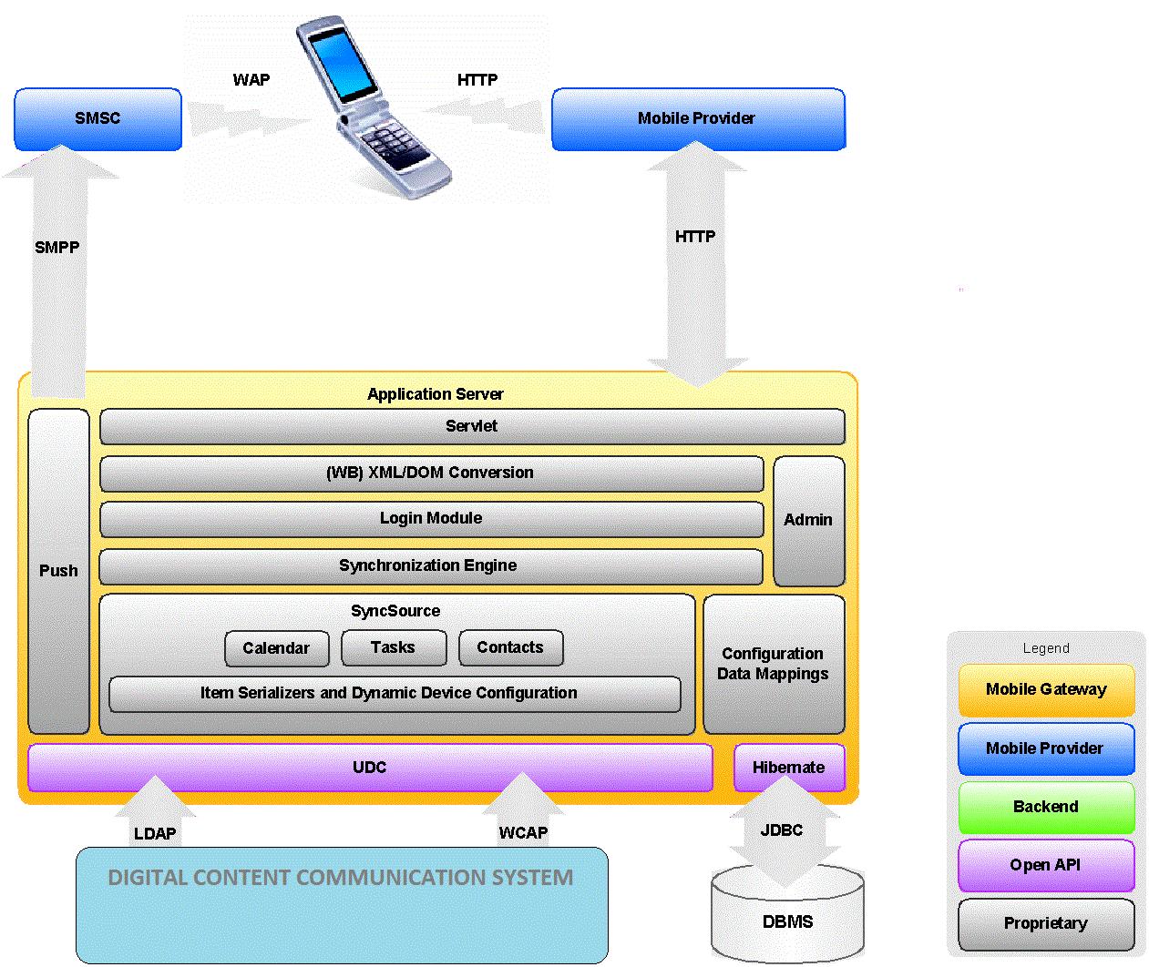
Figure 15: System Architecture

Universal Data Connector (UDC)
On the back-end side, the gateway is based on a flexible plug-in architecture Universal Data Connector (UDC). Sun provides a plug-in for the Online Mobile World Communications Suite. The UDC is provided as an open API component enabling easy integration of any third party Personal Information Management system without modification of the core gateway.

Item Serializers and Dynamic Device Configuration (DDC)
Serializers and deserializers convert a device item's byte array into a Java object (normally a JavaBeans object) and back again. The deserializer converts the byte array received from the client to a Java object for sending to the back-end server. The serializer converts the Java object back to a byte array when sending the item on to the back end server.
Most of the native clients follow the SyncML standard, with only a few device-specific deviations. However, the content of data items, such as a calendar event or contacts differ sometimes substantially between manufacturers and models. For example, field lengths might differ or the event might use G.M.T. or local time only. To handle these differences, the serializers and deserializers must be device specific.
The gateway addresses the issue of device-specific variations of the SyncML protocol and data items with device specific configurations for the serializers and deserializers according to the phone manufacturer and model. Sun's Dynamic Device Configuration (DDC) enables the gateway (through a live update mechanism) to stay constantly up to date with changes to these configurations.

Network element
To provide flexibility, scalability, and high availability, the system architecture is based on a two-tier architecture separating the system into an application server tier (Online Mobile World Communications) and a database server tier.

Spring
Spring Framework simplifies creation of server-side Java programs. Provide convenient wrappers for other technologies. Any Java application can use the core features of the Spring Framework, but there are extensions for building web applications on top of the Java EE platform. Although the Spring Framework does not impose any specific programming model, it has become popular in the Java community as an alternative to.

Hibernate
Hibernate is an object-relational mapping (ORM) library for the Java language, providing a framework for mapping an object-oriented domain model to a traditional relational database. Hibernate solves object-relational impedance mismatch problems by replacing direct persistence-related database accesses with high-level object handling functions.
Hibernate's primary feature is mapping from Java classes to database tables (and from Java data types to SQL data types). Hibernate also provides data query and retrieval facilities. Hibernate generates the SQL calls and relieves the developer from manual result set handling and object conversion, keeping the application portable to all supported SQL databases, with database portability delivered at very little performance overhead.

Application Servers
The application server tier consists of one or many application servers running the gateway server application. The application server runs the SyncML Gateway application as well as the user and administration portals.
Online Mobile World Communications can be deployed on the Sun Application Server 9.0 and 9.1 on a variety of platforms including Solaris OS 9 or 10 and Red Hat Enterprise Linux.

Database Servers
The database server stores log records created during SyncML sessions as well as user records mapping the user's credentials to the back-end server URL. Note that the database server does not store a replication of the actual user data such as calendar events or contacts. However, the database does act as a central repository for metadata required for synchronization, such as synchronization item IDs and the time and date that each mobile device was last synchronized. The following standard Structured Query Language (SQL) databases can be used: Postgres 8.1, MySQL 5, or Oracle 9.

PUSH Engine
The push engine notifies the client device if the user's data stored on the back-end server, changes. If a change occurs, the push engine adds a corresponding event (new, delete, or update) to the event queue.
During the polling interval (configured by the user) the event is placed on hold, the event queue is emptied and processed if synchronization starts during this time. At the end of the polling interval the push engine checks if there are any items in the queue. If there are then it notifies the client device through a SyncML push, a Sync Server alert command.
The purpose of the polling interval is to summarize a series of back-end server changes that occur quickly, one after another. The length of the polling interval balances response time to changes against bandwidth usage. If a change has occurred a SyncML Server alert is constructed and sent to the mobile client in WBXML format. The alert is sent as multiple binary SMS messages using the Short Message Peer to Peer (SMPP) protocol.

4.2.2 Discussion of Alternative Designs
We apply Spring because of flow benefits it can bring to a project:
  - Spring is Lightweight container
  - Objects are created Lazily, Singleton - configuration
  - Components can added Declaratively
  - Initialization of properties is easy – no need to read from properties file
  - Declarative transaction, security and logging service – AOP
  - Application code is much easier to unit test
  - Not required special deployment steps

At the first, we choose JDBC in our design. You can find the information about JDBC in website of Sun (http://java.sun.com/products/jdbc/overview.html):
“The JDBC API is the industry standard for database-independent connectivity between the Java programming language and a wide range of databases. The JDBC API provides a call-level API for SQL-based database access. JDBC technology allows you to use the Java programming language to exploit "Write Once, Run Anywhere" capabilities for applications that require access to enterprise data.”
In the end, we chose Hibernate because advantage of hibernate over JDBC:
- Hibernate is data base independent, same code will work for all databases (in our case is ORCLE). In case of JDBC query must be database specific.
- As Hibernate is set of Objects, you don't need to learn SQL language. You can treat TABLE as an Object. In case of JDBC you need to learn SQL.
- If you use Criteria Quires in Hibernate then hibernate automatically tuned your query and return best result with performance. In case of JDBC you need to tune your queries.
- Hibernate supports Query cache and It will provide the statistics about your query and database status. JDBC Not provides any statistics.
- Development fast in case of Hibernate because you do not need to write queries.

The transport layer for data synchronization between server and client can be HTTP or HTTPS.

The Sun Java Mobile Communications gateway also includes support for MD5 encrypted

authentication for other network elements. The gateway uses several industry-standard transport

protocol.

4.2.3 Description of System Interface
A system use services Digital Content Distribution get content from database or others system to show it on client application.

4.3 Component Diagram
Hibernate, spring component are external framework. Server component will contain the entire user interface. Services component service a special requirement of user. Delegate component manage a special task. We describe detail about Services component and Delegate component in next section.

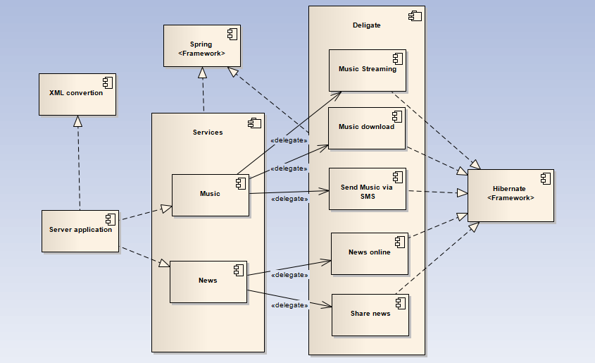
Figure 16: component diagram

4.4 Detailed Description of Components

4.4.1 CRC Cards (Class-Responsibility-Collaborators)
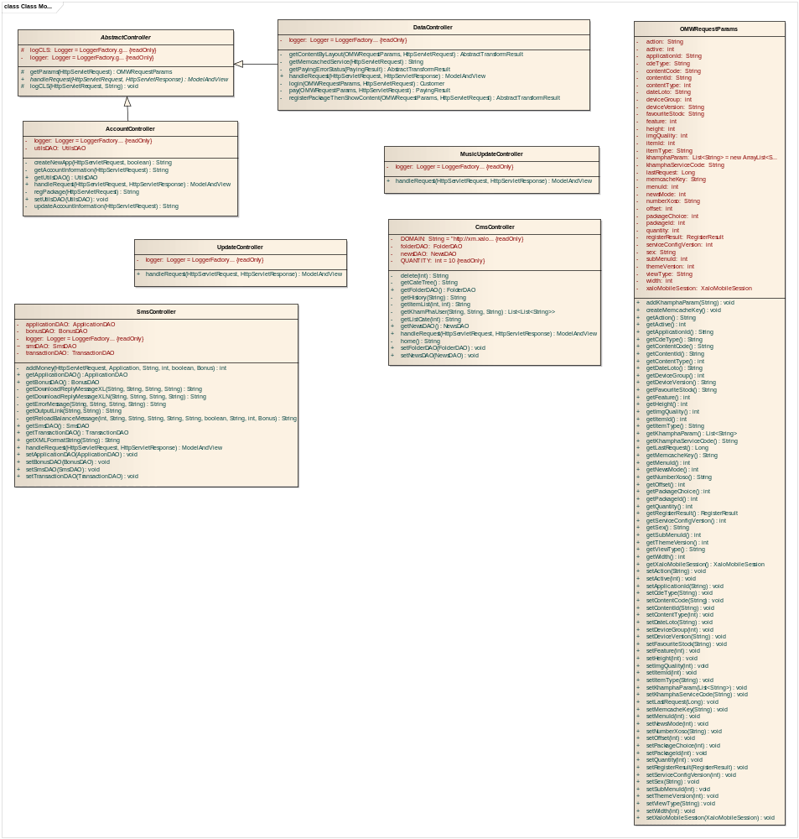

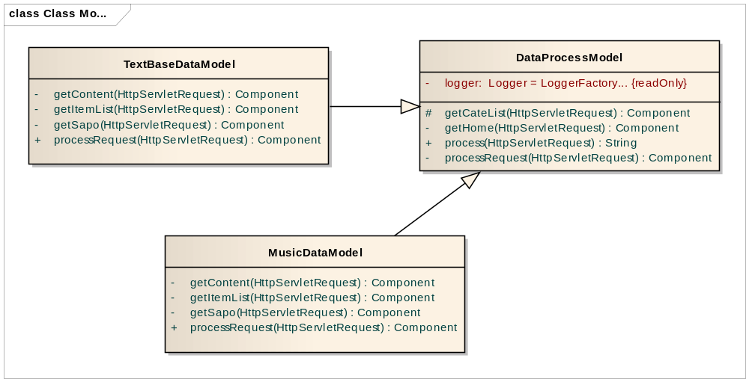

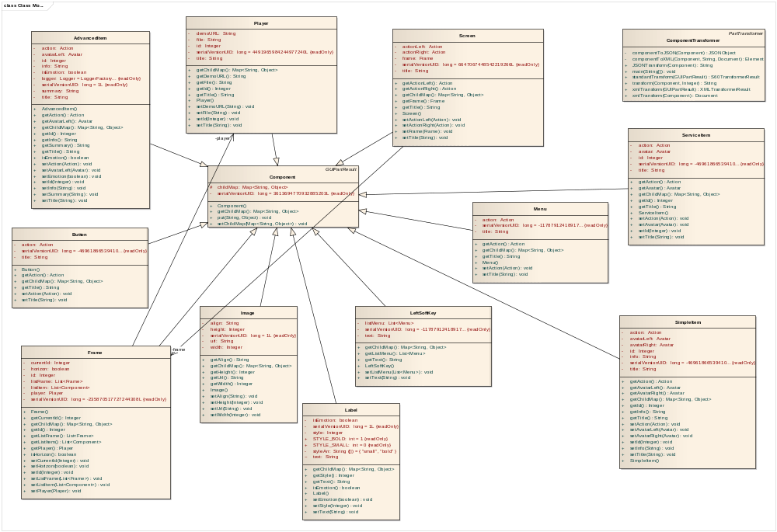

4.4.2 Customer account Component
a. Class Diagram
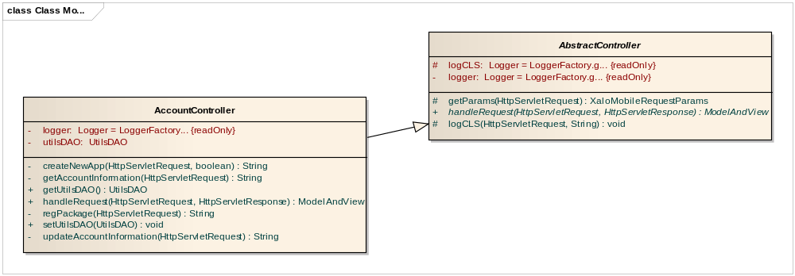
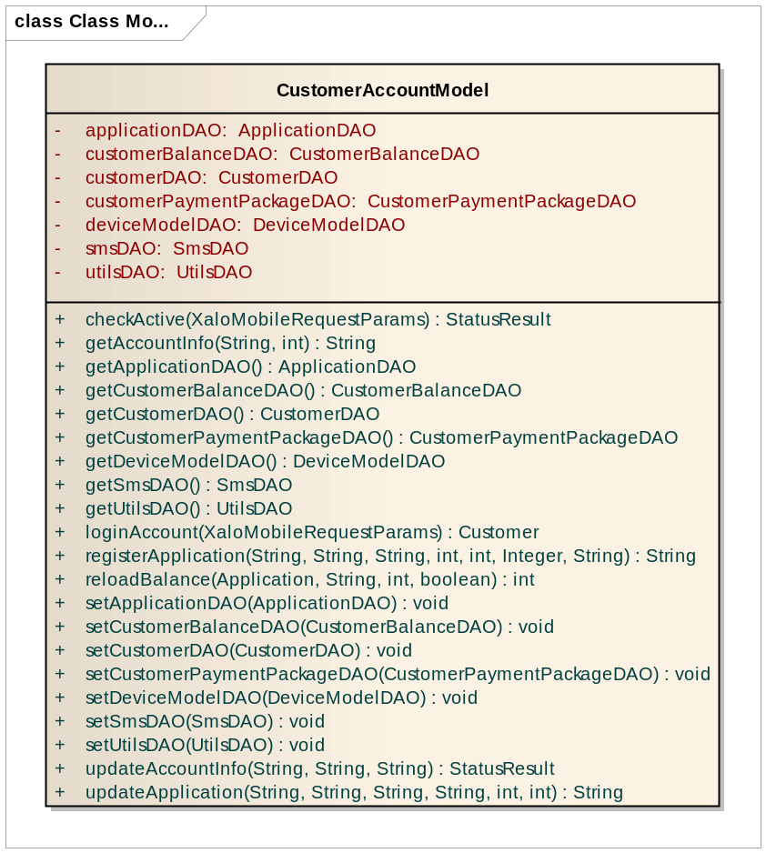
b. Class Diagram Explanation
Class diagram follow MVC model has responsibility about manage cuctomer account.

4.4.3 Read News online Component
a. Class Diagram
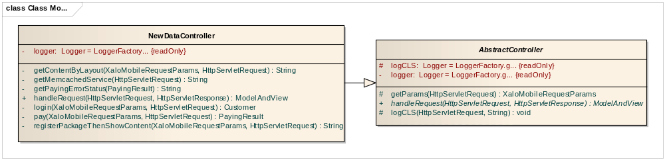
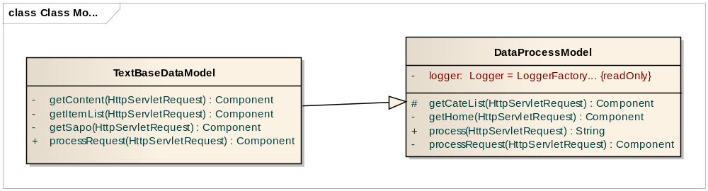

b. Class Diagram Explanation
Class diagram follow MVC model and has responsibility about read news.

4.4.4 Shared news via sms Component
a. Class Diagram
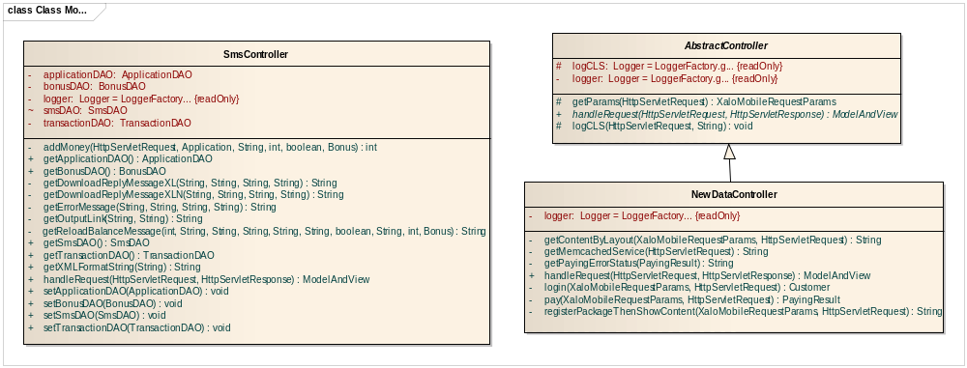
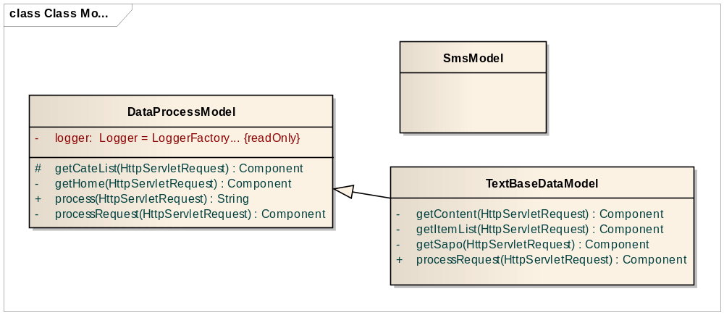
b. Class Diagram Explanation
Class diagram follow MVC model and has responsibility about share news via sms.

4.4.5 Music streaming Component
a. Class Diagram
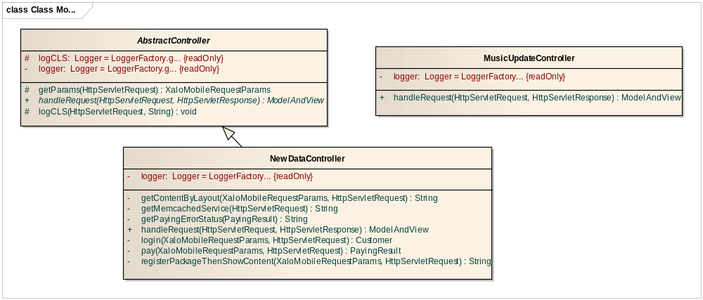
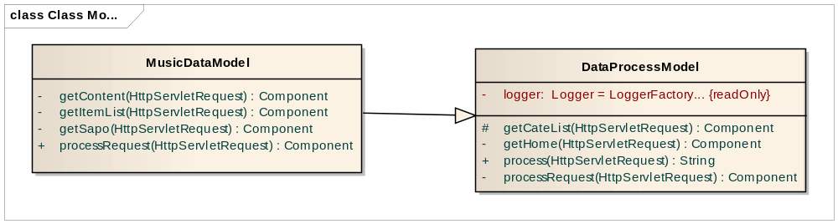
b. Class Diagram Explanation
Class diagram follow MVC model and has responsibility about listen music streaming.

4.4.6 Send music via SMS Component
a. Class Diagram
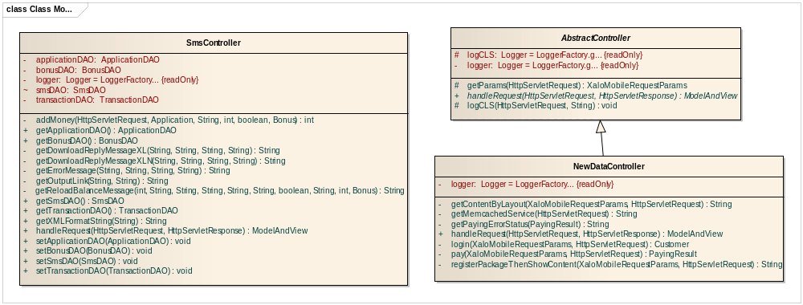
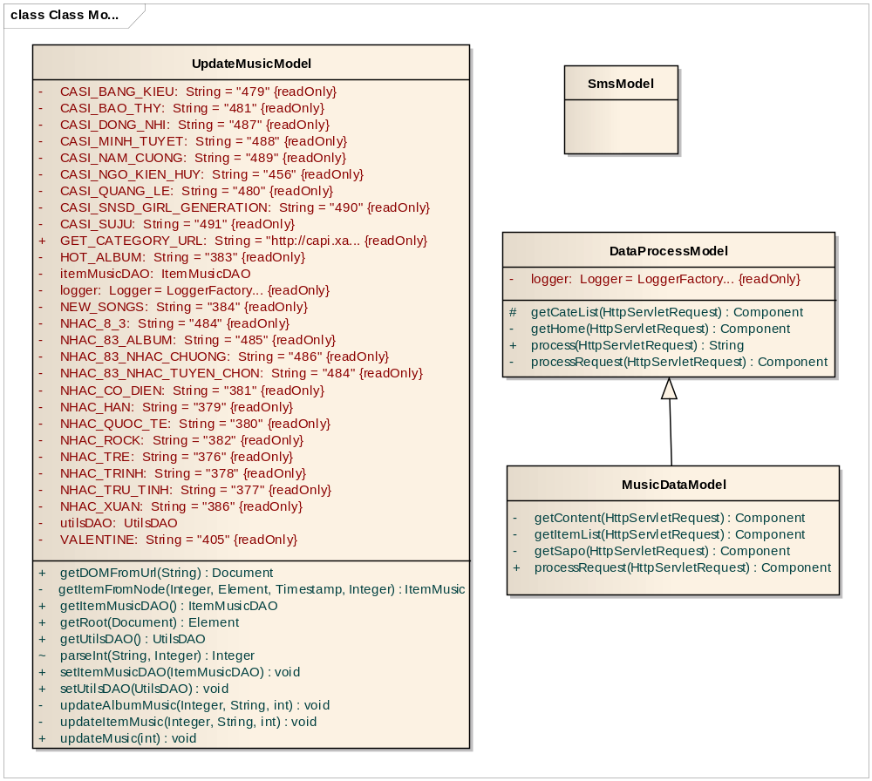
b. Class Diagram Explanation
Class diagram follow MVC model and has responsibility about send music via SMS

4.4.7 Music download Component
a. Class Diagram
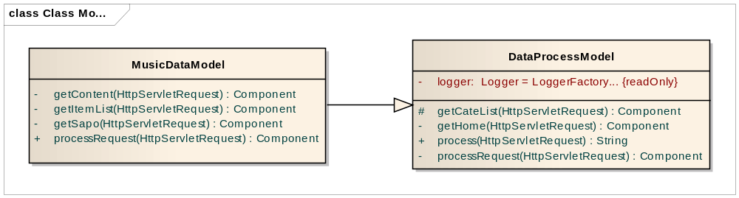
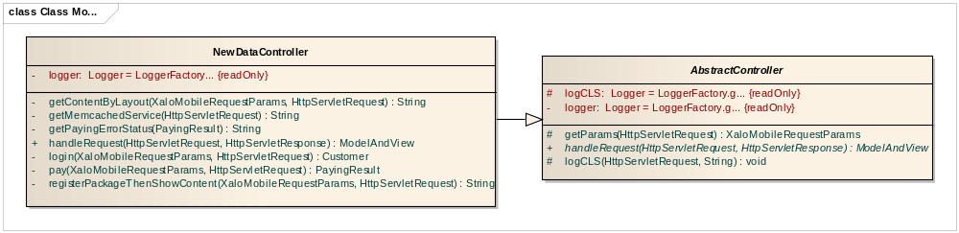
b. Class Diagram Explanation
Class diagram follow MVC model and has responsibility about music download feature.

4.5 Sequence Diagram

4.5.1 Create customer account Sequence Diagram
Check account active
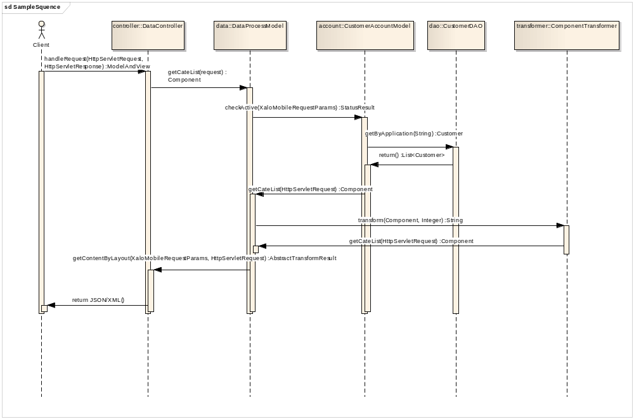
Login account
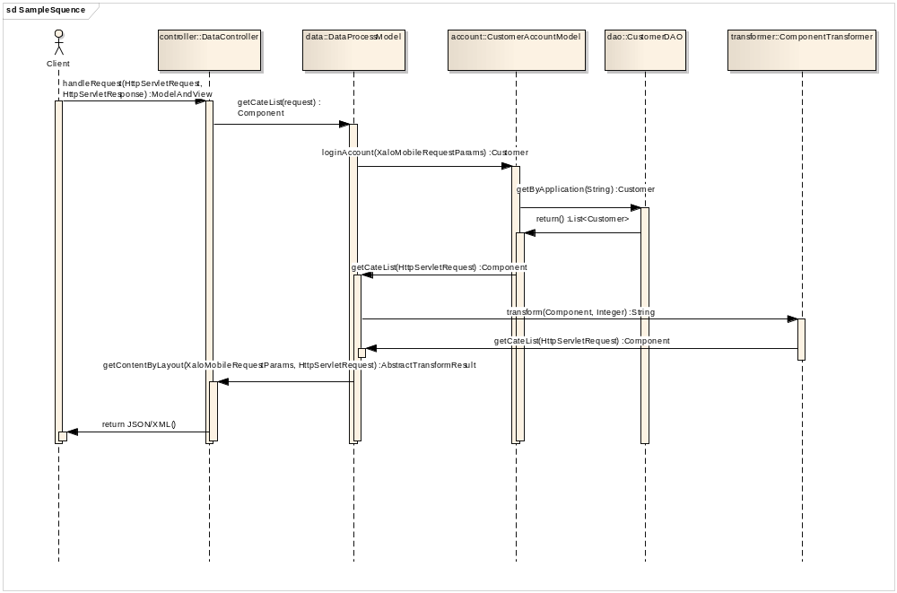

Update account
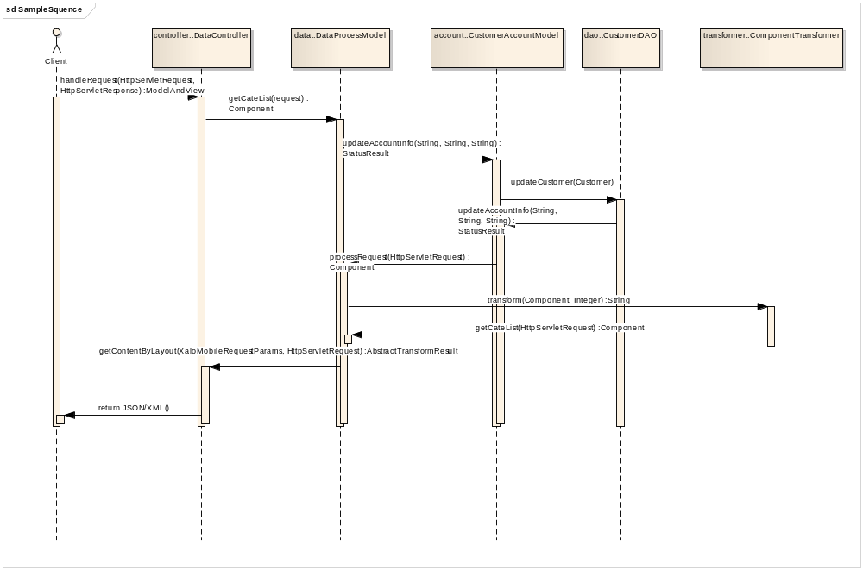

4.5.2 Read news online Sequence Diagram
Get category news
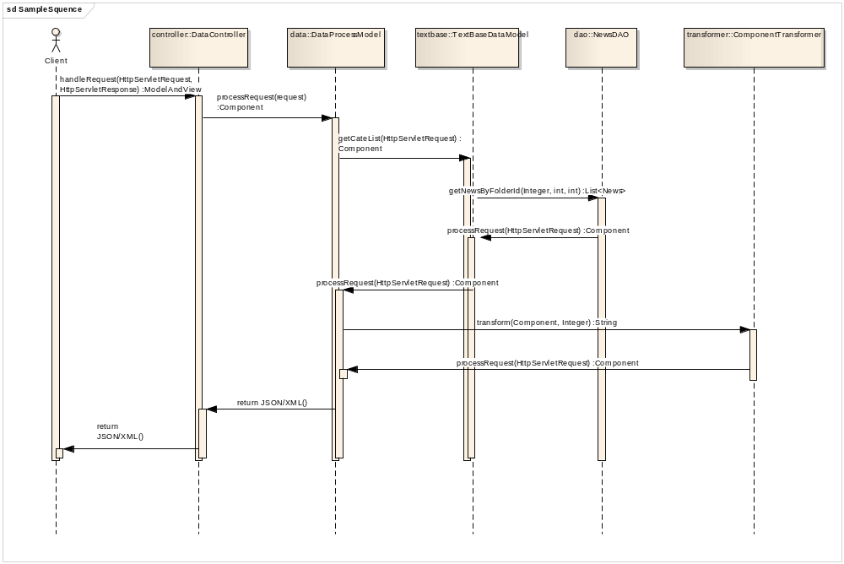

Get list item news
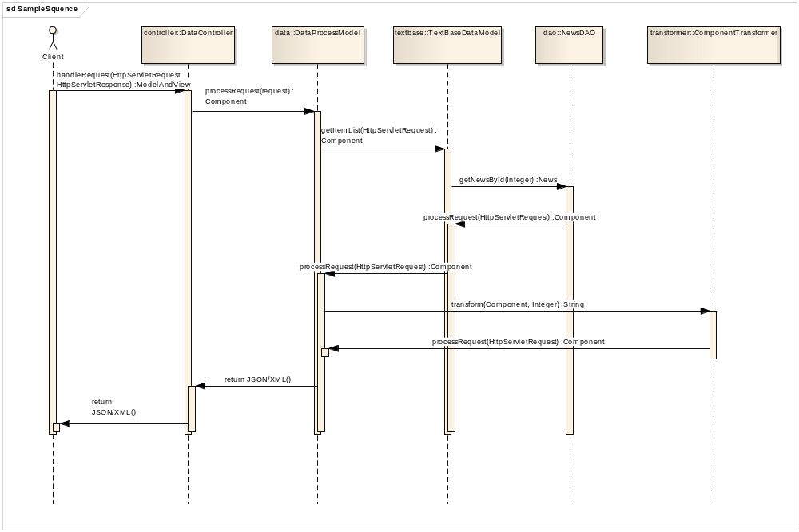
Get news
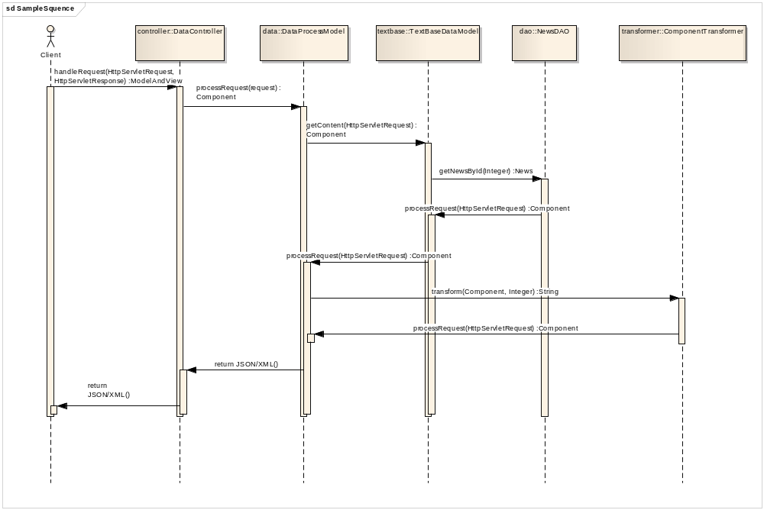

4.5.3 Music streaming Sequence Diagram
List album music

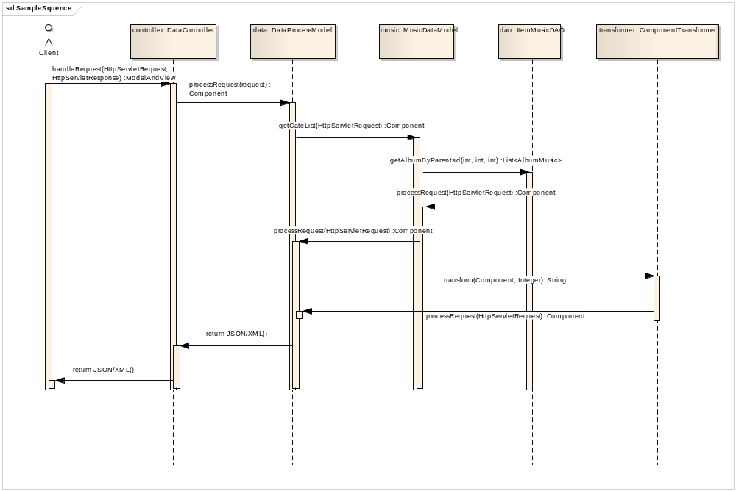

Get list music song in album
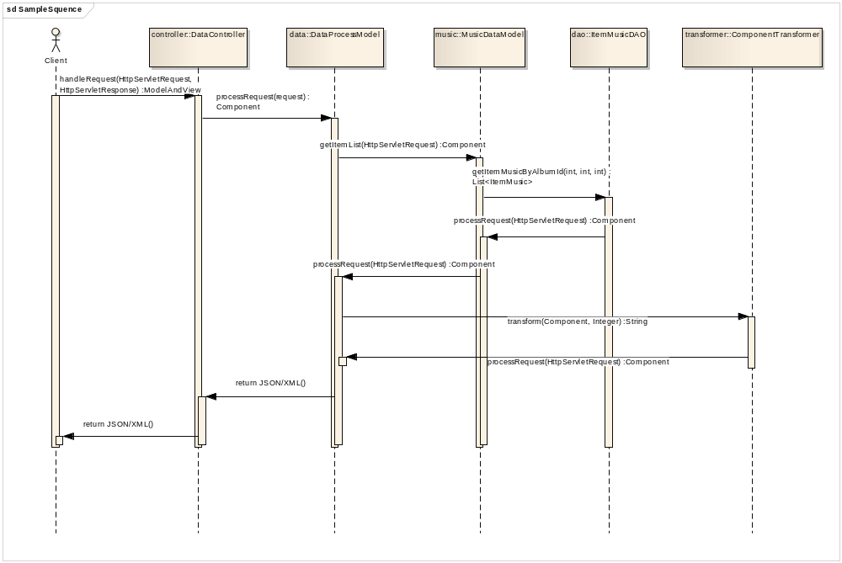

Get song streaming
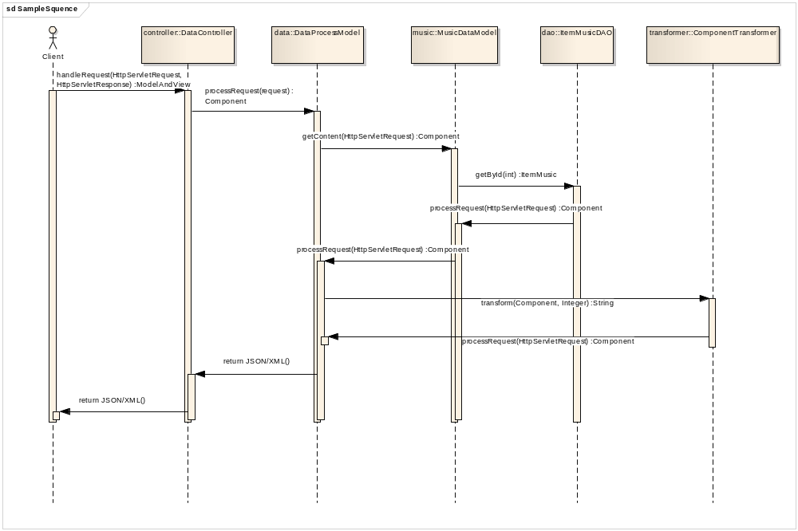

Download and share song via SMS

4.6 User Interface Design

4.6.1 Active application

4.6.1.1 Screen Images


4.6.1.2 Objects and Actions
For the fisrt-time, customers access to system after they setup application. Online Mobile World will automatically request user register service by send sms to system by instant sms content.

4.6.2 Active application: Send sms

4.6.2.1 Screen Images
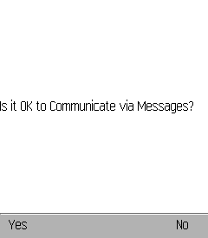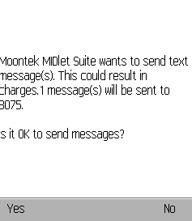

4.6.2.2 Objects and Actions
Customer can use util of application instead of writing sms follow syntax of OMW.

4.6.3 Active application: Register service success

4.6.3.1 Screen Images
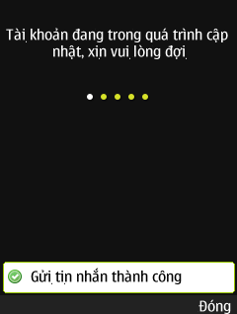

4.6.3.2 Objects and Actions
Express customers can be use application and access to service with their account.

4.6.4 Loading welcome screen

4.6.4.1 Screen Images


4.6.4.2 Objects and Actions
Just present and PR for brand of company
Search action:
Welcome screen: After click icon OMW application on your mobile

4.6.5 List service OMW Screen

4.6.5.1 Screen Images
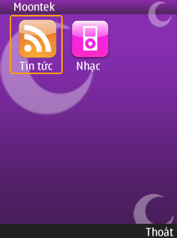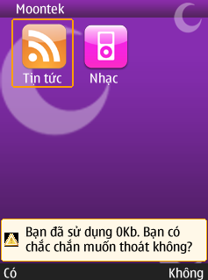

4.6.5.2 Objects and Actions
List all services are supported by Online Mobile World sytem. when you click [Thoát] button, popup message will be showed.

4.6.6 News online service: List category of News

4.6.6.1 Screen Images
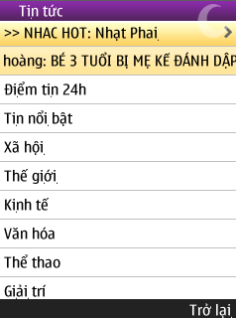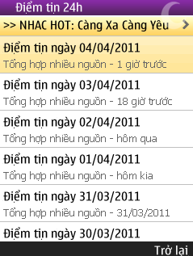
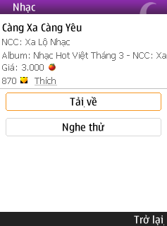

4.6.6.2 Objects and Actions
News will be definted in particular category, and parsing online. Customer can update information online, fastest, and collectively. When customers click to link promotion at top of list news category, they will link to the song in music or service is promotted at there.

4.6.7 News online service: List News of category

4.6.7.1 Screen Images
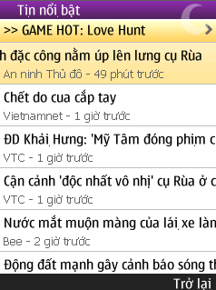

4.6.7.2 Objects and Actions
List news sort by date created. News has to express title, source of new and time for nearest updated. The title of new if too long for size of screen of mobile, when customer move to this news, the title will be dynamic to left or right. In addition, button [Trở lại] to back to previous page.

4.6.8 News online service: News detail

4.6.8.1 Screen Images
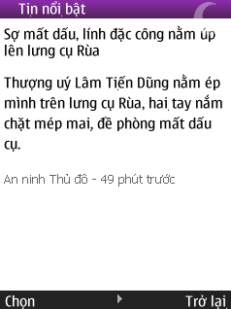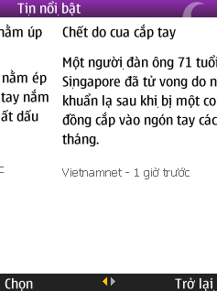



4.6.8.2 Objects and Actions
Show description of news and when customer click to right bution [Chọn], all detail of new will appear. Customer can use left and right control to move to previour or next to read news if they don’t want to waste time click button [Trở lại] and chose news form list.

4.6.9 Music service: List category in service [Nhạc]

4.6.9.1 Screen Images
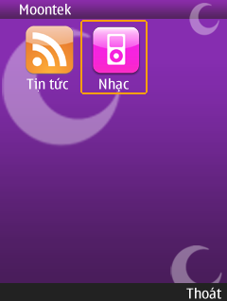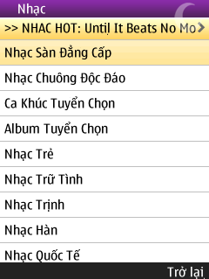

4.6.9.2 Objects and Actions
Music is listted by categories. In addition, button [Trở lại] to back to previous page.

4.6.10 Music service: List album in Music

4.6.10.1 Screen Images
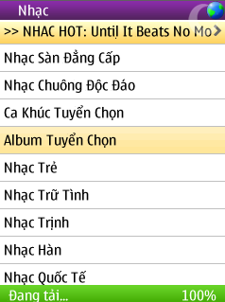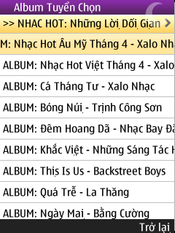

4.6.10.2 Objects and Actions
List album is produced by Online Mobile World system that user can access and use it.

4.6.11 Music service: List song by category and by album

4.6.11.1 Screen Images
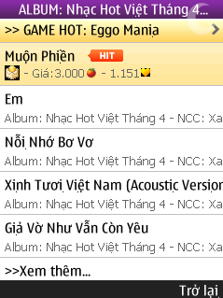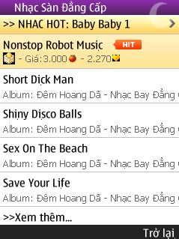
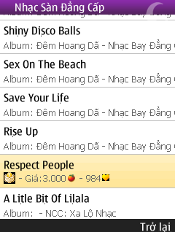

4.6.11.2 Objects and Actions
Producers list song in music service. In addition, to optimal speed of application system just show four songs in list at a time. When customer click [Xem thêm] button, four songs will be showed. In each song must include some information: name, price, hit, like, NCC, album.

4.6.12 Music service: Download songs

4.6.12.1 Screen Images
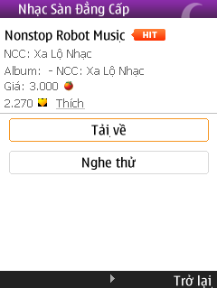

4.6.12.2 Objects and Actions
When customer click button [Tải về], application will refer to link download and get music from server to customer.

4.6.13 Music service: Listen music streaming

4.6.13.1 Screen Images
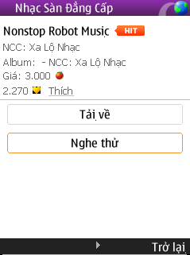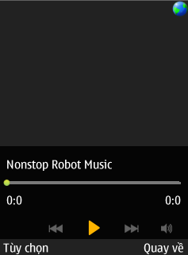

4.6.13.2 Objects and Actions
User click button [Nghe thử], Music player of application will play this song.

4.6.14 Account service

4.6.14.1 Screen Images
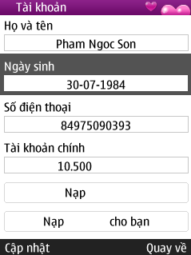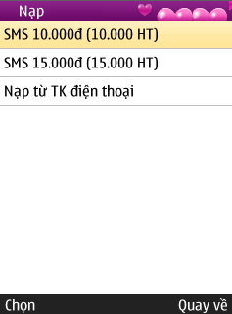
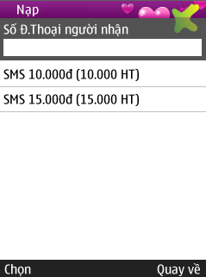

4.6.14.2 Objects and Actions
Service manage information of customer and allow customer load payment for their or friend by sms.

4.7 Database Design or Data Structures

4.7.1 Entity Relationship Diagram
\

4.7.2 Designs Tables and Column Listing
Table
Name
customer
customer_balance
customer_payment_folder
customer_payment_item
customer_payment_package
reload_ppc_history
reload_ppd_history
Category
item_music
item_news
news
item
music_file
music
user_account_category
user_purchase
application
user
ads
devices_model
action
item_type
view_type

Column(s) of "customer" Table
Name | Datatype | Null Option | Length | Is FK | Is PK
id | int | NOT NULL | 11 | No | Yes
pu_id | int | NOT NULL | 11 | No | No
phone_number | varchar | NOT NULL | 45 | No | No
username | varchar | NULL | 100 | No | No
password | varchar | NOT NULL | 100 | No | No
birthday | timestamp | NULL | 0 | No | No
birthtime | int | NOT NULL | 11 | No | No
is_old_info | int | NOT NULL | 11 | No | No
fullname | varchar | NOT NULL | 45 | No | No
email | varchar | NOT NULL | 45 | No | No

Column(s) of "customer_balance" Table
Name | Datatype | Null Option | Length | Is FK | Is PK
id | Int | NOT NULL | 11 | No | Yes
balance | Int | NULL | 11 | Yes | No
sub_balance | int | NULL | 11 | Yes | No

Column(s) of "customer_payment_item" Table
Name | Datatype | Null Option | Length | Is FK | Is PK
customer_id | int | NOT NULL | 11 | No | Yes
ctype | int | NULL | 11 | No | No
item_id | int | NOT NULL | 11 | No | No
price | int | NOT NULL | 11 | No | No
date_purchased | timestamp | NOT NULL | 0 | No | No

Column(s) of "customer_payment_package" Table
Name | Datatype | Null Option | Length | Is FK | Is PK
customer_id | int | NOT NULL | 11 | No | Yes
package_id | int | NULL | 11 | Yes | No
date_expire | timestamp | NOT NULL | 0 | No | No
duration | int | NOT NULL | 11 | No | No
price | int | NOT NULL | 11 | No | No
date_purchased | timestamp | NULL | 0 | No | No

Column(s) of "reload_balance_history" Table
Name | Datatype | Null Option | Length | Is FK | Is PK
id | int | NOT NULL | 11 | No | Yes
customer_id | int | NOT NULL | 11 | Yes | No
so_amount | int | NOT NULL | 11 | Yes | No
diem_amount | int | NULL | 11 | Yes | No
date_reload | timestamp | NULL | 0 | No | No

Column(s) of "reload_ppc_history" Table
Name | Datatype | Null Option | Length | Is FK | Is PK
id | int | NOT NULL | 11 | No | Yes
item_id | int | NULL | 11 | Yes | No
ocp_content_id | varchar | NULL | 20 | No | No
ctype | int | NOT NULL | 11 | No | No
customer_id | int | NULL | 11 | No | No
amount | int | NULL | 11 | No | No
balance_after_reload | int | NOT NULL | 11 | No | No

Column(s) of "reload_ppd_history" Table
Name | Datatype | Null Option | Length | Is FK | Is PK
id | int | NOT NULL | 11 | No | Yes
package_id | int | NULL | 11 | No | No
customer_id | int | NULL | 11 | No | No
amount | int | NULL | 11 | No | No
balance_after_reload | int | NULL | 11 | No | No
date_reload | timestamp | NOT NULL | 0 | No | No

Column(s) of "category" Table
Name | Datatype | Null Option | Length | Is FK | Is PK
id | int | NOT NULL | 11 | No | Yes
parent_id | int | NULL | 11 | No | No
external_id | int | NULL | 11 | No | No
rank | int | NULL | 11 | No | No
is_hot | tinyint | NOT NULL | 1 | No | No
hot_child_id | int | NOT NULL | 11 | No | No
name | varchar | NULL | 100 | No | No
pu_id | int | NOT NULL | 11 | No | No
package | int | NULL | 11 | No | No
tooltip | varchar | NULL | 500 | No | No
item_count | tinyint | NOT NULL | 4 | No | No
avatar | varchar | NOT NULL | 250 | No | No
new_item | varchar | NOT NULL | 10 | No | No
view_type | tinyint | NOT NULL | 4 | No | No
view_count | int |  | 11
published_count | int |  | 11

Column(s) of "item_news" Table
Name | Datatype | Null Option | Length | Is FK | Is PK
id | int | NOT NULL | 11 | No | Yes
title | varchar | NULL | 250 | No | No
summary | text | NULL | 0 | No | No
avatar | varchar | NULL | 500 | No | No
body | text | NULL | 0 | No | No
source | varchar | NULL | 250 | No | No
url | varchar | NOT NULL | 45 | No | No
external_id | int | NOT NULL | 11 | No | No
rank | int | NOT NULL | 11 | No | No

Column(s) of "item_music" Table
Name | Datatype | Null Option | Length | Is FK | Is PK
id | int | NOT NULL | 11 | No | Yes
rank | int | NULL | 11 | No | No
cp_id | int | NULL | 11 | No | No
cp_name | varchar | NULL | 30 | No | No
folder_id | int | NOT NULL | 11 | No | No
album_id | int | NULL | 11 | No | No
title | varchar | NOT NULL | 200 | No | No
demo_link | varchar | NOT NULL | 255 | No | No
link | varchar | NOT NULL | 500 | No | No
description | text | NOT NULL | 0 | No | No
avatar | varchar | NOT NULL | 255
album | varchar | NOT NULL | 255
composer | varchar | NOT NULL | 255
artist | varchar | NOT NULL | 255
bitrate | int | NOT NULL | 11
length | varchar | NOT NULL | 20
view_type | tinyint | NOT NULL | 4
is_delete | tinyint | NOT NULL | 1
is_hot | tinyint | NOT NULL | 1
is_visible | tinyint | NOT NULL | 1
external_album_id | int | NOT NULL | 11
external_id | int | NOT NULL | 11
price | int | NOT NULL | 11
like_count | int | NOT NULL | 11
download_count | int | NOT NULL | 11
search_tag | text | NOT NULL | 0
publish_status | tinyint | NOT NULL | 4
user_created | int | NOT NULL | 11
user_modified | int | NOT NULL | 11
date_created | timestamp | NOT NULL | 0
date_modified | timestamp | NOT NULL | 0
type | int | NOT NULL | 11
package_id | int | NOT NULL | 11
ocp_content_id | varchar | NOT NULL | 20

Column(s) of "item" Table
Name | Datatype | Null Option | Comment | Is FK | Is PK
id | int | NOT NULL | 11 | No | Yes
cp_id | int | NOT NULL | 11 | No | No
folder_id | int | NULL | 11 | No | No
view_type | tinyint | NOT NULL | 4 | No | No
is_delete | tinyint | NOT NULL | 1 | No | No
is_hot | tinyint | NULL | 1 | No | No
is_visible | tinyint | NULL | 1 | No | No
rank | int | NULL | 11 | No | No
price | int | NULL | 11 | No | No
view_count | int | NULL | 11 | No | No
download_count | int | NULL | 11 | No | No
search_tag | text | NULL | 0 | No | No
publish_status | tinyint | NULL | 4 | No | No
user_created | int | NULL | 11 | No | No
user_modified | int | NOT NULL | 11 | No | No
date_created | timestamp | NOT NULL | 0 | No | No
date_modified | timestamp | NOT NULL | 0 | No | No
type | int | NOT NULL | 11 | No | No
package_id | int |  | 11

Column(s) of "action" Table
Name | Datatype | Null Option | Length | Is FK | Is PK
id | tinyint | NOT NULL | 4 | Yes | Yes
name | varchar | NULL | 45 | No | No
description | varchar | NOT NULL | 200 | Yes | No
code | varchar | NULL | 45 | Yes | No

Column(s) of "ads" Table
Name | Datatype | Null Option | Length | Is FK | Is PK
id | int | NOT NULL | 11 | No | Yes
content_href | varchar | NOT NULL | 200 | Yes | No
content_text | varchar | NULL | 100 | Yes | No
image_link | varchar | NULL | 200 | No | No
time_out | int | NULL | 11 | Yes | No
status | int | NULL | 11 | No | No

Reference

- Basem S. El-Haik, Adnan Shaout, 2, illustrated, 2010 Software Design for Six Sigma: A Roadmap for Excellence, John Wiley and Sons.
- Bhuvan Unhelkar, illustrated, 2005 Verification and validation for quality of UML 2.0 models, John Wiley and Sons.
- Joseph Schmuller, 3, illustrated, 2004 Software Sams teach yourself UML in 24 hours, Sams Publishing.
- Michael Jesse Chonoles, James A. Schardt, illustrated, 2004 UML 2 for dummies, For Dummies.
- Hassan Gomaa, illustrated, 2012 Software Modeling and Design: UML, Use Cases, Patterns, and Software Architectures, Cambridge University Press.
- Seth Ladd, Darren Davison, Steven Devijver, Colin Yates, illustrated, 2006 Expert Spring MVC and Web Flow, Apress.
- Paul Tepper Fisher, Brian D. Murphy, illustrated, 2010 Spring Persistence with Hibernate, Apress.
- Stephen Buxton, Lowell Fryman, illustrated, 2009 Database design: know it all, Morgan Kaufmann.

Report No.5: Software Test Documentation

5.1 Introduction

5.1.1 System Overview

Mobile content distribution network is the system of computers networked together across the internet that cooperate transparent that are designed and located to specifically deliver content to end users on any type of wireless or mobile network.

Develop Online Mobile World system base on Mobile Content Distribution Network model to provide digital content such as high quality music, useful information, news, etc in the mobile phone fastest and most convenient. Our system is not really complete of Online mobile world. We only concentrate to develop two popular services: news and music.

This document describes the approach and methodologies used by the testing group to plan, organize and manage the testing of this system. It describes implementation details of test cases or technical details of how the product features should work.

5.1.2 Test Approach

The testing for our project includes: use V model
- Unit test
- Integration test/System test(combined)
- Acceptance test

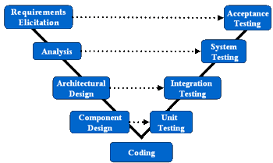

Unit Testing will be done by the developers and will be approved by the implementing team leader. All unit test information (sample, output, data printouts, and defect information…) will be managed by developers and it must be showed when team required.

System/Integration Testing will be performed by the test manager and implementing team leader with assistance from the individual developers as required.

Acceptance Testing will be performed by the test manager and development team leader. The acceptance test will be done for a period of 2 weeks after completion of the System/Integration test process. Programs will enter into Acceptance test after all critical and major defects have been corrected. A program may have one major defect as long as it does not obstruct testing of the program (There is a work around for the error). Prior to final completion of acceptance testing all open critical and major defects must be corrected.

5.2 Test plan

5.2.1 Features to be tested

The following is a list of tested features in our application:
- Test GUI

News includes: Hot news, “Điểm tin 24h”, “Tin nổi bật”, “Xã hội”, “Thế giới”, “Kinh tế”, “Văn hóa”, “Thể thao”, “Giải trí”, “Giáo dục”, “Pháp luật”, “Sức khỏe”, “Khoa học”, “Ô tô xe máy”, “Góc cười”.

Music includes: “ Nhạc Sàn Đẳng Cấp”, “Nhạc Chuông Độc Đáo”, “Ca Khúc Tuyển Chọn”, “Album Tuyển Chọn”, “Nhạc Trẻ”, “Nhạc Trữ Tình”, “Nhạc Trịnh”, “Nhạc Hàn”, “Nhạc Quốc Tế”, “Nhạc Cổ Điển”, “Nhạc Rock”

Check Header, Main screen, Footer of

+ Home page

+ Category page

+ Detail page

- Test function

+ Home page of Moontek service

+ News - Check category

+ News - News list in category

+ News - Reading news on category

+ News - Back manipulation

+ Music - Check category

+ Music - List of song in category

+ Music - Listen song on category

+ Music - Loading music (Paying money depends on song)

+ Music - Back manipulation

Besides, we will test information on screen: test server…
    - Features not to be tested

N/A
    - Testing Tools and Environment
      - Testing Tools
- Testers can implement on system and a mobile phone which has high configuration
      - Testing Environment
- Hardware: PC: Core 2 Duo 2.4GHZ, 2GB RAM

Mobile Device: Mobile Phone Nokia 6500s,Nokia 6303 and

BlackBerry 8700 with GPRS connection
- Software: OS: Windows 7 Professional

JDK v6

Mobile Phone simulation software

Eclipse

TakeScreenPhone software on Mobile Phone to take picture of screen

Microsoft Office 2007

5.3 Test cases

5.3.1 Test cases for GUI
ID | Test Case Description | Test Case Procedure | Expected Output | Result
Home page of Moontek mobi
Precondition: Access into application of Moontek mobi
UIMM – 01 | Check interface of home page: Header | Check every component on header when implement:  1. Access into application of Moontek mobi | Header of home page satisfies the following of requirements:  - The left shows name of service: "Moontek" | Pass
UIMM – 02 | Check main screen interface of home page | Check every component on main screen when implement:  1. Access into application of Moontek mobi | Main screen of home page satisfies the following of requirements:  - Show by list form:  * Show services by list form  * A service includes: Icon, name, the number of new news (if have)…  - Show by grid form:  * Show services of application by grid form  (Table form)on blue background.  * A service includes information: Icon, name… | Pass
UIMM – 03 | Check interface of home page: Footer | Check every component on footer when implement:  - Access into application of Moontek mobi | Footer of home page satisfies the following of requirements:  - The left shows "Tùy chọn" - Show the list of user manipulations present:  - The between shows button (arrow) to move pointer.  - The right shows "thoát" | Pass
UIMM – 04 | Check interface of home page: Footer | - Click “Tùy chọn” on footer | Above of “Tùy chọn” shows a box includes:  + “Chọn”  + “Gửi tặng bạn bè”  + “ Cấu hình”  + “Tài khoản”  + “Đặt làm trang chính”  + “ Hotline”  + “Trợ giúp”  The left of footer shows “Hủy”. White word on black background. | Pass
 | Service: News
 | Precondition: Access into application of Moontek mobi
UIMM – 05 | Check interface of home page of news service: Header | Check every component on header when do the steps:  1. Access to application  2. Click “Tin tức” service | Header of home page of news service satisfies the following of requirements:  - The left shows name of service “Tin tức”: White on blue background | Pass
UIMM – 06 | Check main screen interface of home page of news service | Check every component on main screen when do the steps:  1. Access to application  2. Click "Tin tức" service | Home page main screen of news service satisfies the following of requirements:  - Advertising news: Shows advertising news, black word on light yellow background with form: “>>”, advertising field( capital letter), “:”, name of advertising, “>”.  - Category list of news:  Shows category list of news service includes:  + Latest news  + “Điểm tin 24h”  + “Tin nổi bật”  + “Xã hội”  + “Thế giới”  + “Kinh tế”  + “Văn hóa”  + “Thể thao”  + “Giải trí”  + “Giáo dục”  + “Pháp luật”  + “Sức khỏe”  + “Khoa học”  + “Ô tô xe máy”  + “Góc cười”  The between of two news have a black line | Pass
UIMM – 07 | Check interface of home page of news service: The end of box (footer) | Check every component on footer when do the steps:  1. Access to application  2. Click “Tin tức” service | Footer of home page of news service satisfies the following of requirements:  - The left shows “Tùy chọn” - Shows category list that user can implement.  - The right shows “Trở lại” : white word on black background | Pass
UIMM – 08 |  | - Click to “ Tùy chọn” of footer | The above of “ Tùy chọn” shows a box includes:  + “Chọn”  + “Về trang chủ”  + “Đặt làm trang chính”  + “Thoát”  The left of footer shows “hủy”. White word on black background | Pass
Category Page of news service
Precondition: Access to news service
UIMM – 09 | Check interface category page of new service: Header | Check every component on header when implement the steps:  1. Access to news service  2. Choose category. | Header of Category home of news service satisfies the following of requirements:  - The left shows service name which choose: White on blue background | Pass
UIMM – 10 | Check interface category page of new service: Main screen | Check every component on main screen when implement the steps:  1. Access to news service  2. Choose category. | Main screen of category page news service satisfies the following of requirements:  - Advertising news: Shows “>>”, hot field, “:”, name of hot field (from left to right): black word on light yellow background.  - News list in category: Shows news list in category, a news includes: Name: bold black, source and release time (dd/mm/yyyy) grey word: on white background, news name move to light orange when pointer move to. The final of main screen shows “>>” , “xem thêm…” | Pass
UIMM – 11 | Check interface category page of new service: The end of box(footer) | Check every component on footer when implement the steps:  1. Access to news service  2. Choose category. | Footer of category page news service satisfies the following of requirements:  - The left shows “Tùy chọn” - Shows manipulation list that user can implement: White on black background  - The right shows “Trở lại” : White on black background | Pass
UIMM – 12 |  | - Click “Tùy chọn” of category page of news service | - Change “ Tùy chọn” to “ chọn”, the above of “chọn” shows a box includes:  + “Chọn”  + “Về trang chủ”  + “Thoát”  - The right shows “Hủy” | Pass
Detail page of news service
Precondition: Access to choose category(Or choose service: Reading the article on highlight top)
UIMM – 13 | Check interface of detail page of news service: Header | Check every component on header when implement the steps:  1. Access to news service  2. Choose category  3. Choose article -> reading | Header of detail page of news service satisfies the following of requirements:  - The left shows name of news category which chose: white on blue background | Pass
UIMM – 14 | Check main screen interface of detail page of news service | Check every component on main screen when implement the steps:  1. Access to news service  2. Choose category  3. Choose article -> reading | Main screen of detail page of news service satisfies the following of requirements:  - Article title:  * Showing name of article: Black word on white background  - Content of detail article: View all of detail content of article: Black word on white background  - The final of main screen of detail page: Showing source, issue time: Grey on white background | Pass
UIMM – 15 | Check footer interface of detail page of news service | Check every component on footer when implement the steps:  1. Access to news service  2. Choose category  3. Choose article -> reading | Footer of detail page of news service satisfies the following of requirements:  - The left shows “Chi tiết” - Showing manipulation list that user can implement: white on black background  - Between shows button (arrow) to control the pointer, the number of page of article: white on black background. In the first and the last page of news have only arrow. From the second page has two opposite arows  - The right shows “Trở lại” : White on black background | Pass
 | Service: Music
Home page of music service
Precondition: Access to application of Moontek Mobi
UIMM – 16 | Check header interface of home page of music service | Check every component on header when implement:  1. Click to choose music service | Header of home page of music service satisfies the following of requirements:  - The left shows name of service “Nhạc” | Pass
UIMM – 17 | Check main screen interface of home page of music service | Check every component on main screen when implement:  1. Click to choose music service | Main screen of home page of music service satisfies the following of requirements:  - Advertising news: “>>”, hot field, “:”, name of hot field, “>”  - List of music category:  + “ Nhạc Sàn Đẳng Cấp”  + “Nhạc Chuông Độc Đáo”  + “Ca Khúc Tuyển Chọn”  + “Album Tuyển Chọn”  + “Nhạc Trẻ”  + “Nhạc Trữ Tình”  + “Nhạc Trịnh”  + “Nhạc Hàn”  + “Nhạc Quốc Tế”  + “Nhạc Cổ Điển”  + “Nhạc Rock” | Pass
UIMM – 18 | Check footer interface of home page of music service | Check every component on footer when implement:  1. Click to choose music service | Footer of home page of music service satisfies the following of requirements:  - The left shows “Tùy chọn” - Shows manipulation list that user can implement: white on black background  - The right shows “Trở về”: white on black background | Pass
UIMM – 19 | Check footer interface of home page of music service | - Click “Tùy chọn” of footer of music service | - Change “Tùy chọn” to “Chọn” and the above of “Chọn” shows a box includes:  + “Chọn”  + “Về trang chủ”  + “Gửi tặng bạn bè”  + “Cấu hình”  + “Tài khoản”  + “Hotline”  + “Trợ giúp”  + “Thoát”  - The left shows “Hủy”: white word on black background | Pass
Category page of music service
Precondition: Access to music service
UIMM – 20 | Check header interface of category page of music service | Check every component on header when implement:  1. Click to choose category | Header of category page of music service satisfies the following of requirements:  - The left shows name of music category. White word on blue background | Pass
UIMM – 21 | Check main screen interface of category page of music service | Check every component on main screen when implement:  1. Click to choose category | Main screen of category page of music service satisfies the following of requirements:  - Advertising news: shows “>>”, hot field, “:”, name of hot field, “>” (from left to right): white word on light yellow background.  - Music list in category:  *Show music list in category, a song includes: the left is name, the right I is symbol of HIT(if have, white word on orange box background)  * Album name of song, source, grey word on white background  * Song is focused which will switch color (light orange). Album name and source will change to “- Giá: x.000”, “- number of people who like song”  - The final of main screen shows “>>Xem thêm…” | Pass
UIMM – 22 | Check footer interface of category page of music service | Check every component on footer when implement:  1. Click to choose category | Footer of category page of music service satisfies the following of requirements:  - The left shows “Tùy chọn” - Shows manipulation list that user can implement: white on black background  - The right shows “Trở lại” : white on black background | Pass
UIMM – 23 | Check footer interface of category page of music service | - Click to “Tùy chọn” of footer of music service | - Change “Tùy chọn” to “Chọn” and the above of “Chọn” shows a box includes:  + “Chọn”  + “Về trang chủ”  + “Thoát”  - The left shows “Hủy”, white word on black background | Pass
Detail page of music service
Precondition: Choose category in music service
UIMM – 24 | Check main screen interface of detail page of MP3 service | Check every component on main screen when implement:  1. Choose song in category | Main screen of detail page of MP3 service satisfies the following of requirements:  - Title: shows name of song(black word in white background , symbol “HIT” (if have)  - The below name of song shows:  + “NCC:”  + “Album:”  + “Giá: x.000”  + Number of people who like song, heart symbol, “Thích”  Grey word on white background  - The between shows two buttons  + “Tải về”  + “Nghe thử” | Pass
UIMM – 25 | Check interface when listens song | - Click to button “Nghe thử” | - Content: shows illustrated of song and can listen song  - Title: Shows name of song  - Tool bar: Shows tool bar when listens trial song, it concludes buttons: Play, stop, volume, time… | Pass
UIMM – 26 | Check footer interface of detail page of music service | Check every component on footer when implement:  - Choose song in category | Footer of detail page of music service satisfies the following of requirements:  - The left shows “Tùy chọn” - Shows manipulation list that user can implement: white on black background  - The right shows “Trở lại”: white on black background | Pass
UIMM – 27 |  | - Click to “Tùy chọn” of footer of music service | - Change “Tùy chọn” to “Chọn” and the above of “Chọn” shows a box includes:  + “Tải”  + “Gửi tặng bạn bè”  + “Về trang chủ”  + “Thoát”  - The right shows “Hủy”, white word on black background | Pass
 | Service: “Account”
 | Precondition: Access to account on home page of Moontek mobi
UIMM – 28 | Check header of account service | Check every component of header when implement:  - Access to account | - Shows “ Tài khoản” on the left of header | Pass
UIMM – 29 | Check main screen of account service | Check every component of main screen when implement:  - Access to account | - Shows the following of fields:  + “Họ và tên”, text book  + “Ngày sinh”, text book(dd-mm-yyyy)  + “Số điện thoại”, text book(number)  + “Tài khoản chính”, text book (number “Hồ tiêu”)  + Button “Nạp hồ tiêu”  + Button “ Nạp hồ tiêu cho bạn” | Pass
UIMM – 30 |  | - Access to account  - Click to button “Nạp hồ tiêu” | 2.  - On the left of header shows “Nạp hồ tiêu”  - On main screen shows:  + “SMS 10.000đ (10.0000HT)”  + “SMS 15.000đ (15.000HT)”  + “Nạp từ TK điện thoại”  + “Nạp tiền qua thẻ GATE”  -On the left of footer shows “Chọn” and on the right shows “ Quay về” | Pass
UIMM – 31 |  | - Access to account  - Click to button “Nạp hồ tiêu cho bạn” | 2.  - On the left of header shows “Nạp hồ tiêu”  - On main screen shows:  + “Số Đ.Thoại người nhận”, text field (Number)  + “SMS 10.000đ (10.0000HT)”  + “SMS 15.000đ (15.000HT)”  -On the left of footer shows “Chọn” and on the right shows “ Quay về” | Pass
UIMM – 32 | Check footer of account service | Check every component of footer when implement:  - Access to account | - Shows “cập nhật” on the left and “Quay về” on the right of footer | Pass

5.3.2 Test cases for functions

5.3.2.1 Test cases for client
ID | Test Case Description | Test Case Procedure |  |  |  |  |  |  | Expected Output | Result
 | Home page of Moontek mobi
 | Precondition: Access into application of Moontek mobi
CNMMCC – 01 | Check detail showing services of Moontek mobi | Check services of application of Moontek mobi |  |  |  |  |  |  | Show detail of all of services of Moontek mobi, show exactly form of configuration (list form or gird form) | Pass
CNMMCC – 02 | Check exactly when choose service | Check components on screen of service |  |  |  |  |  |  | Move home page interface of Moontek mobi application to home page interface of service and show true service which chose | Pass
CNMMC – 03 | Check updating of service configuration | Access to Moontek |  |  |  |  |  |  | If service configuration has new version or updating, main screen of Moontek will show a message “Cập nhật cấu hình dịch vụ mới, bạn có đồng ý không?”  - The left shows “Chọn”, the right shows “Đóng” | Pass
CNMMC – 04 | Check updating of service configuration |  |  | - Click to “Chọn” |  |  |  |  | - Shows message “Bạn đang cập nhật cấu hình dịch vụ mới”  - The right shows “Dừng” | Pass
CNMMC – 05 | Check updating of service configuration |  |  | - Click to “Dừng” |  |  |  |  | - Open to main screen of Moontek | Pass
CNMMC – 06 | Check updating of service configuration |  |  | - Click to “Đóng” |  |  |  |  | - Open to main screen of Moontek | Pass
 | Service: News
 | Precondition: Access to news service
 | Check category
CNMMC – 07 | Check completely category showing and exactly when click to choose category link | Check categories of news service  1. Access to news service |  |  |  |  |  |  | - Category: show completely all of categories (only includes name of category).  - Click to choose category: move to category page interface and show exactly category link which chose. | Pass
CNMMC – 08 | Check spelling | - Access to news service |  |  |  |  |  |  | - Check spelling exactly: The first letter is capital letter. | Pass
CNMMC – 09 | Check functions of “Tùy chọn” | - Access to news service  - Choose to a news in list  - Click to “Tùy chọn”  - Click “Chọn” |  |  |  |  |  |  | - Open the home page of news service  - Change color of news category which chose( light orange)  - Show a box includes  + “Chọn”  + “Về Trang chủ”  + “Đặt làm trang chính”  + “Thoát”  - Change “Chọn” from black to orange  - Footer of news page changes color (green), shows “Loading …” and open home page of chose news category | Pass
CNMMC – 10 | Check functions of “Tùy chọn” |  |  |  |  |  | 4.Click to “Về trang chủ” |  | 4. Change “Về trang chủ” from black to orange  - Turn back to home page of news service | Pass
CNMMC – 11 | Check functions of “Tùy chọn” |  |  |  |  |  | 4.Click to “Thoát” |  | 4.Shows a message: “Bạn đã sử dụng …Kb. Bạn có chắc chắn muốn thoát không?”  - In the left shows “Có”, the right shows “Không”. | Pass
CNMMC – 12 |  |  |  |  |  |  | 4.Click to “Thoát”  5.Choose “Không” |  | 5.Shows main screen of news service | Pass
CNMMC – 13 |  |  |  |  |  |  | 4.Click to “Thoát”  5.Choose “Có” | 5. Shows “Close Moontek Mobile” and close service. |  | Pass
 | News list in category
CNMMC – 14 | Check exactly when show news list: name, source, issue time… | Check showing components of news:  1. Click to choose category |  |  |  |  |  |  | Check completely news list and exactly components of news | Pass
CNMMC – 15 | Check function when click to “>>Xem thêm…” on main screen | - Click to “>>Xem thêm…” at the last of main screen |  |  |  |  |  |  | - Show article more than normal | Pass
CNMMC – 16 | Check functions of “Tùy chọn” | - Choose a news in news list of a news category  - Click to “Tùy chọn”  - Choose “Chọn” |  |  |  |  |  |  | - Open news list of a chose news category  - Open a box includes:  + “Chọn”  + “Về trang chủ”  + “Thoát”  - Open detail page of chose news | Pass
CNMMC – 17 | Check functions of “Tùy chọn” |  |  |  |  | 3. Choose “Về trang chủ” |  |  | 3. Turn back to main screen of Moontek | Pass
CNMMC – 18 | Check functions of “Tùy chọn” |  |  |  |  | 3. Choose “Thoát” |  |  | 3. Shows a message “Bạn đã sử dụng …Kb. Bạn có chắc chắn muốn thoát không?”  - The left shows “Có”, the right shows “Không” | Pass
CNMMC – 19 | Check functions of “Tùy chọn” |  |  |  |  | 4. Click to “Không” |  |  | 4. Open main screen of chose news category | Pass
CNMMC – 20 | Check functions of “Tùy chọn” |  |  |  |  | 4.Click to “Có” |  |  | 4. Close Moontek service. | Pass
 | Reading news on category
CNMMC – 21 | Check function of reading news in every category of news service | Check every component on showing screen when read news  1. Choose category  2. Choose article -> Read article |  |  |  |  |  |  | Show exactly interface of detail page, detail content of article(exactly article link which is returned from choosing manipulation of user) | Pass
CNMMC – 22 | Check detail page when reading news | - Choose a news category  - Click to a article  - Click to “Chi tiết” on the left of footer. |  |  |  |  |  |  | - Shows exactly news category which chose  - Shows name of article and the first introduction  - If your service is not expiry, you will read the detail content of article | Pass
CNMMC – 23 | Check detail page when reading news |  |  |  | 3. Click to “Chi tiết” on the left of footer. |  |  |  | 3. If your service is expiry, main screen will show a message “Gói dịch vụ CO BAN của bạn đã hết hạn (Giá 15HT / 30 ngày) Gia hạn 30 ngày)  - On the footer: the left show “Chọn”, the right shows “Đóng” | Pass
CNMMC – 24 | Check detail page when reading news |  |  |  | 4. Click to Đóng |  |  |  | 4. You can reading detail content of article | Pass
CNMMC – 25 | Check detail page when reading news |  |  |  | 4.Click to Chọn |  |  |  | 4. You can continue to open and read detail content of article | Pass
 | Back manipulation
CNMMC – 26 | Check exactly when user implement returning manipulation at every level | - Access to news service : check exactly when clicks “Thoát”  - Choose category in news service: Clicks “ Trở về”  - Choose to read news: clicks “ Trở về” |  |  |  |  |  |  | - Exit from news service -> show home page of Moontek mobi application.  - Turn back from interface of category page to interface of home page of news service.  - Turn back from interface of detail page to interface of correlative category page. | Pass
 | Service: Music
 | Precondition: Access to music service
 | Check category
CNMMC – 27 | Check completely category showing and exactly when click to choose link of category. | Check categories of music service:  - Access to music service |  |  |  |  |  |  | - Category: shows completely all of categories  - Click to choose category: Move to interface of category page and exactly link of category which chose | Pass
CNMMC – 28 | Check function when click to “>>Xem thêm..” on main screen | - Click to “>>Xem thêm..” |  |  |  |  |  |  | - Shows song more than normal | Pass
CNMMC – 29 | Check functions of “Tùy chọn” on footer | - Choose music service  - Click to “Tùy chọn” on footer  - Click to “Chọn” |  |  |  |  |  |  | - Shows all category of music service  - Shows a box:  + “Chọn”  + “Về trang chủ”  + “Gửi tặng bạn bè”  + “Cấu hình”  + “Tài khoản”  + “Hotline”  + “Trợ giúp”  + “Thoát”  - Shows song list of chose music category | Pass
CNMMC – 30 | Check functions of “Tùy chọn” on footer |  | 3.Click to “Chọn” |  |  |  |  |  | 3.Opens song list of chose music category | Pass
CNMMC – 31 | Check functions of “Tùy chọn” on footer |  | 3.Click to “Về Trang chủ” |  |  |  |  |  | 3.Back to home page of Moontek service | Pass
CNMMC – 32 |  |  | 3.Click to “Gửi tặng bạn bè”  4. Click to “Gửi” on footer |  |  |  |  |  | 3. Add mobile phone of person that user want to send a song into “Nhập số điện thoại”  4. Song was sent to for receiver | Pass
CNMMC – 33 |  |  | 3.Click to “Gửi tặng bạn bè”  4. Click to “Quay về” on footer |  |  |  |  |  | 3. Add mobile phone of person that user want to send a song into “Nhập số điện thoại”  4. Back to Home page f music service.Song wasn’t sent to for receiver. | Pass
CNMMC – 34 |  |  | 3.Click to “Cấu hình”  4. Click to “Chấp nhận” on footer  5. Click to “Đóng on footer |  |  |  |  |  | 3. Choose results that user want to show  4. Shows “Đã cập nhât cấu hình thành công. Cấu hình mới sẽ được update vào hệ thống”.  5. Back to “Thông tin cấu hình” page | Pass
CNMMC – 35 |  |  | 3.Click to “Cấu hình”  4. Click to “Quay lại” on footer |  |  |  |  |  | 3. Choose results that user want to show  4. Back to home page of music service | Pass
CNMMC – 36 |  |  | 3.Click to “Tài khoản” |  |  |  |  |  | 3. Opens “tài khoản” page and sees information about using account | Pass
CNMMC – 37 |  |  | 3.Click to “Hotline”  4. Click to “Yes” on footer |  |  |  |  |  | 3.Show “Creat call to: 1900571290”  4. Call to number 1900571290 | Pass
CNMMC – 38 |  |  | 3.Click to “Hotline”  4. Click to “No” on footer |  |  |  |  |  | 3.Show “Creat call to: 1900571290”  4. Back to home page of music service | Pass
CNMMC – 39 |  |  | 3.Click to “Trợ giúp”  4. Click to “Quay về” |  |  |  |  |  | 3. Shows information about :  + “Biểu phí dịch vụ”  + “Hướng dẫn sử dụng”  + “Giới thiệu”  4.Back to home page of music service | Pass
CNMMC – 40 |  |  | 3.Click to “Thoát” |  |  |  |  |  | 3.Close Moontek service | Pass
 | List of song in category
CNMMC – 41 | Check exactly when shows list of song: name of song, price of song loading… | Check showing components of song:  - Click to choose category |  |  |  |  |  |  | Show completely song list and exactly components of song | Pass
CNMMC – 42 | Check functions of “Tùy chọn” on footer | - Choose a music category  - Click to “Tùy chọn” on footer  - Click to “Chọn” |  |  |  |  |  |  | - Show song list of chose music category  - Shows a box:  + “Chọn”  + “Về trang chủ”  + “Thoát”  - Open detail of chose song. User can download or listen trial | Pass
CNMMC – 43 |  | 3.Click to “Về trang chủ” |  |  |  |  |  |  | 3.Turn back to home page of Moontek service | Pass
CNMMC – 44 |  | 3.Click to “Thoát” |  |  |  |  |  |  | 3.Close Moontek service | Pass
 | Listen song on category
CNMMC – 45 | Check function of listening on every category of music service | Check every component on showing screen when listen song.  - Choose song in song list  - Click to button “Nghe thử” |  |  |  |  |  |  | - Show exactly interface of detail page, detail content of song( Exactly link of song which turn back from choosing manipulation of user)  - Shows screen of trial listening and user can listen chose song before loading | Pass
CNMMC – 46 | Check functions of “Tùy chọn” when click to “Nghe thử” | - Click to “Tùy chọn” on footer of trial listening  - Click to “Tải về” |  |  |  |  |  |  | - Shows a box:  + “Tải về”  + “Gửi tặng”  + “Về trang chủ”  + “Thoát”  - Chose song will load to user’s mobile phone | Pass
CNMMC – 47 | Check functions of “Tùy chọn” when click to “Nghe thử” | 2.Click to “Gửi tặng” |  |  |  |  |  |  |  | Pass
CNMMC – 48 | Check functions of “Tùy chọn” when click to “Nghe thử” | 2.Click to “Về trang chủ” |  |  |  |  |  |  | 2.Turn back to home page of Moontek service | Pass
CNMMC – 49 | Check functions of “Tùy chọn” when click to “Nghe thử” | 2.Click to “Thoát” |  |  |  |  |  |  | 2.Close Moontek service | Pass
 | Load music ( paying money depends on song)
CNMMC – 50 | Check function of music loading in music service : paying money depends on song ( only person who has enough money in account) | Check every step when implement:  - Choose song to load  - Check system which eliminate money in account  - Choose link to save song  - Listen song |  |  |  |  |  |  | Load music (paying money depends on song) ensure the following of requirements:  - View detail page of song  - Ensure that system exactly eliminate money as postage of song  - Save song  - Listen song successfully | Pass
 | Load music ( paying money depends on song)
CNMMC – 51 | Check function of music loading in music service : paying money depends on song ( only person who has enough money in account) | Check every step when implement:  - Choose song to load  - System eliminate money and inform not enough money |  |  |  |  |  |  | Load music (paying money depends on song) ensure the following of requirements:  - View detail page of song  - System eliminate money and inform when account not enough money  - Exit (paying money) or access to other service | Pass
 | Back manipulation
CNMMC – 52 | Check exactly when user implement back manipulation in every level | - Access to music service:  1. Check exactly when click “Thoát”  - Choose category in music service:  - Click “Trở về”  - Song detail : 1. Click “ Trở về” |  |  |  |  |  |  | - Exit from music service -> Show home page of Moontek mobi application  - Turn back from interface of category page to interface of home page of music service  - Turn back from interface of detail page to interface correlative category page | Pass

5.3.2.2 Test cases for server
ID | Test Case Description | Test Case Procedure | Expected Output | Result
CNMMS – 01 | Check showing image in news content | - Client send request to get detail news page  - Server gets image content from database, calculate wide, long of image | - Server receives request from client  - Server shows image in news content which get from database | Pass

Log:
java.io.IOException: Server returned HTTP response code: 400 for URL: http://10.151.190.31:17129/Image/?url=+http%3A%2F%2Fvas.mobifo
nemedia.com.vn%2Fcms2%2Fuserfiles%2Fimage%2Fphuckx%2F1442.JPG&w=88&h=1000&crop=top&v=b730ad3bf23dcbe7f50e9ba4e105ef3f&q=30
at sun.reflect.GeneratedConstructorAccessor52.newInstance(Unknown Source)
at sun.reflect.DelegatingConstructorAccessorImpl.newInstance(Unknown Source)
at java.lang.reflect.Constructor.newInstance(Unknown Source)
at sun.net.www.protocol.http.HttpURLConnection$6.run(Unknown Source)
at java.security.AccessController.doPrivileged(Native Method)
at sun.net.www.protocol.http.HttpURLConnection.getChainedException(Unknown Source)
at sun.net.www.protocol.http.HttpURLConnection.getInputStream(Unknown Source)
at com.tinhvan.xm.common.ByteUtil.getBytesImageFromURL(ByteUtil.java:443)
at com.tinhvan.xm.common.ByteUtil.parsingNewData(ByteUtil.java:579)
at com.tinhvan.xm.server.model.proxydata.ProxyDataPartNews.getItemContent(ProxyDataPartNews.java:68)
at com.tinhvan.xm.server.model.proxydata.ProxyDataPartNews.getContent(ProxyDataPartNews.java:42)
at com.tinhvan.xm.server.model.proxydata.ProxyDataPart.getContent(ProxyDataPart.java:39)
at com.tinhvan.xm.server.model.proxydata.ProxyDataLayout.getContent(ProxyDataLayout.java:86)
at com.tinhvan.xm.server.model.LayoutModel.getContentByLayout(LayoutModel.java:93)
at com.tinhvan.xm.server.controller.DataController.getContentByLayout(DataController.java:319)
at com.tinhvan.xm.server.controller.DataController.handleRequest(DataController.java:176)
at org.springframework.web.servlet.mvc.SimpleControllerHandlerAdapter.handle(SimpleControllerHandlerAdapter.java:48)
at org.springframework.web.servlet.DispatcherServlet.doDispatch(DispatcherServlet.java:875)
at org.springframework.web.servlet.DispatcherServlet.doService(DispatcherServlet.java:807)
at org.springframework.web.servlet.FrameworkServlet.processRequest(FrameworkServlet.java:571)
at org.springframework.web.servlet.FrameworkServlet.doGet(FrameworkServlet.java:501)
at javax.servlet.http.HttpServlet.service(HttpServlet.java:621)
at javax.servlet.http.HttpServlet.service(HttpServlet.java:722)
at org.apache.catalina.core.ApplicationFilterChain.internalDoFilter(ApplicationFilterChain.java:303)
at org.apache.catalina.core.ApplicationFilterChain.doFilter(ApplicationFilterChain.java:208)
at org.apache.catalina.core.StandardWrapperValve.invoke(StandardWrapperValve.java:243)
at org.apache.catalina.core.StandardContextValve.invoke(StandardContextValve.java:201)
at org.apache.catalina.core.StandardHostValve.invoke(StandardHostValve.java:163)
at org.apache.catalina.valves.ErrorReportValve.invoke(ErrorReportValve.java:108)
at org.apache.catalina.core.StandardEngineValve.invoke(StandardEngineValve.java:118)
at org.apache.catalina.connector.CoyoteAdapter.service(CoyoteAdapter.java:402)
at org.apache.coyote.http11.Http11Processor.process(Http11Processor.java:249)
at org.apache.coyote.http11.Http11Protocol$Http11ConnectionHandler.process(Http11Protocol.java:267)
at org.apache.coyote.http11.Http11Protocol$Http11ConnectionHandler.process(Http11Protocol.java:245)
at org.apache.tomcat.util.net.JIoEndpoint$SocketProcessor.run(JIoEndpoint.java:260)
at java.util.concurrent.ThreadPoolExecutor$Worker.runTask(Unknown Source)
at java.util.concurrent.ThreadPoolExecutor$Worker.run(Unknown Source)
at java.lang.Thread.run(Unknown Source)
Caused by: java.io.IOException: Server returned HTTP response code: 400 for URL: http://10.151.190.31:17129/Image/?url=+http%3A%2F%2
Fvas.mobifonemedia.com.vn%2Fcms2%2Fuserfiles%2Fimage%2Fphuckx%2F1442.JPG&w=88&h=1000&crop=top&v=b730ad3bf23dcbe7f50e9ba4e105ef3f&q=3
0
at sun.net.www.protocol.http.HttpURLConnection.getInputStream(Unknown Source)
at sun.net.www.protocol.http.HttpURLConnection.getHeaderField(Unknown Source)
at java.net.URLConnection.getHeaderFieldInt(Unknown Source)
at java.net.URLConnection.getContentLength(Unknown Source)
at com.tinhvan.xm.common.ByteUtil.getBytesImageFromURL(ByteUtil.java:442)
... 30 more

ID | Test Case Description | Test Case Procedure | Expected Output | Result
CNMMS – 02 | Check connecting between server and database | - Start server | - Server connects with database successful | Pass

XM ERROR [2011-04-21 22:44:32,253] org.hibernate.util.JDBCExceptionReporter (logExceptions:101) - Cannot create PoolableConnectionFactory (Could not create connection to database server. Attempted reconnect 3 times. Giving up.)
XM WARN [2011-04-21 22:44:32,272] org.hibernate.cfg.SettingsFactory (buildSettings:144) - Could not obtain connection metadata
org.apache.tomcat.dbcp.dbcp.SQLNestedException: Cannot create PoolableConnectionFactory (Could not create connection to database server. Attempted reconnect 3 times. Giving up.)
at org.apache.tomcat.dbcp.dbcp.BasicDataSource.createPoolableConnectionFactory(BasicDataSource.java:1549)
at org.apache.tomcat.dbcp.dbcp.BasicDataSource.createDataSource(BasicDataSource.java:1388)
at org.apache.tomcat.dbcp.dbcp.BasicDataSource.getConnection(BasicDataSource.java:1044)
at org.springframework.orm.hibernate3.LocalDataSourceConnectionProvider.getConnection(LocalDataSourceConnectionProvider.java:82)
at org.hibernate.cfg.SettingsFactory.buildSettings(SettingsFactory.java:111)
at org.hibernate.cfg.Configuration.buildSettings(Configuration.java:2101)
at org.hibernate.cfg.Configuration.buildSessionFactory(Configuration.java:1325)
at org.springframework.orm.hibernate3.LocalSessionFactoryBean.newSessionFactory(LocalSessionFactoryBean.java:814)
at org.springframework.orm.hibernate3.LocalSessionFactoryBean.buildSessionFactory(LocalSessionFactoryBean.java:732)
at org.springframework.orm.hibernate3.AbstractSessionFactoryBean.afterPropertiesSet(AbstractSessionFactoryBean.java:211)
at org.springframework.beans.factory.support.AbstractAutowireCapableBeanFactory.invokeInitMethods(AbstractAutowireCapableBeanFactory.java:1369)
at org.springframework.beans.factory.support.AbstractAutowireCapableBeanFactory.initializeBean(AbstractAutowireCapableBeanFactory.java:1335)
at org.springframework.beans.factory.support.AbstractAutowireCapableBeanFactory.doCreateBean(AbstractAutowireCapableBeanFactory.java:473)
at org.springframework.beans.factory.support.AbstractAutowireCapableBeanFactory$1.run(AbstractAutowireCapableBeanFactory.java:409)
at java.security.AccessController.doPrivileged(Native Method)
at org.springframework.beans.factory.support.AbstractAutowireCapableBeanFactory.createBean(AbstractAutowireCapableBeanFactory.java:380)
at org.springframework.beans.factory.support.AbstractBeanFactory$1.getObject(AbstractBeanFactory.java:264)
at org.springframework.beans.factory.support.DefaultSingletonBeanRegistry.getSingleton(DefaultSingletonBeanRegistry.java:222)
at org.springframework.beans.factory.support.AbstractBeanFactory.doGetBean(AbstractBeanFactory.java:261)
at org.springframework.beans.factory.support.AbstractBeanFactory.getBean(AbstractBeanFactory.java:185)
at org.springframework.beans.factory.support.AbstractBeanFactory.getBean(AbstractBeanFactory.java:164)
at org.springframework.beans.factory.support.DefaultListableBeanFactory.preInstantiateSingletons(DefaultListableBeanFactory.java:423)
at org.springframework.context.support.AbstractApplicationContext.finishBeanFactoryInitialization(AbstractApplicationContext.java:728)
at org.springframework.context.support.AbstractApplicationContext.refresh(AbstractApplicationContext.java:380)
at org.springframework.web.context.ContextLoader.createWebApplicationContext(ContextLoader.java:255)
at org.springframework.web.context.ContextLoader.initWebApplicationContext(ContextLoader.java:199)
at org.springframework.web.context.ContextLoaderListener.contextInitialized(ContextLoaderListener.java:45)
at org.apache.catalina.core.StandardContext.listenerStart(StandardContext.java:4135)
at org.apache.catalina.core.StandardContext.start(StandardContext.java:4630)
at org.apache.catalina.core.ContainerBase.start(ContainerBase.java:1045)
at org.apache.catalina.core.StandardHost.start(StandardHost.java:785)
at org.apache.catalina.core.ContainerBase.start(ContainerBase.java:1045)
at org.apache.catalina.core.StandardEngine.start(StandardEngine.java:445)
at org.apache.catalina.core.StandardService.start(StandardService.java:519)
at org.apache.catalina.core.StandardServer.start(StandardServer.java:710)
at org.apache.catalina.startup.Catalina.start(Catalina.java:581)
at sun.reflect.NativeMethodAccessorImpl.invoke0(Native Method)
at sun.reflect.NativeMethodAccessorImpl.invoke(Unknown Source)
at sun.reflect.DelegatingMethodAccessorImpl.invoke(Unknown Source)
at java.lang.reflect.Method.invoke(Unknown Source)
at org.apache.catalina.startup.Bootstrap.start(Bootstrap.java:289)
at org.apache.catalina.startup.Bootstrap.main(Bootstrap.java:414)
Caused by: com.mysql.jdbc.exceptions.jdbc4.MySQLNonTransientConnectionException: Could not create connection to database server. Attempted reconnect 3 times. Giving up.
at sun.reflect.NativeConstructorAccessorImpl.newInstance0(Native Method)
at sun.reflect.NativeConstructorAccessorImpl.newInstance(Unknown Source)
at sun.reflect.DelegatingConstructorAccessorImpl.newInstance(Unknown Source)
at java.lang.reflect.Constructor.newInstance(Unknown Source)
at com.mysql.jdbc.Util.handleNewInstance(Util.java:409)
at com.mysql.jdbc.Util.getInstance(Util.java:384)
at com.mysql.jdbc.SQLError.createSQLException(SQLError.java:1015)
at com.mysql.jdbc.SQLError.createSQLException(SQLError.java:989)
at com.mysql.jdbc.SQLError.createSQLException(SQLError.java:984)
at com.mysql.jdbc.SQLError.createSQLException(SQLError.java:929)
at com.mysql.jdbc.ConnectionImpl.connectWithRetries(ConnectionImpl.java:2226)
at com.mysql.jdbc.ConnectionImpl.createNewIO(ConnectionImpl.java:2127)
at com.mysql.jdbc.ConnectionImpl.<init>(ConnectionImpl.java:774)
at com.mysql.jdbc.JDBC4Connection.<init>(JDBC4Connection.java:49)
at sun.reflect.NativeConstructorAccessorImpl.newInstance0(Native Method)
at sun.reflect.NativeConstructorAccessorImpl.newInstance(Unknown Source)
at sun.reflect.DelegatingConstructorAccessorImpl.newInstance(Unknown Source)
at java.lang.reflect.Constructor.newInstance(Unknown Source)
at com.mysql.jdbc.Util.handleNewInstance(Util.java:409)
at com.mysql.jdbc.ConnectionImpl.getInstance(ConnectionImpl.java:375)
at com.mysql.jdbc.NonRegisteringDriver.connect(NonRegisteringDriver.java:289)
at org.apache.tomcat.dbcp.dbcp.DriverConnectionFactory.createConnection(DriverConnectionFactory.java:38)
at org.apache.tomcat.dbcp.dbcp.PoolableConnectionFactory.makeObject(PoolableConnectionFactory.java:582)
at org.apache.tomcat.dbcp.dbcp.BasicDataSource.validateConnectionFactory(BasicDataSource.java:1556)
at org.apache.tomcat.dbcp.dbcp.BasicDataSource.createPoolableConnectionFactory(BasicDataSource.java:1545)
... 41 more
Caused by: com.mysql.jdbc.exceptions.jdbc4.CommunicationsException: Communications link Failure

The last packet sent successfully to the server was 0 milliseconds ago. The driver has not received any packets from the server.
at sun.reflect.NativeConstructorAccessorImpl.newInstance0(Native Method)
at sun.reflect.NativeConstructorAccessorImpl.newInstance(Unknown Source)
at sun.reflect.DelegatingConstructorAccessorImpl.newInstance(Unknown Source)
at java.lang.reflect.Constructor.newInstance(Unknown Source)
at com.mysql.jdbc.Util.handleNewInstance(Util.java:409)
at com.mysql.jdbc.SQLError.createCommunicationsException(SQLError.java:1118)
at com.mysql.jdbc.MysqlIO.<init>(MysqlIO.java:343)
at com.mysql.jdbc.ConnectionImpl.connectWithRetries(ConnectionImpl.java:2168)
... 55 more
Caused by: java.net.ConnectException: Connection timed out: connect
at java.net.PlainSocketImpl.socketConnect(Native Method)
at java.net.PlainSocketImpl.doConnect(Unknown Source)
at java.net.PlainSocketImpl.connectToAddress(Unknown Source)
at java.net.PlainSocketImpl.connect(Unknown Source)
at java.net.SocksSocketImpl.connect(Unknown Source)
at java.net.Socket.connect(Unknown Source)
at java.net.Socket.connect(Unknown Source)
at java.net.Socket.<init>(Unknown Source)
at java.net.Socket.<init>(Unknown Source)
at com.mysql.jdbc.StandardSocketFactory.connect(StandardSocketFactory.java:256)
at com.mysql.jdbc.MysqlIO.<init>(MysqlIO.java:292)
... 56 more

ID | Test Case Description | Test Case Procedure | Expected Output | Result
CNMMS – 03 | Check server to get news list successful | - Server connects with database and gets news list when was requested. For example, seeing news in HIGHLIGHT NEWS category | - Server get news list from database successful | Pass

XM ERROR [2011-04-21 22:44:04,112] com.tinhvan.xm.server.controller.DataController (handleRequest:226) - {}
java.lang.StringIndexOutOfBoundsException: String index out of range: -6
at java.lang.String.substring(Unknown Source)
at com.tinhvan.xm.common.ByteUtil.parsingNewData(ByteUtil.java:606)
at com.tinhvan.xm.server.model.proxydata.ProxyDataPartText.getItemContent(ProxyDataPartText.java:82)
at com.tinhvan.xm.server.model.proxydata.ProxyDataPartText.getContent(ProxyDataPartText.java:44)
at com.tinhvan.xm.server.model.proxydata.ProxyDataPart.getContent(ProxyDataPart.java:39)
at com.tinhvan.xm.server.model.proxydata.ProxyDataLayout.getContent(ProxyDataLayout.java:86)
at com.tinhvan.xm.server.model.LayoutModel.getContentByLayout(LayoutModel.java:93)
at com.tinhvan.xm.server.controller.DataController.getContentByLayout(DataController.java:319)
at com.tinhvan.xm.server.controller.DataController.handleRequest(DataController.java:176)
at org.springframework.web.servlet.mvc.SimpleControllerHandlerAdapter.handle(SimpleControllerHandlerAdapter.java:48)
at org.springframework.web.servlet.DispatcherServlet.doDispatch(DispatcherServlet.java:875)
at org.springframework.web.servlet.DispatcherServlet.doService(DispatcherServlet.java:807)
at org.springframework.web.servlet.FrameworkServlet.processRequest(FrameworkServlet.java:571)
at org.springframework.web.servlet.FrameworkServlet.doGet(FrameworkServlet.java:501)
at javax.servlet.http.HttpServlet.service(HttpServlet.java:621)
at javax.servlet.http.HttpServlet.service(HttpServlet.java:722)
at org.apache.catalina.core.ApplicationFilterChain.internalDoFilter(ApplicationFilterChain.java:303)
at org.apache.catalina.core.ApplicationFilterChain.doFilter(ApplicationFilterChain.java:208)
at org.apache.catalina.core.StandardWrapperValve.invoke(StandardWrapperValve.java:243)
at org.apache.catalina.core.StandardContextValve.invoke(StandardContextValve.java:201)
at org.apache.catalina.core.StandardHostValve.invoke(StandardHostValve.java:163)
at org.apache.catalina.valves.ErrorReportValve.invoke(ErrorReportValve.java:108)
at org.apache.catalina.core.StandardEngineValve.invoke(StandardEngineValve.java:118)
at org.apache.catalina.connector.CoyoteAdapter.service(CoyoteAdapter.java:402)
at org.apache.coyote.http11.Http11Processor.process(Http11Processor.java:249)
at org.apache.coyote.http11.Http11Protocol$Http11ConnectionHandler.process(Http11Protocol.java:267)
at org.apache.coyote.http11.Http11Protocol$Http11ConnectionHandler.process(Http11Protocol.java:245)
at org.apache.tomcat.util.net.JIoEndpoint$SocketProcessor.run(JIoEndpoint.java:260)
at java.util.concurrent.ThreadPoolExecutor$Worker.runTask(Unknown Source)
at java.util.concurrent.ThreadPoolExecutor$Worker.run(Unknown Source)
at java.lang.Thread.run(Unknown Source)

ID | Test Case Description | Test Case Procedure | Expected Output | Result
CNMMS – 04 | Check client log in to system successful | 1. Client log in to system, start application firstly. | 1. Start application successful | Pass

XM DEBUG [2011-04-21 23:51:14,250] com.tinhvan.xm.server.controller.DataController (handleRequest:140) - Login FAIL application id : 12345678
XM DEBUG [2011-04-21 23:51:24,539] com.tinhvan.xm.server.controller.AbstractController (getParams:109) - Create Request Params Successful
com.tinhvan.xm.common.exception.XaloMobileDBException
at com.tinhvan.xm.server.db.dao.CustomerDAO.getByApplication(CustomerDAO.java:113)
at com.tinhvan.xm.server.model.account.CustomerAccountModel.loginAccount(CustomerAccountModel.java:162)
at com.tinhvan.xm.server.controller.DataController.login(DataController.java:465)
at com.tinhvan.xm.server.controller.DataController.handleRequest(DataController.java:105)
at org.springframework.web.servlet.mvc.SimpleControllerHandlerAdapter.handle(SimpleControllerHandlerAdapter.java:48)
at org.springframework.web.servlet.DispatcherServlet.doDispatch(DispatcherServlet.java:875)
at org.springframework.web.servlet.DispatcherServlet.doService(DispatcherServlet.java:807)
at org.springframework.web.servlet.FrameworkServlet.processRequest(FrameworkServlet.java:571)
at org.springframework.web.servlet.FrameworkServlet.doGet(FrameworkServlet.java:501)
at javax.servlet.http.HttpServlet.service(HttpServlet.java:617)
at javax.servlet.http.HttpServlet.service(HttpServlet.java:717)
at org.apache.catalina.core.ApplicationFilterChain.internalDoFilter(ApplicationFilterChain.java:290)
at org.apache.catalina.core.ApplicationFilterChain.doFilter(ApplicationFilterChain.java:206)
at org.apache.catalina.core.StandardWrapperValve.invoke(StandardWrapperValve.java:233)
at org.apache.catalina.core.StandardContextValve.invoke(StandardContextValve.java:191)
at org.apache.catalina.core.StandardHostValve.invoke(StandardHostValve.java:127)
at org.apache.catalina.valves.ErrorReportValve.invoke(ErrorReportValve.java:102)
at org.apache.catalina.core.StandardEngineValve.invoke(StandardEngineValve.java:109)
at org.apache.catalina.connector.CoyoteAdapter.service(CoyoteAdapter.java:298)
at org.apache.coyote.http11.Http11Processor.process(Http11Processor.java:857)
at org.apache.coyote.http11.Http11Protocol$Http11ConnectionHandler.process(Http11Protocol.java:588)
at org.apache.tomcat.util.net.JIoEndpoint$Worker.run(JIoEndpoint.java:489)
at java.lang.Thread.run(Unknown Source)

ID | Test Case Description | Test Case Procedure | Expected Output | Result
CNMMS – 05 | Check speed of server connecting | 1.Open any category | 1. Server shows result faster than 3s | Pass

XM ERROR [2011-04-21 23:51:53,030] net.rubyeye.xmemcached.XMemcachedClient (connect:475) - connect to 192.168.90.16:1122 error
java.util.concurrent.ExecutionException: java.net.ConnectException: Connection timed out: no further information
at com.google.code.yanf4j.core.impl.FutureImpl.get(FutureImpl.java:145)
at net.rubyeye.xmemcached.XMemcachedClient.connect(XMemcachedClient.java:462)
at net.rubyeye.xmemcached.XMemcachedClient.<init>(XMemcachedClient.java:710)
at net.rubyeye.xmemcached.XMemcachedClientBuilder.build(XMemcachedClientBuilder.java:222)
at com.tinhvan.xm.server.memcached.MemoryCache.getMemcachedClient(MemoryCache.java:136)
at com.tinhvan.xm.server.memcached.MemoryCache.build(MemoryCache.java:75)
at com.tinhvan.xm.server.memcached.MemoryCache.<clinit>(MemoryCache.java:69)
at com.tinhvan.xm.server.controller.DataController.getMemcachedService(DataController.java:493)
at com.tinhvan.xm.server.controller.DataController.handleRequest(DataController.java:214)
at org.springframework.web.servlet.mvc.SimpleControllerHandlerAdapter.handle(SimpleControllerHandlerAdapter.java:48)
at org.springframework.web.servlet.DispatcherServlet.doDispatch(DispatcherServlet.java:875)
at org.springframework.web.servlet.DispatcherServlet.doService(DispatcherServlet.java:807)
at org.springframework.web.servlet.FrameworkServlet.processRequest(FrameworkServlet.java:571)
at org.springframework.web.servlet.FrameworkServlet.doGet(FrameworkServlet.java:501)
at javax.servlet.http.HttpServlet.service(HttpServlet.java:617)
at javax.servlet.http.HttpServlet.service(HttpServlet.java:717)
at org.apache.catalina.core.ApplicationFilterChain.internalDoFilter(ApplicationFilterChain.java:290)
at org.apache.catalina.core.ApplicationFilterChain.doFilter(ApplicationFilterChain.java:206)
at org.apache.catalina.core.StandardWrapperValve.invoke(StandardWrapperValve.java:233)
at org.apache.catalina.core.StandardContextValve.invoke(StandardContextValve.java:191)
at org.apache.catalina.core.StandardHostValve.invoke(StandardHostValve.java:127)
at org.apache.catalina.valves.ErrorReportValve.invoke(ErrorReportValve.java:102)
at org.apache.catalina.core.StandardEngineValve.invoke(StandardEngineValve.java:109)
at org.apache.catalina.connector.CoyoteAdapter.service(CoyoteAdapter.java:298)
at org.apache.coyote.http11.Http11Processor.process(Http11Processor.java:857)
at org.apache.coyote.http11.Http11Protocol$Http11ConnectionHandler.process(Http11Protocol.java:588)
at org.apache.tomcat.util.net.JIoEndpoint$Worker.run(JIoEndpoint.java:489)
at java.lang.Thread.run(Unknown Source)
Caused by: java.net.ConnectException: Connection timed out: no further information
at sun.nio.ch.SocketChannelImpl.checkConnect(Native Method)
at sun.nio.ch.SocketChannelImpl.finishConnect(Unknown Source)
at net.rubyeye.xmemcached.impl.MemcachedConnector.onConnect(MemcachedConnector.java:287)
at com.google.code.yanf4j.nio.impl.Reactor.dispatchEvent(Reactor.java:302)
at com.google.code.yanf4j.nio.impl.Reactor.run(Reactor.java:141)
XM ERROR [2011-04-21 23:51:53,049] net.rubyeye.xmemcached.impl.MemcachedConnector$InnerControllerStateListener (onException:375) - Exception occured in controller
java.io.IOException: Connect to 192.168.90.16:1122 Fail,Connection timed out: no further information
at net.rubyeye.xmemcached.impl.MemcachedConnector.onConnect(MemcachedConnector.java:301)
at com.google.code.yanf4j.nio.impl.Reactor.dispatchEvent(Reactor.java:302)
at com.google.code.yanf4j.nio.impl.Reactor.run(Reactor.java:141)
XM ERROR [2011-04-21 23:51:53,053] com.google.code.yanf4j.nio.impl.Reactor (dispatchEvent:324) - Reactor dispatch events error
java.io.IOException: Connect to 192.168.90.16:1122 Fail,Connection timed out: no further information
at net.rubyeye.xmemcached.impl.MemcachedConnector.onConnect(MemcachedConnector.java:301)
at com.google.code.yanf4j.nio.impl.Reactor.dispatchEvent(Reactor.java:302)
at com.google.code.yanf4j.nio.impl.Reactor.run(Reactor.java:141)

5.4 Detail plan
Task Name | Duration | Start | Finish | Work (hrs) | Complete (%) | Resource Name
Test Cases Development |  | 3/1/2011 | 13/1/2011 |  | 0%
Test Cases Writing |  | 3/1/2011 | 7/1/2011 | 4 hrs | 100% | ThaoLTB, LongND
Test Cases Review & Update |  | 8/1/2011 | 13/1/2011 | 5 hrs | 100% | ThaoLTB, LongND
Execute Test |  | 31/1/2011 | 20/3/2011
Unit Test |  | 31/1/2011 | 3/2/2011
News – Hot news |  |  |  | 1 hrs | 50% | MinhNX, ThaoLTB
News – “Điểm tin 24h” |  |  |  | 1 hrs | 50% | MinhNX, ThaoLTB
News – “Tin nổi bật” |  |  |  | 1 hrs | 50% | MinhNX, ThaoLTB
News – “Xã hội” |  |  |  | 1 hrs | 50% | MinhNX, ThaoLTB
News – “Thế giới” |  |  |  | 1 hrs | 50% | MinhNX, ThaoLTB
News – “Kinh tế” |  |  |  | 1 hrs | 50% | MinhNX, ThaoLTB
News – “Văn hóa” |  |  |  | 1 hrs | 50% | MinhNX, ThaoLTB
News – “Thể thao” |  |  |  | 1 hrs | 50% | MinhNX, ThaoLTB
News – “Giải trí” |  |  |  | 1 hrs | 50% | MinhNX, ThaoLTB
News – “Giáo dục” |  |  |  | 1 hrs | 50% | MinhNX, ThaoLTB
News – “Pháp luật” |  |  |  | 1 hrs | 50% | MinhNX, ThaoLTB
News – “Sức khỏe” |  |  |  | 1 hrs | 50% | MinhNX, ThaoLTB
News – “Khoa học” |  |  |  | 1 hrs | 50% | MinhNX, ThaoLTB
News – “Ô tô xe máy” |  |  |  | 1 hrs | 50% | MinhNX, ThaoLTB
News – “Góc cười” |  |  |  | 1 hrs | 50% | MinhNX, ThaoLTB
Music – “Nhạc Sàn Đẳng Cấp” |  |  |  | 1 hrs | 50% | MinhNX, ThaoLTB
Music – “Nhạc Chuông Độc Đáo” |  |  |  | 1 hrs | 50% | MinhNX, ThaoLTB
Music – “Ca Khúc Tuyển Chọn” |  |  |  | 1 hrs | 50% | MinhNX, ThaoLTB
Music – “Album Tuyển Chọn” |  |  |  | 1 hrs | 50% | MinhNX, ThaoLTB
Music – “Nhạc Trẻ” |  |  |  | 1 hrs | 50% | MinhNX, ThaoLTB
Music – “Nhạc Trữ Tình” |  |  |  | 1 hrs | 50% | MinhNX, ThaoLTB
Music – “Nhạc Trịnh” |  |  |  | 1 hrs | 50% | MinhNX, ThaoLTB
Music – “Nhạc Hàn” |  |  |  | 1 hrs | 50% | MinhNX, ThaoLTB
Music – “Nhạc Quốc Tế” |  |  |  | 1 hrs | 50% | MinhNX, ThaoLTB
Music – “Nhạc Cổ Điển” |  |  |  | 1 hrs | 50% | MinhNX, ThaoLTB
Music – “Nhạc Rock” |  |  |  | 1 hrs | 50% | MinhNX, ThaoLTB
Integration Test |  | 8/2/2011 | 21/2/2011
News – Hot news |  |  |  | 4 hrs | 50% | ThaoLTB, LongND
News – “Điểm tin 24h” |  |  |  | 2 hrs | 50% | ThaoLTB, LongND
News – “Tin nổi bật” |  |  |  | 2 hrs | 50% | ThaoLTB, LongND
News – “Xã hội” |  |  |  | 2 hrs | 50% | ThaoLTB, LongND
News – “Thế giới” |  |  |  | 2 hrs | 50% | ThaoLTB, LongND
News – “Kinh tế” |  |  |  | 2 hrs | 50% | ThaoLTB, LongND
News – “Văn hóa” |  |  |  | 2 hrs | 50% | ThaoLTB, LongND
News – “Thể thao” |  |  |  | 2 hrs | 50% | ThaoLTB, LongND
News – “Giải trí” |  |  |  | 2 hrs | 50% | ThaoLTB, LongND
News – “Giáo dục” |  |  |  | 2 hrs | 50% | ThaoLTB, LongND
News – “Pháp luật” |  |  |  | 2 hrs | 50% | ThaoLTB, LongND
News – “Sức khỏe” |  |  |  | 2 hrs | 50% | ThaoLTB, LongND
News – “Khoa học” |  |  |  | 2 hrs | 50% | ThaoLTB, LongND
News – “Ô tô xe máy” |  |  |  | 2 hrs | 50% | ThaoLTB, LongND
News – “Góc cười” |  |  |  | 2 hrs | 50% | ThaoLTB, LongND
Music – “Nhạc Sàn Đẳng Cấp” |  |  |  | 2 hrs | 50% | ThaoLTB, LongND
Music – “Nhạc Chuông Độc Đáo” |  |  |  | 2 hrs | 50% | ThaoLTB, LongND
Music – “Ca Khúc Tuyển Chọn” |  |  |  | 2 hrs | 50% | ThaoLTB, LongND
Music – “Album Tuyển Chọn” |  |  |  | 2 hrs | 50% | ThaoLTB, LongND
Music – “Nhạc Trẻ” |  |  |  | 2 hrs | 50% | ThaoLTB, LongND
Music – “Nhạc Trữ Tình” |  |  |  | 2 hrs | 50% | ThaoLTB, LongND
Music – “Nhạc Trịnh” |  |  |  | 2 hrs | 50% | ThaoLTB, LongND
Music – “Nhạc Hàn” |  |  |  | 2 hrs | 50% | ThaoLTB, LongND
Music – “Nhạc Quốc Tế” |  |  |  | 2 hrs | 50% | ThaoLTB, LongND
Music – “Nhạc Cổ Điển” |  |  |  | 2 hrs | 50% | ThaoLTB, LongND
Music – “Nhạc Rock” |  |  |  | 2 hrs | 50% | ThaoLTB, LongND
System Test |  | 28/2/2011 | 20/3/2011
News – Hot news |  |  |  | 4 hrs | 50% | ThaoLTB, LongND
News – “Điểm tin 24h” |  |  |  | 2 hrs | 50% | ThaoLTB, LongND
News – “Tin nổi bật” |  |  |  | 2 hrs | 50% | ThaoLTB, LongND
News – “Xã hội” |  |  |  | 2 hrs | 50% | ThaoLTB, LongND
News – “Thế giới” |  |  |  | 2 hrs | 50% | ThaoLTB, LongND
News – “Kinh tế” |  |  |  | 2 hrs | 50% | ThaoLTB, LongND
News – “Văn hóa” |  |  |  | 2 hrs | 50% | ThaoLTB, LongND
News – “Thể thao” |  |  |  | 2 hrs | 50% | ThaoLTB, LongND
News – “Giải trí” |  |  |  | 2 hrs | 50% | ThaoLTB, LongND
News – “Giáo dục” |  |  |  | 2 hrs | 50% | ThaoLTB, LongND
News – “Pháp luật” |  |  |  | 2 hrs | 50% | ThaoLTB, LongND
News – “Sức khỏe” |  |  |  | 2 hrs | 50% | ThaoLTB, LongND
News – “Khoa học” |  |  |  | 2 hrs | 50% | ThaoLTB, LongND
News – “Ô tô xe máy” |  |  |  | 2 hrs | 50% | ThaoLTB, LongND
News – “Góc cười” |  |  |  | 2 hrs | 50% | ThaoLTB, LongND
Music – “Nhạc Sàn Đẳng Cấp” |  |  |  | 2 hrs | 50% | ThaoLTB, LongND
Music – “Nhạc Chuông Độc Đáo” |  |  |  | 2 hrs | 50% | ThaoLTB, LongND
Music – “Ca Khúc Tuyển Chọn” |  |  |  | 2 hrs | 50% | ThaoLTB, LongND
Music – “Album Tuyển Chọn” |  |  |  | 2 hrs | 50% | ThaoLTB, LongND
Music – “Nhạc Trẻ” |  |  |  | 2 hrs | 50% | ThaoLTB, LongND
Music – “Nhạc Trữ Tình” |  |  |  | 2 hrs | 50% | ThaoLTB, LongND
Music – “Nhạc Trịnh” |  |  |  | 2 hrs | 50% | ThaoLTB, LongND
Music – “Nhạc Hàn” |  |  |  | 2 hrs | 50% | ThaoLTB, LongND
Music – “Nhạc Quốc Tế” |  |  |  | 2 hrs | 50% | ThaoLTB, LongND
Music – “Nhạc Cổ Điển” |  |  |  | 2 hrs | 50% | ThaoLTB, LongND
Music – “Nhạc Rock” |  |  |  | 2 hrs | 50% | ThaoLTB, LongND
Acceptance Test |  | 27/3/2010 | 10/4/2010 |  |  | ThaoLTB, LongND

5.5 Checklists

5.5.1 Checklists of code
I - CHECK JAVA CODE
# |  | Yes | No | NA
1 | DID YOU VERIFY YOUR CODE WITH CHECK STYLE AND FINDBUG?
2 | Does the code correctly implement the design?
3 | Does the code implement meet customer's requirement?
4 | Are it use descriptive variable and constant names used in accord with naming conventions?
5 | Are there variables with confusingly similar names?
6 | Is it defining variables properly with meaningful, consistent, and clear names?
7 | Did you remove all System.out.println()?
8 | Did you remove unnecessary log information?
9 | Check variables before use. Make sure that variables are not null.
10 | Make sure that you have write java doc for class, method and complex source.

5.5.2 Case and Requirement Mapping Review Checklist
Question | Yes | No | PASS | Note | Priority
DOCUMENT CONTROL
Does test case apply correct template? | x |  |  | OK | High
Does the naming convention follow CM Plan? | x |  |  | OK | High
Verify whether document control procedures have been followed by checking for the following: |  |  |  |  | High
Is it describes clearly modification history in [Records] sheet? | x |  |  | OK | High
Does it mention the corresponding version of Requirement in [Requirement Mapping] sheet? | x |  |  | OK | High
Is the document checked Spelling and Grammar in MS Excel tool (F7) | x |  |  | OK | Low
REQUIREMENT MAPPING REVIEW CHECKLIST
Do the requirement items cover all sections of the relevant Functional Spec? (Use Cases, Views, Role & Permission, Look & Feel, Workflow, Interface to other system) | x |  |  | OK | High
Are there requirement items for app data migration? |  | x |  | OK | High
Are there requirement items for app performance? | x |  |  | OK | High
Are test case reference listed out? |  | x |  | OK | Medium
Are test case number filled? | x |  |  | OK | Medium
TEST CASE REVIEW CHECKLIST
Requirement coverage
Is there at least one-1st priority test case for each requirement item in the Requirement Mapping? | x |  |  | OK | High
Is there test case for the app's general look & feel? | x |  |  | OK | High
Is there test case for the app GUI navigation? | x |  |  | OK | High
Are the test cases for each use case following the rule below? If No, please explain the reason in Notes column |  |  |  |  | High
Field validation test cases for each field data type of the relevant form. | x |  |  | OK | High
You have enough functional test cases for each business rule of the use case. | x |  |  | OK | High
Is there one security test case for each role of the system and the test case consists of functions that the role can perform? | x |  |  | OK | High
Do all mandatory columns are filled data? |  |  |  |  | High
Requirement ID | x |  |  | OK | High
Test case ID | x |  |  | OK | High
Test case Title | x |  |  | OK | High
Test Procedure | x |  |  | OK | High
Expected Result | x |  |  | OK | High
Priority | x |  |  | OK | High
Type | x |  |  | OK | High
Does title of test cases briefly and easy understand? | x |  |  | OK | Medium
Are common test cases (if they are used) included in the [Comment Case] sheet? |  |  | x | OK | Low
Do the data migration test cases cover the followings: |  |  |  |  | High
Test case selection
Does the test case consider the cases, where a user has several roles? | x |  |  |  | High
Do function test cases consist of both successful and unsuccessful cases? | x |  |  | OK | High
Other
Are you prioritizing the test cases? |  |  |  | OK | Medium
TEST DATA REVIEW CHECKLIST
Is test data prepared and baseline? If no, please give your explain in Note column | x |  |  | OK | High
Are many users for each role prepared for testing? | x |  |  | OK | High

5.6 Appendix

TEST LOGS
Test ID | Test results | Incident Report
UIMM – 03 | Footer of home page satisfies the following of requirements:  - The left shows "Tùy chọn". Show the list of user manipulations present. | The left of footer don’t show “Tùy chọn”
UIMM – 04 | Above of “Tùy chọn” shows a box includes:  + Chọn  +Gửi tặng bạn bè  + Cấu hình  + Tài khoản  + Hotline  + Trợ giúp  The left of footer shows “Hủy”. White word on black background. | The left of footer don’t show “Tùy chọn”
UIMM – 07 | Footer of home page of news service satisfies the following of requirements:  - The left shows "Tùy chọn" - Shows category list that user can implement. | The left of footer don’t show “Tùy chọn”
UIMM – 08 | The above of “ Tùy chọn” shows a box includes:  + “Chọn”  + “Về trang chủ”  + “Đặt làm trang chính”  + “Thoát”  The left of footer shows “hủy”. White word on black background | The left of footer don’t show “Tùy chọn”
UIMM – 11 | Footer of category page news service satisfies the following of requirements:  - The left shows "Tùy chọn" - Shows manipulation list that user can implement: White on black background  The right shows "Trở lại" : White on black background | The left of footer don’t show “Tùy chọn”
UIMM – 12 | - Change “ Tùy chọn” to “ chọn”, the above of “chọn” shows a box includes:  + “Chọn”  + “Về trang chủ”  + “Thoát”  The right shows “Hủy” | The left of footer don’t show “Tùy chọn”
UIMM – 15 | Footer of detail page of news service satisfies the following of requirements:  - The left shows "Chi tiết" - Showing manipulation list that user can implement: white on black background  - Between shows button (arrow) to control the pointer, the number of page of article: white on black background. In the first and the last page of news have only arrow. From the second page has two opposite arows  The right shows "Trở lại" : White on black background | The left of footer don’t show “Chi tiết”
UIMM – 18 | Footer of home page of music service satisfies the following of requirements:  - The left shows "Tùy chọn" - Shows manipulation list that user can implement: white on black background  The right shows "Trở về" : white on black background | The left of footer don’t show “Tùy chọn”
UIMM – 19 | - Change “Tùy chọn” to “Chọn” and the above of “Chọn” shows a box includes:  + “Chọn”  + “Về trang chủ”  + “Đặt làm trang chính”  + “Thoát”  The left shows “Hủy”: white word on black background | The left of footer don’t show “Tùy chọn”
UIMM – 22 | Footer of category page of music service satisfies the following of requirements:  - The left shows "Tùy chọn" - Shows manipulation list that user can implement: white on black background  The right shows "Trở lại" : white on black background | The left of footer don’t show “Tùy chọn”
UIMM – 23 | - Change “Tùy chọn” to “Chọn” and the above of “Chọn” shows a box includes:  + “Chọn”  + “Về trang chủ”  + “Thoát”  The left shows “Hủy”, white word on black background | The left of footer don’t show “Tùy chọn”
UIMM – 26 | Footer of detail page of music service satisfies the following of requirements:  - The left shows "Tùy chọn" - Shows manipulation list that user can implement: white on black background  - The right shows "Trở lại" : white on black background | The left of footer don’t show “Tùy chọn”
UIMM – 27 | - Change “Tùy chọn” to “Chọn” and the above of “Chọn” shows a box includes:  + “Tải”  + “Gửi tặng bạn bè”  + “Về trang chủ”  + “Thoát”  The right shows “Hủy”, white word on black background | The left of footer don’t show “Tùy chọn”
CNMMC – 09 | - Open the home page of news service  - Change color of news category which chose( light orange)  - Show a box includes  + “Chọn”  + “Về Trang chủ”  + “Đặt làm trang chính”  + “Thoát”  - Change “Chọn” from black to orange  Footer of news page changes color (green), shows “Loading …” and open home page of chose news category | The left of footer don’t show “Tùy chọn”
CNMMC – 16 | - Open news list of a chose news category  - Open a box includes:  + “Chọn”  + “Về trang chủ”  + “Thoát”  Open detail page of chose news | The left of footer don’t show “Tùy chọn”
CNMMC – 22 | - Shows exactly news category which chose  - Shows name of article and the first introduction  - If your service is not expiry, you will read the detail content of article | The left of footer don’t show “Chi tiết”
CNMMC – 29 | - Shows all category of music service  - Shows a box:  + “Chọn”  + “Về trang chủ”  + “Đặt làm trang chính”  + “Thoát”  Shows song list of chose music category | The left of footer don’t show “Tùy chọn”
CNMMC – 33 | - Show song list of chose music category  - Shows a box:  + “Chọn”  + “Về trang chủ”  + “Thoát”  Open detail of chose song. User can download or listen trial | The left of footer don’t show “Tùy chọn”
CNMMC – 36 | - Show exactly interface of detail page, detail content of song( Exactly link of song which turn back from choosing manipulation of user)  - Shows screen of trial listening and user can listen chose song before loading | Don’t open detail page of chose song
CNMMC – 37 | - Shows a box:  + “Tải về”  + “Gửi tặng”  + “Về trang chủ”  + “Thoát”  Chose song will load to user’s mobile phone | The left of footer don’t show “Tùy chọn”
CNMMS – 01 | - Server receives request from client  - Server shows image in news content which get from database | Don’t show link of image in news content
CNMMS – 02 | - Server connects with database successful | Don’t connect with database
CNMMS – 03 | - Server get news list from database successful | Crash when get to news list
CNMMS – 04 | - Start application successful | Crash when client log in to system
CNMMS – 05 | - Server shows result faster 3s | Server gives result slower than 3s

Test Report
Test Report
Sum of TestCase |  | 89
Number of TestCase | 1 | 30
Number of TestCase | 2 | 87
Number of TestCase | 3 | 89
Number of TestCase Failed | 1 | 26
Number of TestCase Failed | 2 | 2
Number of TestCase Failed | 3 | 0
Number of TestCase Pending | 1 | 33
Number of TestCase Pending | 2 | 0
Number of TestCase Pending | 3 | 0
Defect |  | 59
Number of opening defect |  | 0
Number of Closed defect |  | 59

Reference
- Dinesh C. Verma - 2002, Content distribution networks- An Engineering Approach, John Wiley and Sons
- Martin Pol, Ruud Teunissen, Erik van Veenendaal, 2002, Software testing:a guide to the TMap approach, Addison Wesley
- Hung Quoc Nguyen, Michael Hackett, Bob Johnson, Robert Johnson, 2003, Testing applications on the Web: test planning for mobile and Internet-based systems, Wiley pub.
- Cem Kaner, James Bach, Bret Pettichord, 2002, Lessons learned in software testing:a context-driven approach, Wiley
- Dr. K.V.K.K. Prasad- 2004, Software Testing Tools, Dream Tech Press
- Kanglin Li, Mengqi Wu, 2004, Effective GUI test automation: developing an automated GUI testing tool, SYBEX

Report No.6: Software User’s Manual

6.1 Installation guide
Installation on the mobile device
To run this application, your mobile phone must be supported java. First, you must download Moontek JAD file to install. There are 2 ways to download this file.

- Download directly from mobile device
In your mobile device, you enter address sever of Moontek and download directly to your phone. Find that file in your phone memory or memory card to install. After Installing successful, open Applications or Games folder (dependent in some type of mobile) and run

- Download from PC and then copy to mobile phone.
You use browsers (IE, Firefox or Chromes…) and enter address server of Moontek in address bar
Click download bar or “Tải về” to download JAD file
Connect your phone to PC and transfer JAD file to phone.
In your mobile phone,
Choose JAD file that you have just copied and install.
After Installing successful, open Applications or Games folder (dependent in some type of mobile) and run
At the first time, this screen appears

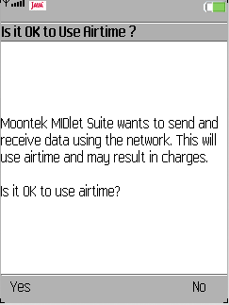

Choose “Yes” and the Home page appears
Choose “No” to cancel

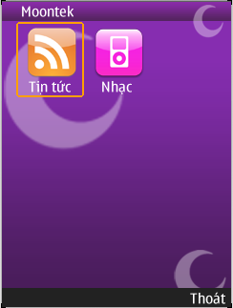

Homepage show 2 main features “Tin tức ” and “Nhạc”
Choose “Thoát” to exit

6.2 User’s Guide

6.2.1 Reading news

At the homepage of application, you choose “Tin tức”

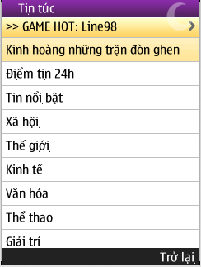

This screen show all news that refer form show social web newspapers
This information is updated every time.
In the top of screen, there is a tab for introducing new games. You can check or play some games. For example in that above screen is Line 98 game.
You can choose type of news you want to read. It is divided into some parts.
“Điểm tin 24h”
“Tin nổi bật”
“Xã hội”
“Thế giới”
“Kinh tế”
“Văn hóa”
“Thể thao”
“Giải trí”…..
For example, you want to read economic news:

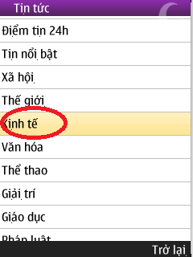

You move to “Kinh tế” and enter

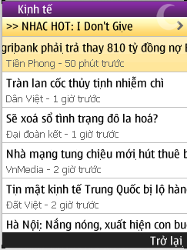

In “Kinh tế”, news about economic from some newspapers appear. You can see news from Tiền Phong , Dân Việt, Đại Đoàn Kết, Vnmedia and Đất Việt…
You can read any news by move to it and enter.
The content of news like this screen

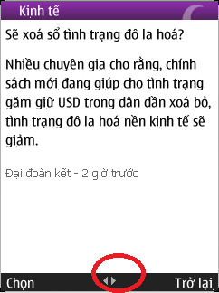

It only shows the title of news on the screen. If you want to read full news please continuous enter and the system will request your account to register new package. Choose yes. For information refer 2.3 manage Account
You can choose to other news quickly by press next or previous button on the bottom bar.
If you want to back to previous screen choose “Trở về” on the left of bottom.
Similar that if you want to back to top menu.

6.2.2 Listening and downloading music

6.2.2.1 Structure of Music
Similar with reading news, at the home screen of application
You choose “Nhạc”

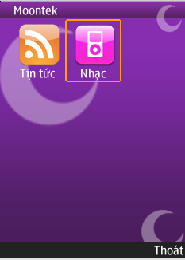

Following screen appears with all the type of music. Such as:
“Nhạc sàn đẳng cấp”
”Nhạc Chuông độc đáo”
”Ca khúc tuyển chọn”
“Album tuyển chọn”
”Nhạc trẻ”
“Nhạc trữ tình”…
Like following screen
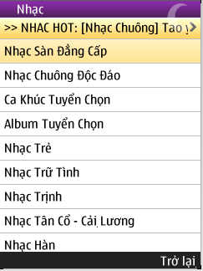

Music box is divided into some types of music. You can easy choose the type you like by move and enter.

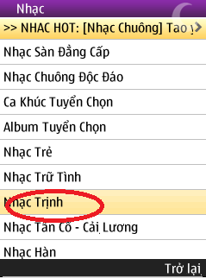

For example, You choose “ Nhạc Trịnh”.
A Screen will appears like this follow screen

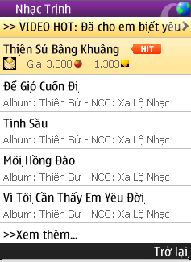

In this screen, it is divided into 3 main parts. The top part is some video clips. The second is the name of songs in “Nhạc Trịnh” album. Such as :
“Thiên sứ bâng khuâng”
“Để gió cuốn đi”
”Tình sầu”
”Môi Hồng đào”
“Vì tôi cần thấy em yêu đời”
The bottom part is more option.
There are many songs in this “Nhạc Trịnh” album. But the screen is not enough large to show full. It only shows 5 songs per 1 screen. So if you want to see more songs you can choose “Xem thêm”
If you want back to previous screen please choose “Trở lại”
And continuous choose “Trở lại” If you want to back more to “Nhạc” folder or Home screen.
You choose a song.
Default, All song appears with album name
Example:
“Tình sầu” song in “Thiên sứ”Album
Some information of it is showed. The price of it- “Giá” and the number of people voted like it.- the heart symbol
Example:
“Tình sầu” song
Its price is 3000 and it is liked by 2381 people.
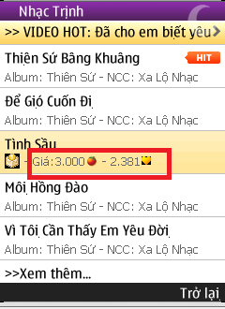

6.2.2.2 Listening to music
You choose any song you want.
Example: The song “Non Stop” in the “Nhạc Sàn tuyển chọn”
How to choose this song? Refer in 2.2.1 Structures of Music
After do all step successful.
The screen of song will appears like following screen.

You choose “Nghe thử”

Click Play to hear this song.
Note: You will only hear a part of this song.

6.2.2.3 Downloading music
You choose any song you want.
Example: The song “Tình sầu” in the above screen.
How to choose this song? Refer in 2.2.1 Structures of Music
After do all step successful.
The screen of song will appears like following screen.

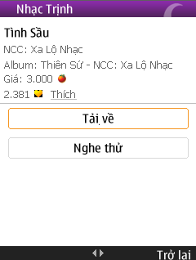

This screen shows all information about this song.
It belongs to “Nhạc Trịnh” and has original in “Xa Lộ Nhạc”
It belongs to “Thiên Sứ” Album and this album has orginal in “Xa Lộ Nhạc” too
And the price of the song and the number of people like it.
If you like it you can also vote for it by choosing “Thích”.
As you can see, there are two main buttons is “Tải về “
And “Nghe thử”
+ About download the song or “Tải về”
Note: You have to pay money to download
When you choose “Tải về” a notice board will appears to show you about the price.

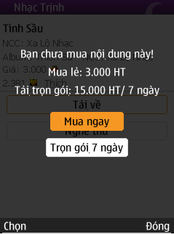

It shows you about the price of the song.
If you only download this song you will pay 3000 or you want to download this song anytime you want and only during in 1 week you will pay 15000
If you want more information about this content refer to 2.3 Manage Account

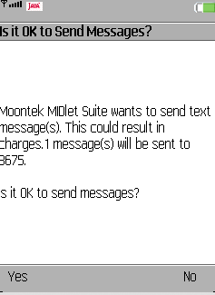

A message appears to notice you that a SMS will be sent to server to load this song to your phone.
If you still want to download please choose “Yes”
Or choose “No” if you want to cancel this download

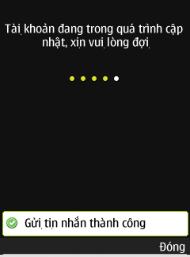

After sending the SMS, a screen will appear to show you that your message is sent successfully.
Please wait for few seconds and download the song to your mobile phone

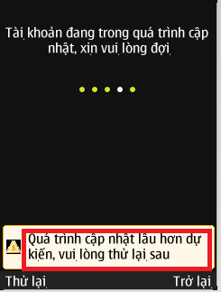

If this notice bar like above picture that mean there is an error has just occur.
Please contact to the administrator or check your connection to internet.

6.3 Managing account

6.3.1 Structure of Account
After install this application, you are created an account.
Choose “Tai khoan ” to view your account
In your account table, you will see some information
“Họ và Tên”
“Ngày Sinh”
“Số điện thoại”
“Tài khoản chinh”
“Nạp tiền”
…
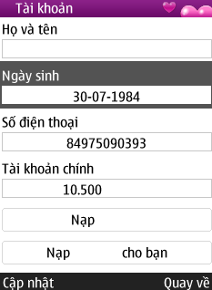

When account is created, there is no information is added.
You can add more.
“Họ và Tên”
This is the place to write your name
“Ngày Sinh”
You write your birth day
“Số điện thoại”
You write your mobile phone number
“Tài khoản chinh”
It is the amount of money you have in your account
“Nạp tiền”
This is the function that you add more money for your account
In the left of bottom, there is a button that named “Cập nhật”
After you add full your information you can choose “Cập nhật” to
Update your account
If you want to back to Home screen please choose “Quay về”

6.3.2 Adding money for your account
Your account has all information about you such as name, age, phone number and the amount of money…
To view more information or content of news and download your favorite songs you have to pay money by your account.
In “Tài khoản”
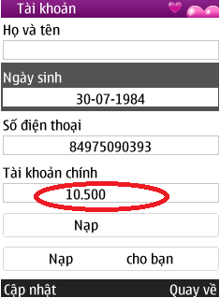

You choose “Tài khoản chính” to check your balance of account
That are the money that you have
If that amount is equal zero you can’t view full news and download music.
For example:
The money of account on above screen is 10500
+ To add money for your account
You choose “”Nạp Tiền” function

In this function, you will see two ways to add
“SMS 10000d”
You choose if you want to add 10000d to you account
“SMS 15000d”
You choose if you want to add 15000d to your account
After you choose
A confirm message appear to confirm your request
Choose “Đồng ý” if you really want to add
Choose “Đóng” if you want to back
And other function is sending money for other person

You write his/her name phone number in “Số đthoại người nhận” Text field
Then choose the amount of money you want to send to his/her
It similar with adding money for your account but you must add the person’s phone number you want to send.

Reference

- A. Lee Blackstone, 1995, Manage globally sell locally: the art of strategic account management, Book Press
- Thomas C. Jepsen, Farooq Anjum, 2001, Java in telecommunications: solutions for next generation network, Wiley
- Michael Talbot-Smith, 1999, Audio engineer’s reference book
- Michael J. O'Farrell, John R. Levine, Jostein Algroy, James Pearce, Daniel Appelquist, 2008, Mobile Internet for Dummies, Wiley
-William Hanson, 2009, The Egde of Medicine: The Technology That will change our lives,Wiley

7. Appendix

7.1 Appendix A
meeting minuteS1

Project: |  | Online Mobile World |  | Project Code: |  | CS_OMW
Super Visior |  | LongNT |  | Conductor:
 |  |  |  | Secretary:
Project Leader: |  | Nguyễn Xuân Minh – 00204 |  | Conductor:
 |  |  |  | Secretary: |  | Phạm Ngọc Sơn
Date: |  | 01/01/2011 |  | Time: |  | 17h00
Venue:
Topic of meeting:
A t t e n d e e s :
No | Full name |  | Unit/Group |  | Position |  | Attendance
1 | Nguyễn Xuân Minh – 00017 |  |  |  | Team Leader |  | Present
2 | Phạm Ngọc Sơn – 00286 |  |  |  | Team Member |  | Present
3 | Lê Thị Bích Thảo – 00238 |  |  |  | Team Member |  | Present
4 | Nguyễn Đức Long – 00104 |  |  |  | Team Member |  | Present
5 | Trương Đức Vinh - 00290 |  |  |  | Team Member |  | Present
Objectives
Agenda
- Report information to supervisor about: team, project.
- Information about team member, role and responsibilities
  - Team member
  - Team leader
  - Responsibilities of team member

- Information about project
  - Name of team
  - What kind of project?
  - The problem of this will be solves?
  - When this start?
  - Technique will be used?
Contents
- Team: member, role and responsibilities
- Project:
  - Learning application on mobile and build application on mobile which popular in Vietnam
  - Decide to develop news and music service for OMW
Conclusion
Discussed Items | Decisions
Team | Decision:  Team  - Team have 5 member  - Phạm Ngọc Sơn– 00286  - Lê Thị Bích Thảo – 00238  - Nguyễn Đức Long – 00104  - Trương Đức Vinh - 00290  - Role  - Team leader  - Nguyễn Xuân Minh – 00017  - Responsibilities  - Team leader :  - Project manager  - Management team  - Monitor activities of team member  - Report to supervisor about status team, project, the issues and the concerns  - Team member:  - Provide assistance to other team members when required  - Attend work sessions, team, relevant subteam and meeting  - Complete assigned tasks in project and update task logs
Project | - Learning application on mobile and build application on mobile which popular in Vietnam  - Project scope: News and Music service

7.2 Appendix B
meeting minuteS2

Project: |  | Online Mobile World |  | Project Code: |  | CS_OMW
Supervisor |  | LongNT |  | Conductor:
 |  |  |  | Secretary:
Project Leader: |  | Nguyễn Xuân Minh – 00017 |  | Conductor:
 |  |  |  | Secretary: |  | Phạm Ngọc Sơn
Date: |  | 03/01/2011 |  | Time: |  | 17h00
Venue:
Topic of meeting:
A t t e n d e e s :
No | Full name |  | Unit/Group |  | Position |  | Attendance
1 | Nguyễn Trường Long |  |  |  | Supervisor |  | Present
2 | Nguyễn Xuân Minh – 00017 |  |  |  | Team Leader |  | Present
3 | Phạm Ngọc Sơn – 00286 |  |  |  | Team Member |  | Present
4 | Lê Thị Bích Thảo – 00238 |  |  |  | Team Member |  | Present
5 | Nguyễn Đức Long – 00104 |  |  |  | Team Member |  | Present
6 | Trương Đức Vinh - 00290 |  |  |  | Team Member |  | Present
Objectives
Agenda
- Determine project scope
- Information about project
  - Role of team members: OMW
  - Name of team : Moontek
  - A part of ERP ( build for hyundai Thanh Cong Viet Nam)
  - Begin 03/01/2011
  - Technique : java 1.6, J2ME, J2EE, Eclipe, Tom Cat 6, Spring, Hibernate…
Content
- Check status of project: making report 1
- Project scope: develop News and Music service in OMW
- Team: member, role and responsibilities
  - Team Leader: Nguyễn Xuân Minh – 00017
  - Business analyst
    - get the requirement from customer
    - have deep into the business and understand the processes and make use of the knowledge in the process and concerns about News and Music on other supplier
  - Technique leader
    - Have deep in technique and overview about the project
    - Monitor technique to solve issues
  - Implementation Manager
    - Delegate coding tasks
    - Monitor the development of this project’s code when Team members inform the Implementation Manager via email that significant changes to the code has occurred to ensure that the System is correctly coded
  - Testing Manager
- Co-ordinate all testing phases
    - Communicate issues and concerns regarding the test plan with the project manager
  - Software Administrator
    - Perform System administration duties such as installing software that are required by Teams
  - Agenda writer
    - Creating the agenda for an upcoming meeting
  - Quality Assurance Manager
    - Checking that the quality and managerial processes in the SQAP and SPMP are being followed and devote one to two hours per week for this task
Conclusion
Discussed Items | Decisions
Team | Decision:  Team  - Team Leader: Nguyễn Xuân Minh – 00017  - Business analyst - Trương Đức Vinh – 00290  - Technique leader – Phạm Ngọc Sơn – 00286  - Implementation Manager –Nguyễn Đức Long – 00104  - Testing Manager – Lê Thị Bích Thảo – 00238  - Configuration Manager - Phạm Ngọc Sơn – 00286  - Software Administrator -Nguyễn Đức Long – 00104  - Agen da writer – Lê Thị Bích Thảo – 00238  - Quality Assurance Manager –Lê Thị Bích Thảo - 00238
Project | - Online Mobile Worrld

7.3 Appendix C
meeting minuteS 3

Project: |  | Online Mobile World |  | Project Code: |  | CS_OMW
Supervisor |  | LongNT |  | Conductor:
 |  |  |  | Secretary:
Project Leader: |  | Nguyễn Xuân Minh– 00017 |  | Conductor:
 |  |  |  | Secretary: |  | Phạm Ngọc Sơn
Date: |  | 10/01/2011 |  | Time:
Venue:
Topic of meeting: |  | Review report 1& guide report 2
A t t e n d e e s :
No | Full name |  | Unit/Group |  | Position |  | Attendance
1 | Nguyễn Trường Long |  |  |  | Supervisor |  | Present
1 | Nguyễn Xuân Minh – 00017 |  |  |  | Team Leader |  | Present
2 | Phạm Ngọc Sơn – 00286 |  |  |  | Team Member |  | Present
3 | Lê Thị Bích Thảo – 00238 |  |  |  | Team Member |  | Present
4 | Nguyễn Đức Long – 00104 |  |  |  | Team Member |  | Present
5 | Trương Đức Vinh - 00290 |  |  |  | Team Member |  | Present
Objectives
Agenda
- Review report 1
- Guide report 2

Contents
- Review report 1:
+ Supervisor’s comment: good report, need to give information about references
- Guide report 2:
+ Following Capstone project_ studentGuide_IS.
+ Hold meeting to make project plan
+ Contact with supervisor if have any question
+ Deadline: 17/01/2011
Conclusion
Discussed Items | Decisions
Report 1 | Decision:  - Edit following supervisor’s comment
Report 2 | - Start create report 2  - Following Capstone project_ studentGuide_IS  - Notice deadline(17/01/2011)

7.4 Appendix D
meeting minuteS 4

Project: |  | Online Mobile Word |  | Project Code: |  | CS_OMW
Supervisor |  | LongNT |  | Conductor:
 |  |  |  | Secretary:
Project Leader: |  | Nguyễn Xuân Minh– 00017 |  | Conductor:
 |  |  |  | Secretary: |  | Phạm Ngọc Sơn
Date: |  | 17/01/2011 |  | Time: |  | 17h00
Venue:
Topic of meeting:
A t t e n d e e s :
No | Full name |  | Unit/Group |  | Position |  | Attendance
1 | Nguyễn Trường Long |  |  |  | Supervisor |  | Present
2 | Nguyễn Xuân Minh – 00017 |  |  |  | Team Leader |  | Present
3 | Phạm Ngọc Sơn – 00286 |  |  |  | Team Member |  | Present
4 | Lê Thị Bích Thảo – 00238 |  |  |  | Team Member |  | Present
5 | Nguyễn Đức Long – 00104 |  |  |  | Team Member |  | Present
6 | Trương Đức Vinh - 00290 |  |  |  | Team Member |  | Present
Objectives
Agenda
- Review report 2
- Guide report 3
Content
- Review report 2:
+ Supervisor’s comment: give detail management plan
- Guide report 3:
+ Should follow Capstone project_ studentGuide_IS.
+ Prepare information for report 3: define required environment; analyst and define clearly all requirements; from requirement, create use cases (note to not lack of requirements), define database tables (needn’t define all attribute in these tables)
+ Contact with supervisor if have any question
+ Deadline: next 1 weeks.
Conclusion
Discussed Items | Decisions
Report 2 | Decision:  Add content following supervisor’s comments.
Report 3 | - Start create report 3  - Following Capstone project_ studentGuide_IS  - Hold meeting to prepare information for report 3  - Notice deadline: next 1 weeks

7. 5 Appendix E
meeting minuteS 5

Project: |  | Online Mobile World |  | Project Code: |  | CS_OMW
Supervisor |  | LongNT |  | Conductor:
 |  |  |  | Secretary:
Project Leader: |  | Nguyễn Xuân Minh– 00017 |  | Conductor:
 |  |  |  | Secretary: |  | Trương Đức Vinh
Date: |  | 21/01/2011 |  | Time: |  | 17h00
Venue:
Topic of meeting:
A t t e n d e e s :
No | Full name |  | Unit/Group |  | Position |  | Attendance
2 | Nguyễn Xuân Minh – 00017 |  |  |  | Team Leader |  | Present
3 | Phạm Ngọc Sơn – 00286 |  |  |  | Team Member |  | Present
4 | Lê Thị Bích Thảo – 00238 |  |  |  | Team Member |  | Present
5 | Nguyễn Đức Long – 00104 |  |  |  | Team Member |  | Present
6 | Trương Đức Vinh - 00290 |  |  |  | Team Member |  | Present
Objectives
Agenda
- Check status of project
- Guide report 3
Content
- Status of project:
+ Report status of project:
- Set up environment: java 1.6, J2ME, J2EE …
- Research applied technology
- Make report 3 (User requirement specification and System requirement specification);
+ Guide to research technology: what and how it will be apply in this project (through internet or supervisor if have problem while researching).
- Guide report 3:
+ User interface: what components are needed; What functions are needed
+ Entity relationship diagram or data structure:
- Research the way to create a right entity relationship diagram or data structure.
- Note to use notation suitable. Do not use arrow notation between database tables.
- Need to explain the meaning of notation that was use in this Entity relationship diagram or data structure.
+ Note to add reference: when you use a sentence in a book or document or someone’s words, you must to point out it clearly.
+ Contact with supervisor if have any question
+ Submit report on time.

Conclusion
Discussed Items | Decisions
Decision:
- Continue study applied technology
Report 3 | - Continue making report 3  - Do following supervisor’s comments  - Submit report on time.

7.6 Appendix F
meeting minuteS 6

Project: |  | Online Mobile World |  | Project Code: |  | CS_OMW
Supervisor |  | LongNT |  | Conductor:
 |  |  |  | Secretary:
Project Leader: |  | Nguyễn Xuân Minh– 00017 |  | Conductor:
 |  |  |  | Secretary: |  | Lê Thị Bích Thảo
Date: |  | 24/01/2010 |  | Time: |  | 17h00
Venue:
Topic of meeting:
A t t e n d e e s :
No | Full name |  | Unit/Group |  | Position |  | Attendance
1 | Nguyễn Trường Long |  |  |  | Supervisor |  | Present
2 | Nguyễn Xuân Minh – 00017 |  |  |  | Team Leader |  | Present
3 | Phạm Ngọc Sơn – 00286 |  |  |  | Team Member |  | Present
4 | Lê Thị Bích Thảo – 00238 |  |  |  | Team Member |  | Present
5 | Nguyễn Đức Long – 00104 |  |  |  | Team Member |  | Present
6 | Trương Đức Vinh - 00290 |  |  |  | Team Member |  | Present
Objectives
Agenda
- Check status of project
- Review report 3
- Guide report 4
Content
- Status of project:
+ Report status of project:
- Create prototype
- Start designing system: component, classes
- Make report 4: discuss about system architecture design.
- Review report 3
+ User requirement specification: must be more clearly, analyst conflict between requirements or risk.
+ User interface (system requirement specification): don’t need too detailed.
+ Data structure: should explain relation between two tables, why they have relation like that.
- Guide report 4:
+ Should follow Capstone project_ studentGuide_IS.
+ Prepare information for report 4:
- Choose system architecture model will be used to descript this system; define all component and relation between them.
- Detailed description component: can see guide in document of SAD- software architecture design subject (sequence diagram, component diagram, class diagram, flow chart)
- Data structure: base on requirement, define all attribute (name, type…) must have in tables.
+ Contact with supervisor if have any question
+ Note to deadline: 28/02/2011
Conclusion
Discussed Items | Decisions
Report 4 | - Continue making report 3  - Following Capstone project_ studentGuide_IS  - Hold meeting to prepare information for report 3  - Submit report on time.

7. 7 Appendix G
meeting minuteS 7

Project: |  | OMW |  | Project Code: |  | CS_OMW
Supervisor |  | LongNT |  | Conductor:
 |  |  |  | Secretary:
Project Leader: |  | Nguyễn Xuân Minh– 00017 |  | Conductor:
 |  |  |  | Secretary: |  | Lê Thị Bích Thảo
Date: |  | 28/02/2011 |  | Time: |  | 17h00
Venue:
Topic of meeting:
A t t e n d e e s :
No | Full name |  | Unit/Group |  | Position |  | Attendance
1 | Nguyễn Trường Long |  |  |  | Supervisor |  | Present
2 | Nguyễn Xuân Minh – 00017 |  |  |  | Team Leader |  | Present
3 | Phạm Ngọc Sơn – 00286 |  |  |  | Team Member |  | Present
4 | Lê Thị Bích Thảo – 00238 |  |  |  | Team Member |  | Present
5 | Nguyễn Đức Long – 00104 |  |  |  | Team Member |  | Present
6 | Trương Đức Vinh - 00290 |  |  |  | Team Member |  | Present
Objectives
Agenda
- Check status of project
- Review report 4
- Guide report 5
Content
- Status of project:
+ Report status of project:
- Start implementing system (create common component, action component…)
- Continue making report 4(Detailed description of components)

- Review report 4:
+ Comments for report 4: Current classes are too large. Classes should be divided more detailed. It is good when use inheritance to design classes.
+ Contact with supervisor if have any question
+ Submit report on time.

Conclusion
Discussed Items |  |  | Decisions
Report 3 |  |  | - Continue making report 5  - Following Capstone project_ studentGuide_IS  - Hold meeting to prepare information for report 3  - Submit report on time.
7.8 Appendix H | meeting minuteS 8

Project: |  | OMW |  |  | Project Code: |  | CS_OMW
Supervisor |  | LongNT |  |  | Conductor:
 |  |  |  |  | Secretary:
Project Leader: |  | Nguyễn Xuân Minh– 00017 |  |  | Conductor:
 |  |  |  |  | Secretary: |  | Lê Thị Bích Thảo
Date: |  | 11/04/2011 |  |  | Time: |  | 17h00
Venue:
Topic of meeting:
A t t e n d e e s :
No | Full name |  |  | Unit/Group |  | Position |  | Attendance
1 | Nguyễn Trường Long |  |  |  |  | Supervisor |  | Present
2 | Nguyễn Xuân Minh – 00017 |  |  |  |  | Team Leader |  | Present
3 | Phạm Ngọc Sơn – 00286 |  |  |  |  | Team Member |  | Present
4 | Lê Thị Bích Thảo – 00238 |  |  |  |  | Team Member |  | Present
5 | Nguyễn Đức Long – 00104 |  |  |  |  | Team Member |  | Present
6 | Trương Đức Vinh - 00290 |  |  |  |  | Team Member |  | Present
Objectives
Agenda
- Check status of project
- Review report 5
- Guide report 6
Content
- Status of project:
+ Report status of project:
- Continue making report 6(Detailed description of components)

- Review report 5:
+ Comments for report 5: Test cases need to cover all cases
+ Contact with supervisor if have any question
+ Submit report on time.

Conclusion
Discussed Items |  |  | Decisions
Report 3 |  |  | - Continue making report 6  - Following Capstone project_ studentGuide_IS  - Hold meeting to prepare information for report 6  - Submit report on time.
7.9 Appendix I | meeting minuteS 8

Project: |  | OMW |  |  | Project Code: |  | CS_OMW
Supervisor |  | LongNT |  |  | Conductor:
 |  |  |  |  | Secretary:
Project Leader: |  | Nguyễn Xuân Minh– 00017 |  |  | Conductor:
 |  |  |  |  | Secretary: |  | Lê Thị Bích Thảo
Date: |  | 18/04/2011 |  |  | Time: |  | 17h00
Venue:
Topic of meeting:
A t t e n d e e s :
No | Full name |  |  | Unit/Group |  | Position |  | Attendance
1 | Nguyễn Trường Long |  |  |  |  | Supervisor |  | Present
2 | Nguyễn Xuân Minh – 00017 |  |  |  |  | Team Leader |  | Present
3 | Phạm Ngọc Sơn – 00286 |  |  |  |  | Team Member |  | Present
4 | Lê Thị Bích Thảo – 00238 |  |  |  |  | Team Member |  | Present
5 | Nguyễn Đức Long – 00104 |  |  |  |  | Team Member |  | Present
6 | Trương Đức Vinh - 00290 |  |  |  |  | Team Member |  | Present
Objectives
Agenda
- Review report 6
- Making sum of report
Content
- Review report 6:
+ Comments for report 6: Making detail installation guide and uer’s guide
+ Contact with supervisor if have any question
+ Submit report on time.

Conclusion
Discussed Items | Decisions
Report 3 | - Continue making sum of report  - Following Capstone project_ studentGuide_IS  - Submit report on time.

8 GLOSSARY

ID | Acronym | Definition
1 | OMW | Online Mobile World
2 | HTTP | Hypertext Transfer Protocol
3 | SQL | Structured Query Language
4 | MVC | Model View Control
5 | OS | Operating System
6 | SMS | Short Message Services
7 | JSON | JavaScript Object Notation
8 | J2EE | Java 2 Platform Emterprise Edition
9 | J2ME | Java 2 Micro Edition
10 | URL | Uniform Resource Locator
11 | HTML | Hyper Text Markup Language
12 | WIFI | Wireless Fidelity
13 | GPRS | General Packet Radio Service

